Biodiversity values
Biodiversity is the name given to the variety of living things: the different flora, fauna and organisms; the genetic information they contain; and the ecosystems they form. Biodiversity values were fundamental in establishing a CAR reserve system under Victorian RFAs and were a focus of the related CRAs.
The National Reserve System (NRS) is Australia’s network of public, Indigenous and private protected areas over land and inland freshwater. Its focus is to secure long-term protection for samples of Australia’s diverse ecosystems and the plants and animals they support. The NRS includes the protected areas and reserves established and effectively managed through the collective efforts of the Australian Government, states, territories, local government, Indigenous and private landholders, and non-government organisations.
Indicators of biodiversity value can include the number and diversity of flora and fauna species, ecological communities and forest types. These indicators consider the range of flora and fauna species and communities, and the reserves established to protect biodiversity.

Indicator 1.1a: Area of forest by forest type and tenure

Forest type assessment in the Comprehensive Regional Assessment
Forest type information provided in the CRA documents was described under the Forest Ecosystem Assessment sections of the respective reports and used the EVCs as the basic mapping units. However, no dedicated forest cover (by forest type) was presented. Comparisons of forest type information between the CRA process and the current data are therefore limited to changes in EVC area, and forest productive areas, as presented in Indicator 2.1a.

Area of forest, by forest type

Differences in mapping approaches
The information presented here is drawn from different processes that each contribute to inform the narrative around current forest extent by RFA region. However, the different processes present varying estimates of total forest cover in Victoria. This is important to note, as it explains the inherent uncertainty in landscape-scale landcover analysis. In Table 22, forest type statistics derived from the National Forest Inventory (NFI) are presented for the Victorian RFA regions. Table 23 presents time-series data produced by DELWP and disaggregated based on public and private tenure; however, it does not have forest type information.
The total forest cover estimates differ between these processes. In the Victorian context, differences in mapping methodology are likely to be most pronounced in the Mallee, or in similarly naturally fragmented forest types. This is due to complexities in classifying remotely sensed imagery in non-uniform land covers. It is also important to note that the NFI dataset represents forest cover as at 2016, while the Victorian data represents forest cover as at 2013.

Australia’s National Forest Inventory
The definition of forest’ used in this report is derived from Australia’s NFI. It can be summarised as an area of single-stemmed woody vegetation with a dominant vegetation with height of greater than 2 metres and canopy cover greater than 20 per cent. While Victoria calculates its own forest type and area estimates through the Victorian Forest Monitoring Program (VFMP), the aggregation of the plot network does not currently allow the data to be disaggregated by RFA region. In consequence, the forest type statistics presented here are derived from the NFI area values as outlined in the ASOFR.
The ASOFR is a comprehensive synthesis report of national, state and territory data and information on the multiple environmental, economic and social values, benefits and services of Australia’s forests. The fifth report in the ASOFR series, Australia’s state of the forests report 2018, brings together and reports on data and information current to June 2016 (Montréal Process Implementation Group for Australia and NFI Steering Committee 2018).
Assembled for ASOFR 2018, the Forests of Australia (2018) spatial dataset reports the extent and type of Australia’s forests. Forest extent is calculated using a multiple lines of evidence (MLE) approach that analyses multiple forest cover datasets from national and state sources to delineate forest extent with improved accuracy. This methodology was first used for calculating forest extent for ASOFR 2013 and was again used for ASOFR 2018. Forest typing was determined using a combination of national and state and territory vegetation information datasets. Further information on the data sources used for the MLE and forest typing can be found in Indicator 1.1a of ASOFR 2018 (Montréal Process Implementation Group for Australia and NFI Steering Committee 2018, pp. 45–74).
Forests in the NFI and the Forests of Australia (2018) dataset are classed under three broad forest categories of Native forest, Commercial plantation and Other forest. Within the Native forest category there are eight forest types that describe the dominant genera and structure types. These include Acacia, Callitris, Casuarina, Eucalypt, Mangrove, Melaleuca and Rainforest. The eighth type – Other native forest – includes a range of less frequently occurring forest genera and native forests of unknown type. The Eucalypt forest type is further classified into 11 forest subtypes based on the form of dominant trees, mature tree height and crown cover. Further information on forest form, height and crown cover can be found in ASOFR 2018 Indicator 1.1a (ibid.).
The Commercial plantation category includes three types: Softwood plantation (mostly pines), Hardwood plantation (mostly eucalypts), and mixed or unknown plantations. The Other forest category includes non-commercial plantations and planted forests.
ASOFR 2018 reported 8.2 million hectares of forest occurs in Victoria, including 7.6 million hectares of Native forest, 0.41 million hectares of Commercial plantation, and 0.16 million hectares of Other forest. Of the total forest area in Victoria, 6.2 million hectares of forest occurs in the five Victoria RFA regions, with 5.6 million hectares of Native forest, 0.41 million hectares of Commercial plantation and 0.13 million hectares of Other forest. By RFA region, 1.6 million hectares of forest is in the Gippsland RFA region, 1.4 million hectares in each of the North East and West Victoria regions, 1.1 million hectares is in the East Gippsland region and 0.72 million hectares is in the Central Highlands region.
The most common forest type in the Victorian RFA regions is the Eucalypt forest type with 5.4 million hectares, followed by 0.17 million hectares of the Other native forest type. By Eucalypt forest subtypes there are 2.8 million hectares of Eucalypt medium open forest and 1.3 million hectares of the Eucalypt tall open forest subtype (Table 22).

Table 22: NFI forest area in Victoria RFA regions, as at 2016
 | Area ('000 ha)
NFI forest type  Forest category | Forest, by RFA regiona
 | Central Highlands | East Gippsland | Gippsland | North East | West Victoria | Total in RFA regions | Total not in RFA regions | Total in Victoria
Native forest
Acacia | 0 | 8 | 24 | 2 | 2 | 36 | 1 | 37
Callitris | 0 | 0 | 0 | 0 | 23 | 23 | 0 | 23
Casuarina | 0 | 0 | 0 | 0 | 1 | 1 | 47 | 48
Eucalypt | 688 | 1,031 | 1,416 | 1,270 | 973 | 5,378 | 1,797 | 7,175
Eucalypt mallee open | 0 | 0 | 0 | 0 | 0 | 0 | 11 | 11
Eucalypt mallee woodland | 0 | 0 | 0 | 0 | 52 | 53 | 1,227 | 1,280
Eucalypt low closed | 1 | 2 | 2 | 4 | 4 | 14 | 0 | 14
Eucalypt low open | 4 | 7 | 11 | 30 | 14 | 66 | 3 | 69
Eucalypt low woodland | 1 | 4 | 3 | 3 | 6 | 16 | 4 | 20
Eucalypt medium closed | 17 | 15 | 20 | 19 | 25 | 96 | 0 | 97
Eucalypt medium open | 349 | 457 | 798 | 745 | 414 | 2,762 | 331 | 3,092
Eucalypt medium woodland | 36 | 110 | 221 | 91 | 377 | 835 | 202 | 1,036
Eucalypt tall closed | 31 | 18 | 26 | 28 | 13 | 116 | 0 | 117
Eucalypt tall open | 239 | 398 | 317 | 335 | 58 | 1,348 | 19 | 1,367
Eucalypt tall woodland | 9 | 20 | 17 | 16 | 10 | 72 | 1 | 73
Mangrove | 0 | 0 | 0 | 0 | 0 | 0 | 0 | 0
Melaleuca | 0 | 0 | 7 | 0 | 8 | 15 | 4 | 19
Rainforest | 5 | 10 | 3 | 0 | 2 | 20 | 0 | 20
Other native forest | 9 | 55 | 33 | 5 | 65 | 167 | 155 | 322
Total native forest | 703 | 1,104 | 1,483 | 1,277 | 1,073 | 5,640 | 2,004 | 7,644
Commercial plantation
Hardwood plantation | 3 | 3 | 29 | 3 | 158 | 197 | 1 | 198
Softwood plantation | 9 | 2 | 59 | 53 | 92 | 215 | 1 | 215
Unknown or mixed species | 0 | 0 | 1 | 0 | 0 | 1 | 0 | 1
Total commercial plantation | 12 | 6 | 89 | 56 | 250 | 412 | 2 | 414
Other forest
Total other forest | 8 | 2 | 26 | 18 | 80 | 134 | 28 | 162
Total all forest types | 723 | 1,113 | 1,598 | 1,350 | 1,403 | 6,187 | 2,034 | 8,220
a RFA region boundary data supplied by Victoria DELWP.
Notes: Totals may not tally due to rounding.
Area derived by ABARES from Forests of Australia (2018) dataset.

Forest cover change
Forest cover change estimates were made as part of the VSOFR process over two time periods, 2009 and 2013. These figures were published in the 2013 and 2018 VSOFRs respectively.
Positive gains were shown in all RFA regions except the North East. Gains in other areas were attributed to regrowth from successive mega-fires in the decade to 2010. It is important to note that these forest area change figures are not related to the forest area described above and in Table 22 and vary on account of the different processes and methodologies used to create the analysis.

Area of forest, by tenure
According to the Victorian forest cover assessment, forest on public land accounts for nearly 6.5 million hectares, with about 1.2 million hectares of forest on private land. Of public land forest, almost half (47 per cent per cent) is in State forests and almost half (47 per cent per cent) is in land tenures focused on conservation. Approximately 77 per cent of forests are located within the RFA regions.
The proportion of land in each RFA region that is forested varies. The West RFA region is the largest (over 5.7 million hectares total area) and is 22 per cent forested, whereas the East Gippsland RFA region is the second smallest (1.1 million hectares total area) and is 90 per cent forested.
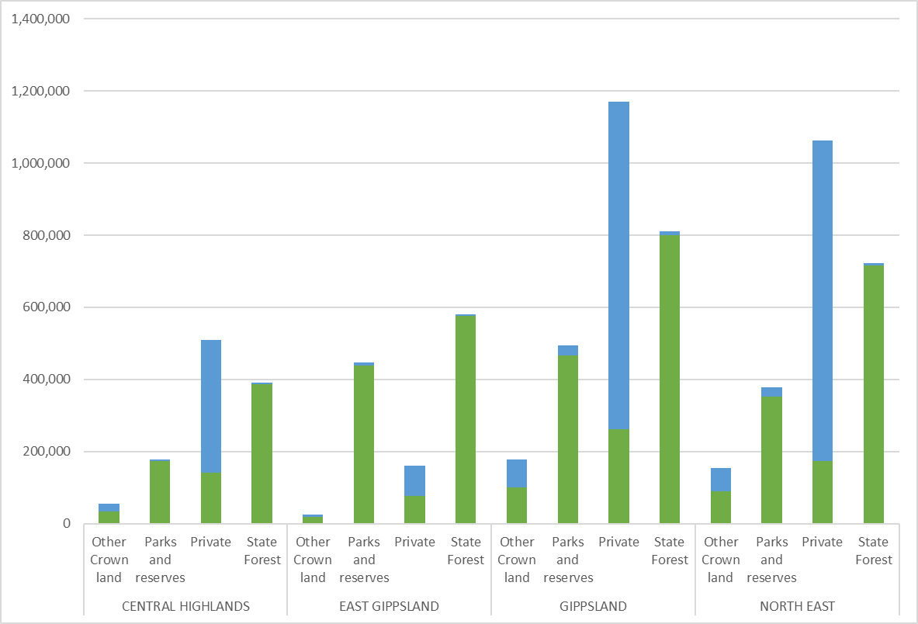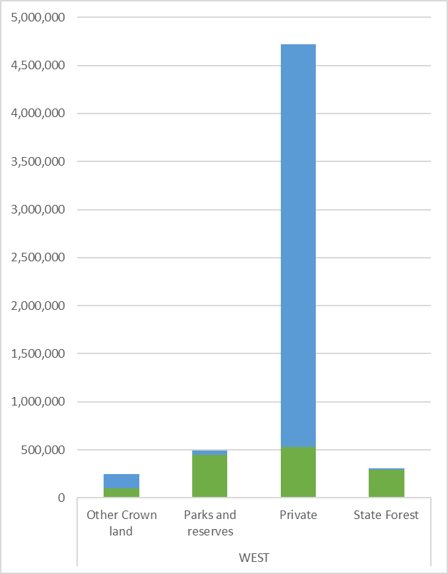
Figure 5: Forest cover and non-forest from Victoria’s forest cover estimates, 2013
Note: Forest cover is shown in green and non-forest is shown in blue.
The mix of forest on public and private land also varies between RFA regions. The West RFA region has the highest proportion of forest on private land (36 per cent of total forest in the region), which partly reflects the significant plantation industry in the west of the state. In the Central Highlands RFA region, 17 per cent of forest is on private land, while in other RFA regions the proportion is less than 15 per cent.
Table 23: Forest cover change by RFA and tenure, 2009–13
 |  |  | 2009 |  |  |  |  | 2013
 |  |  | Forest |  | Non-forest |  |  | Forest |  |  | Non-forest
 |  | All Land area | Area | per cent | Area | per cent | All  Land | Area | per cent | Area |  | per cent
 | Central Highlands
Parks and reserves |  | 174 | 170 | 14.9 | 4 | 0.3 | 197 | 175 | 15.40 | 22 |  | 0.3
State forest |  | 402 | 395 | 34.9 | 7 | 0.5 | 145 | 142 | 12.53 | 3 |  | 32.4
Other Crown land |  | 50 | 31 | 2.7 | 19 | 1.6 | 403 | 35 | 3.01 | 368 |  | 1.9
Private land |  | 509 | 145 | 12.8 | 364 | 32.2 | 391 | 386 | 34.10 | 5 |  | 0.4
Total Central Highlands |  | 1,132 | 740 | 65.3 | 393 | 34.7 | 1,132 | 737 | 65.04 | 396 |  | 35.0
 | East Gippsland
Parks and reserves |  | 448 | 436 | 35.9 | 12 | 1.0 | 447 | 440 | 36.21 | 7 |  | 0.6
State forest |  | 583 | 576 | 47.4 | 7 | 0.5 | 86 | 78 | 6.39 | 8 |  | 6.9
Other Crown land |  | 27 | 19 | 1.5 | 8 | 0.6 | 102 | 18 | 1.45 | 84 |  | 0.6
Private land |  | 160 | 75 | 6.1 | 85 | 7.0 | 582 | 576 | 47.49 | 6 |  | 0.4
Total East Gippsland |  | 1,213 | 1,104 | 90.9 | 111 | 9.1 | 1,213 | 1,111 | 91.54 | 103 |  | 8.5
 | Gippsland
Parks and reserves |  | 491 | 446 | 16.8 | 45 | 1.7 | 545 | 466 | 17.55 | 79 |  | 1.1
State forest |  | 864 | 846 | 31.8 | 18 | 0.7 | 290 | 261 | 9.83 | 29 |  | 34.3
Other Crown land |  | 136 | 59 | 2.2 | 77 | 2.9 | 1,01 | 100 | 3.76 | 910 |  | 3.0
Private land |  | 1,170 | 246 | 9.2 | 924 | 34.8 | 812 | 800 | 30.13 | 12 |  | 0.4
Total Gippsland |  | 2,655 | 1,595 | 60.0 | 1,062 | 40.0 | 2,655 | 1,627 | 61.27 | 1,029 |  | 38.7
 | North East
Parks and reserves |  | 368 | 332 | 14.3 | 36 | 1.5 | 418 | 353 | 15.23 | 65 |  | 1.1
State forest |  | 783 | 763 | 32.9 | 20 | 0.9 | 201 | 175 | 7.52 | 26 |  | 38.3
Other Crown land |  | 110 | 56 | 2.4 | 54 | 2.3 | 979 | 90 | 3.84 | 889 |  | 2.8
Private land |  | 1,060 | 185 | 8.0 | 875 | 37.7 | 724 | 716 | 30.88 | 8 |  | 0.3
Total North East |  | 2,317 | 1,335 | 57.6 | 984 | 42.4 | 2,317 | 1,332 | 57.47 | 986 |  | 42.5
 | West
Parks and reserves |  | 517 | 473 | 8.2 | 44 | 0.7 | 604 | 449 | 7.77 | 155 |  | 0.7
State forest |  | 303 | 282 | 4.9 | 21 | 0.4 | 575 | 532 | 9.20 | 43 |  | 72.7
Other Crown land |  | 231 | 80 | 1.4 | 151 | 2.6 | 4,291 | 98 | 1.68 | 4,193 |  | 2.7
Private land |  | 4,725 | 501 | 8.7 | 4,224 | 73.2 | 305 | 293 | 5.07 | 12 |  | 0.2
Total West |  | 5,770 | 1,334 | 23.1 | 4,439 | 76.9 | 5,770 | 1,369 | 23.73 | 4,401 |  | 76.3
 | Non-RFA
Parks and reserves |  | 1,665 | 1,111 | 11.5 | 554 | 5.7 | 1,359 | 1,120 | 11.62 | 239 |  | 5.9
State forest |  | 393 | 231 | 2.4 | 162 | 1.7 | 832 | 264 | 2.74 | 568 |  | 72.2
Other Crown land |  | 376 | 118 | 1.2 | 258 | 2.7 | 7,053 | 92 | 0.95 | 6,961 |  | 2.5
Private land |  | 7,204 | 247 | 2.6 | 6,957 | 72.2 | 394 | 228 | 2.36 | 166 |  | 1.7
Total non-RFA |  | 9,635 | 1,706 | 17.7 | 7,929 | 82.3 | 9,635 | 1,702 | 17.66 | 7,933 |  | 82.3
Grand total |  | 22,725 | 7,810 | 34.4 | 14,915 | 65.6 | 22,722 | 7,8760 | 34.66 | 14,846 |  | 65.3

Note: Numbers may not add up due to rounding. Source: DELWP – forest cover change maps were produced from Landsat data and processed using the Random Forest Model. The forest masks are derived from 2009 and 2013 imagery to represent the 2013 and 2018 publication years.

Indicator 1.1c: Area of forest in protected area categories
In the context of the RFAs, the management of forests in Australia is guided by the NFPS: a set of broad goals agreed to by Commonwealth, state and territory governments. The goal of the NFPS is to implement the concept of sustainable forest management, aiming for Australia’s native forests to conserve biological diversity, heritage and cultural values, while at the same time developing an internationally competitive forest products industry based on native forests that are managed sustainably.
Major elements of the NFPS include a commitment to the development of a CAR reserve system, and implementation of strategies to protect old-growth forests and wilderness as part of the reserve system. The CAR reserve system is based on three principles:
- including the full range of vegetation communities (comprehensive)
- ensuring the level of reservation is large enough to maintain species diversity (adequate)
- conserving the diversity within each vegetation community, including genetic diversity (representative).
The system identifies the forested areas based on JANIS criteria to protect nature conservation reserves. It contains four categories: formal reserves, informal reserves, areas managed by prescription and areas managed for protection on private land, defined as follows:
- Dedicated (Formal) Reserve – including Crown land formally reserved for environmental protection and where timber harvesting is prohibited (such as national parks, state parks, forest parks, nature conservation reserve and other conservation reserves)
- Informal Reserve – including public land protected to achieve conservation values while excluding timber harvesting, or protected under an approved management plan; this is mostly defined by areas of SPZ within State forest
- Values Protected by Prescription – in Victoria, those prescriptions defined under the Code of practice for timber production 2014, related to areas of steep slopes, or very rare values, values with fragmented distributions, or values naturally occurring in linear form such as riparian vegetation
- Private Land – defined by a registered on-title security agreement for third party offset sites as either:
- a Trust for Nature offset covenant under the Conservation Trust Act 1972 (Vic.)
- a section 69 agreement under the Conservation, Forests and Lands Act 1970 (Vic.)
- alternatively, as a Land Management Co-operative Agreement (DELWP).

Extent of protected areas in RFA regions
The area and proportion of forest ecosystems reserved through formal and informal processes, and the changes to that area over time, reflect policy interventions that drive strategies to conserve biodiversity.
Additions to the CAR reserve system arise from two main processes: the first being the transfer of State forest to the reserve system (most significantly the Otway National Park in 2004), which forms part of the formal reserve. The second process comes from prescriptions from the Code of Practice, which have seen significant increases in the Central Highlands, which are aligned with efforts to preserve habitat of the critically endangered Leadbeater’s Possum.
The CRA process reported a total of 5.3 million hectares of public land area within the boundaries of the five RFA regions. This included 2.96 million hectares in State forest and 1.93 million hectares in parks and reserves. A further 2.9 million hectares was private land, and 47 per cent of the area within the RFA areas was forested (Table 24). The total CAR reserve system defined when the RFAs were signed totalled 2.63 million hectares.
By 2018, dedicated reserves and SPZs had increased to over 3.3 million hectares. This accounts for the application of an additional 330 thousand hectares of exclusions under the Code, and an increased area with SPZs. This constitutes an overall increase of 730 thousand hectares added to CAR reserves during the period 1999–2018 (Figure 6).
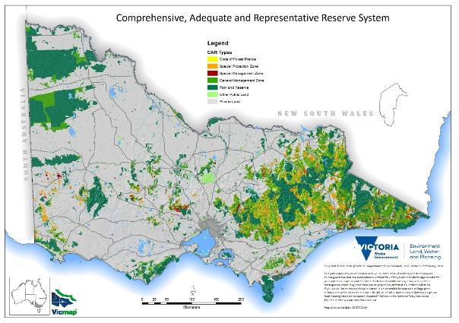
Figure 6: CAR reserves in Victorian RFA areas

Table 24: Tenure and protected area categories as represented in the CRA documents (1996 – 1999)
Original RFAs | Central Highlands  (ha) | East Gippsland  (ha) | Gippsland  (ha) | North East  (ha) | West  (ha) | Total  (ha)
Size of RFA region (ha) | 1,132,000 | 1,213,000 | 2,655,000 | 2,317,000 | 5,770,000 | 13,087,000
Private land (ha) | 502,800 | 156,000 | 1,200,000 | 1,057,300 | 4,800,000 | 7,716,000
Public land (ha) | 600,000 | 1,044,000 | 1,400,000 | 1,260,700 | 1,000,000 | 5,305,000
State forest (ha) | 389,800 | 637,000 | 806,000 | 718,700 | 411,000 | 2,962,000
Forest cover (ha) | 740,000 | 1,120,000 | 1,630,000 | 1,340,000 | 1,370,000 | 6,180,000
Conservation reserves (NP and flora & fauna reserves) (ha) (a) | 179,700 | 409,500 | 514,700 | 392,000 | 437,000 | 1,933,000
SPZ (b) | 109,200 | 164,300 | 248,000 | 7,590* | 176,000 | 705,000
Total area of forest protected (a+ b) | 288,900 | 573,800 | 762,000 | 399,000 | 613,000 | 2,630,000
a Formal protected area
b Informal protected area
* Taken from 2003 assessment as value not found in the CRA documents.
Source: CRAs from original RFA assessment. Numbers may not add up due to rounding.
Table 25: Tenure and protected area categories, 2018
Area/Tenure | Protected | Central Highlands  (ha) | East Gippsland  (ha) | Gippsland  (ha) | North East  (ha) | West  (ha) | Total  (ha)
Size of RFA |  | 1,132,000 | 1,213,000 | 2,655,000 | 2,317,000 | 5,770,000 | 13,087,000
Dedicated Reserves (a) | YES | 183,556 | 465,746 | 549,743 | 434,099 | 542,109 | 2,175,252
Informal reserves (b) | YES | 94,727 | 109,785 | 252,276 | 172,566 | 130,134 | 759,487
Prescription-ModEx/CFP/RF (c) | YES | 84,319 | 87,833 | 211,080 | 233,890 | 6,514 | 623,637
Private Land Covenants (d) | YES | 330 | 33 | 28,933 | 294 | 6,380 | 35,971
Unprotected – GMZ/SMZ | NO | 179,709 | 318,217 | 325,882 | 238,395 | 159,809 | 1,222,013
Unprotected – Other Public Land/Private | NO | 558,976 | 173,920 | 1,278,592 | 1,197,092 | 4,915,032 | 8,123,611
Total |  | 2,233,617 | 2,368,534 | 5,301,506 | 4,593,336 | 11,529,978 | 26,026,971
Total Protected (a+b+c+d) |  | 362,932 | 663,397 | 1,042,032 | 840,849 | 685,137 | 3,594,347
Source: Data derived from DELWP corporate spatial layers PLM25, FMZ100 and RFA25.

International Union for Conservation of Nature protected areas
The IUCN is the global authority on the status of the natural world. IUCN defines a protected area as ‘a clearly defined geographical space, recognised, dedicated and managed, through legal or other effective means, to achieve the long-term conservation of nature with associated ecosystem services and cultural values’ (IUCN 2019b).
All Victorian formal reserves are assigned an IUCN protected area category based on protection status and primary land management (Figure 7). Informal reserves are not assigned an IUCN protected area category. These categories cover areas of forest and non-forest. IUCN categories are assigned in Victoria by DELWP and submitted to CAPAD. The CAPAD documents for IUCN extend from 1997 to 2016.
In the context of the RFA process, the Dedicated Reserve component of the CAR reserve system should be equivalent to Categories I, II, III or IV as defined by the IUCN Commission for National Parks and Protected Areas in 1994 (IUCN 2019a). Definitions of the category system are provided below:
- Ia Strict Nature Reserve: Category Ia are strictly protected areas set aside to protect biodiversity and also possibly geological/geomorphic features, where human visitation, use and impacts are strictly controlled and limited to ensure protection of the conservation values.
- Ib Wilderness Area: Category Ib protected areas are usually large unmodified or slightly modified areas, retaining their natural character and influence without permanent or significant human habitation, which are protected and managed so as to preserve their natural condition.
- II National Park: Category II protected areas are large natural or near natural areas set aside to protect large-scale ecological processes, along with the complement of species and ecosystems characteristic of the area, which also provide a foundation for environmentally and culturally compatible, spiritual, scientific, educational, recreational and visitor opportunities.
- III Natural Monument or Feature: Category III protected areas are set aside to protect a specific natural monument, which can be a landform, sea mount, submarine cavern, geological feature such as a cave or even a living feature such as an ancient grove. They are generally quite small protected areas and often have high visitor value.
- IV Habitat/Species Management Area: Category IV protected areas aim to protect particular species or habitats and management reflects this priority. Many Category IV protected areas will need regular, active interventions to address the requirements of particular species or to maintain habitats, but this is not a requirement of the category.
- V Protected Landscape/Seascape: A protected area where the interaction of people and nature over time has produced an area of distinct character with significant, ecological, biological, cultural and scenic value: and where safeguarding the integrity of this interaction is vital to protecting and sustaining the area and its associated nature conservation and other values.
- VI Protected area with sustainable use of natural resources: Category VI protected areas conserve ecosystems and habitats together with associated cultural values and traditional natural resource management systems. They are generally large, with most of the area in a natural condition, where a proportion is under sustainable natural resource management and where low-level non-industrial use of natural resources compatible with nature conservation is seen as one of the main aims of the area.

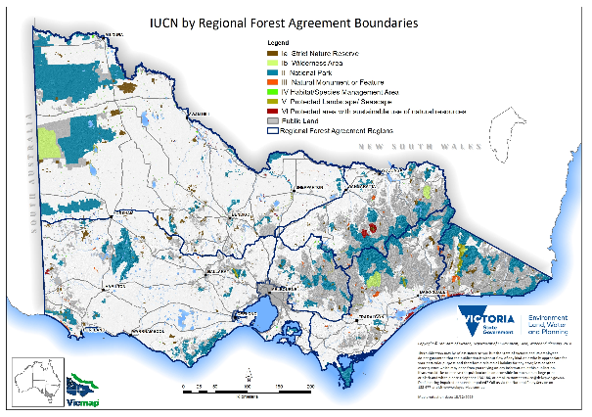
Figure 7: IUCN protected areas in Victoria as at 2016
Source: CAPAD 2016

Table 26: IUCN area categories per RFA 2014–16 (forest and non-forest)
IUCN category | RFA | 2014 (ha) | 2016 (ha)
IA | Central Highlands | 12,339 | 12,339
 | East Gippsland | 28,924 | 28,924
 | Gippsland | 36,562 | 36,565
 | Non-RFA | 234,514 | 234,442
 | North East | 37,126 | 37,126
 | West | 69,414 | 69,366
IB | Central Highlands | 0 | 0
 | East Gippsland | 61,193 | 61,193
 | Gippsland | 107,634 | 107,634
 | Non-RFA | 536,126 | 536,125
 | North East | 34,938 | 34,939
 | West | 0 | 0
II | Central Highlands | 159,042 | 158,970
 | East Gippsland | 316,163 | 316,161
 | Gippsland | 309,211 | 309,156
 | Non-RFA | 843,379 | 842,876
 | North East | 306,444 | 306,436
 | West | 386,019 | 385,996
III | Central Highlands | 2,369 | 2,366
 | East Gippsland | 17,534 | 17,514
 | Gippsland | 16,655 | 16,655
 | Non-RFA | 10,355 | 10,356
 | North East | 8,839 | 8,839
 | West | 18,589 | 18,587
IV | Central Highlands | 3,371 | 3,371
 | East Gippsland | 314 | 314
 | Gippsland | 1,404 | 1,404
 | Non-RFA | 30,305 | 30,295
 | North East | 3,015 | 3,016
 | West | 9,082 | 9,061
V | Central Highlands | 5,693 | 5,693
 | East Gippsland | 34,428 | 34,428
 | Gippsland | 16,517 | 16,517
 | Non-RFA | 65,374 | 65,374
 | North East | 3,384.9 | 3,384.9
 | West | 9,699.03 | 9,699.03
VI | Central Highlands | 0 | 0
 | East Gippsland | 8,772.39 | 8,772.39
 | Gippsland | 45,928.08 | 45,884.79
 | Non-RFA | 45,221.58 | 43,269.84
 | North East | 24,010.11 | 24,010.11
Source: CAPAD dataset

Extent of RFA forest and non-forest ecosystems in protected areas
Assessment of forest ecosystems is important to determine whether representative examples of these ecosystems and the natural ecological processes that support them are maintained throughout their natural range.
Ecological vegetation classes are the basic mapping units used for biodiversity planning and conservation assessment at landscape, regional and broader scales in Victoria. They are derived from large-scale forest type and vegetation community mapping and are based on the following types of information:
- species composition;
- forest structure;
- dominant species;
- ecological information relevant to the species that comprise the communities (including life history and response to disturbance and reproductive strategies); and
- physical environmental attributes such as aspect, elevation, geology and soils, landform, rainfall, salinity and climatic zones.
Each EVC represents one or more plant communities that occur in similar types of environments. The communities in each EVC tend to show similar ecological responses to environmental factors such as disturbance (e.g. bushfire). As well as representing plant communities, the EVCs can be used as a guide to the distribution of individual species and groups of species, including animals, and lower plants such as mosses and liverworts.
For the purposes of RFAs, EVCs are equivalent to forest ecosystems, as defined in the Nationally Agreed Criteria for the Establishment of a Comprehensive, Adequate and Representative Reserve System for Forests in Australia (Commonwealth of Australia 1997) (JANIS criteria).
Current EVC maps for Victoria are publicly accessible on NatureKit and the Spatial Datamart

Comprehensive Regional Assessment
The extent of forest ecosystems in the Victorian RFA regions were assessed through the CRA process between 1996 and 1999.
Under the CRA process, an assessment of the existing reserve system was undertaken to establish the reservation levels at that time for each EVC as a proportion of its pre-1750 extent.
At the time of assessment, a total of 103 extant EVCs were identified as occurring in the Gippsland RFA region. Fourteen EVCs occur predominantly on private land, with the remaining 89 occurring mainly on public land. Fifty-nine were classified as endangered, vulnerable or rare within the Gippsland RFA region.
In the North East RFA region, a total of 58 EVCs were identified. Thirty-one occur predominantly on private land, with the remaining 27 occurring mainly on public land. A total of 46 EVCs were classified as endangered, vulnerable or rare.
In the West RFA region, a total of 96 EVCs were identified as currently occurring. Twenty of the EVCs occur predominantly on private land, with the remaining 76 occurring mainly on public land. A total of 74 EVCs were classified as endangered, vulnerable or rare.
In the East Gippsland RFA region, a total of 49 EVCs were identified. More than 15 per cent of the pre-1750 extent of all but one EVC (Limestone Grassy Woodland) is protected in the conservation reserve system, while for most EVCs in the region, 60 per cent or greater is protected in the conservation reserve system. A total of 20 EVCs were classified as rare. Tables referring to endangered or vulnerable EVCs are missing from the East Gippsland CRA.
In the Central Highlands, a total of 43 EVCs were identified. A total of 27 EVCs were classified as endangered, vulnerable or rare.
The conservation status of EVCs in all RFA regions was assessed in the CRAs using the Nationally Agreed Criteria for the Establishment of a Comprehensive, Adequate and Representative Reserve System for Forests in Australia (Table 27; JANIS 1997).
Table 27: Nationally Agreed Criteria for the Establishment of a Comprehensive, Adequate and Representative Reserve System for Forests in Australia (JANIS 1997)
Status of EVC | Criteria
Rare | R1. Total range generally less than 10,000 ha.  R2. Total area generally less than 1,000 ha.  R3. Patch sizes generally less than 100 ha.
Vulnerable | V1. Approaching greater than 70 per cent lost (depletion) and remains subject to threatening processes.  V2. Includes EVCs where threatening processes have caused:  - significant changes in species composition,  - loss or significant decline in species that play a major role within the ecosystem, or  - significant alteration to ecosystem processes.  V3. Not depleted but subject to continuing threatening processes which may reduce its extent.
Endangered | E1. Distribution has contracted to less than 10 per cent of original range.  E2. Less than 10 per cent of original area remaining.  E3. 90 per cent of area is in small patches subject to threatening processes and unlikely to persist.

Conservation Status Reassessment
The conservation status of EVCs in Victoria’s five RFA regions has been reassessed in line with the national reserve criteria (Table 27; JANIS 1997), presented in Appendix 5 and summarised below.
The conservation status reassessment of EVCs was conducted using the best available information and considered the impact of past and potential future threatening processes relevant to EVCs within each RFA region.
Threatening processes considered in this assessment included land clearing, altered fire regimes, weed invasion, timber harvesting, sea level rise, climate change, overabundant or introduced grazers and browsers, livestock grazing, cropping and the cumulative effect of these threats.
In line with JANIS (1997) conservation statuses were assigned using both area-based criteria and consideration of the impact of past and likely future threats. This included the extent to which threatening processes had caused significant changes in species composition, loss or significant decline in species that play a major role within the ecosystem, a significant alteration to ecosystem processes and/or where significant threatening processes may reduce the extent of an EVC. The impact of future threatening processes was assessed through to 2069 (50-year horizon) using a mix of predictive modelling, spatial analysis and relevant academic literature.
As at 1 December 2019, a total of 375 EVC RFA combinations (excluding mosaics, complexes, aggregates and other mapping units) were mapped across the five Victorian RFA regions: 50 in Central Highlands, 50 in East Gippsland, 93 in Gippsland, 55 in North East and 127 in West. The conservation status of EVCs in each region is summarised in Table 28.
Table 28.Conservation status (JANIS 1997) of EVCs within each RFA region as at 2019
EVC Conservation Status | Central Highlands | East Gippsland | Gippsland | North East | West
No Status | 2 | 6 | 10 | 4 | 8
Vulnerable | 35 | 29 | 58 | 34 | 69
Rare | 7 | 9 | 14 | 7 | 37
Endangered | 6 | 6 | 11 | 10 | 13
Total | 50 | 50 | 93 | 55 | 127

In comparison to the CRA process 20 years ago, substantially more EVCs have been assigned a conservation status in 2019 using the JANIS (1997) criteria. For many Vulnerable EVCs, the combined impacts of climate change, altered fire regimes, impacts of deer browsing, and for some forest EVCs – ongoing timber-harvesting – means that criterion V3 (“Not depleted but subject to continuing threatening processes which may reduce its extent”) has been triggered even if these EVCs are relatively common and not currently depleted.
Over the life of the current RFAs, many threatening processes have continued or accelerated. The Gippsland Biodiversity Assessment report for the CRA (Commonwealth of Australia, 1999) noted at the time that several relatively widespread EVCs are subject to a variety of threatening processes but were not judged at that time to be impacted to a sufficiently significant degree (i.e. in extent and/or severity) to be considered endangered, vulnerable or rare in accordance with the JANIS criteria. For example, EVCs with heathy understoreys (Heathy Dry Forest, Heathy Woodland, Granitic Hills Woodland) are particularly sensitive to altered fire regimes and the resultant reduced diversity is commonly identified across the region. The understorey composition of mountain forest EVCs (Damp Forest, Wet Forest, Montane Wet Forest, Shrubby Damp Forest, Shrubby Wet Forest), particularly old individuals of some prominent understorey species (e.g. tree ferns), is significantly impacted by mechanical disturbance associated with timber harvesting. Open fertile EVCs (Montane Grassy Woodland, Sub-alpine Grassland) are favoured for grazing and are relatively more prone to weed invasion. The conservation status of these EVCs at that time was analogous to the “near threatened” category that is applied to some species.
Following the reassessment conducted in 2019, a number of these EVCs are now judged as Vulnerable.
Stabilising the status of these EVCs relies on a range of management strategies aimed at minimising long-term impacts and is achieved through the CAR Reserve System and complementary active management strategies. Management mechanisms currently available to address the threatening processes listed above includes (but is not limited to): Victorian Government on-ground programs for biodiversity (e.g. weed control), private land conservation mechanisms, regulatory mechanisms (e.g. Code of Practice for Timber Production, Code of Practice for Bushfire Management on Public Land and native vegetation removal regulations).

Analysis of forest and non-forest ecosystems by land tenure, including reservation and depletion analysis
A reserve system that is comprehensive, adequate and representative in its regional coverage of forest ecosystems is an important component of RFAs. The extent of representation of EVCs in conservation reserves has been used as the basis for evaluating the current reservation status of forest ecosystems in the region and subsequent analysis against the JANIS criteria as required under the RFAs.
As a general criterion, 15 per cent of the pre-1750 extent of each forest ecosystem should be protected in the CAR reserve system with flexibility considerations applied according to regional circumstances, and recognising that as far as possible and practicable, the proportion of Dedicated Reserves should be maximised.
The conservation status assessment is relevant to JANIS (1997) Criteria 2 and 3 which specify reservation objectives for EVCs classified as endangered, vulnerable or rare which include: all remaining occurrences of rare and endangered EVCs should be reserved or protected by other means as far as is practicable, and at least 60 per cent of the remaining extent of vulnerable EVCs should be reserved.
JANIS (1997) contains regional flexibility provisions in consideration of differing regional circumstances to ensure that the CAR reserve system delivers optimal nature conservation outcomes as well as acceptable social and economic outcomes. Therefore, the criteria are to be considered guidelines rather than mandatory targets.
Table 29 below summarises the area of terrestrial ecosystems in the Victorian RFA regions and the proportion that is protected as at 2019. Appendix 5 shows the area of all terrestrial ecosystems in each individual RFA region, by individual forest and non-forest ecosystems as at 2019.
The EVC map used at the time of the CRAs has since been updated, including updates to the native vegetation extent and progressive improvements in the modelling of EVCs based on new information. The EVC map used in this report is an updated 2019 layer which uses a 2015 native vegetation extent and includes an updated rainforest map and minor typology changes.
The EVC data 2019 summarised in Table 29 is not directly comparable to the data used in the CRA process (1998-2000) given these updates. Differences between the two data sets include: changes to the method used to generate the pre-1750 EVC model, changes to the method DELWP uses to creates a view of EVC extent (using a new native vegetation extent model and the pre 1750 dataset), applying nomenclature standards to EVCs which may have resulted in the discontinuation of certain EVC names, the splitting of EVCs, reconciliation of mapping units (such as mosaics and complexes), the delineation of new EVC types and spatial adjustments.
Of the 7.5 million hectares of terrestrial ecosystems identified in the five RFA regions (current extent), a total of 3.6 million hectares (47 per cent) is protected as at 2019 within the CAR reserve system (formal reserve, informal reserve, prescription and private land covenants). As at 2019, across all RFA regions, forest ecosystems have been depleted on average by 40 per cent and non-forest ecosystems have been depleted by 65 per cent since European settlement.
Victoria is the most intensively settled and cleared state in Australia. Large areas of Victoria were cleared for agriculture and although the rate of land clearing has slowed since the introduction of Victoria’s native vegetation regulations in 1989, the quality and extent of native vegetation continues to decline by about 4,000 habitat hectares each year. This trajectory is largely driven by activities inconsistent with (or in breach of) the regulatory framework (resulting in loss of extent of native vegetation), together with insufficient management of threats (resulting in loss of quality).
In response, DELWP has developed a statewide Biodiversity Plan: Protecting Victoria's Environment – Biodiversity 2037 (DELWP 2017c). This document sets out a strategic vision to protect biodiversity and reverse the trajectory of native vegetation decline. In addition, the Office of the Conservation Regulator (OCR) was established early in 2019. The function of the OCR is to provide a central point of coordination and oversight for DELWP’s regulatory functions including the natural environment, timber harvesting, public land use, fire prevention, wildlife and biodiversity. More detail about the OCR is provided on page 304 of this report and in the Overview of Victoria’s Forest Management System 2020.

Table 29: Summary of forest and non-forest ecosystems by RFA
 | Forest ecosystem | Pre-1750 extent (ha) | Current extent as at June 2019 (ha) | per cent depletion since 1750 | per cent of pre-1750 extent protected as at Dec 2019 (CAR Reserve System) | per cent of remaining ecosystem protected as at Dec 2019 (CAR Reserve System) | Area of terrestrial ecosystems not in protected areas as at June 2019 (ha)
Central Highlands | Total | 1,131,782 | 830,927 | 27 per cent | 32 per cent | 44 per cent | 439,188
 | Forest | 1,064,891 | 806,250 | 24 per cent | 33 per cent | 44 per cent | 421,739
 | Non-Forest | 66,891 | 24,678 | 63 per cent | 11 per cent | 29 per cent | 17,449
East Gippsland | Total | 1,238,561 | 1,155,338 | 7 per cent | 53 per cent | 57 per cent | 430,356
 | Forest | 1,177,480 | 1,116,689 | 5 per cent | 54 per cent | 57 per cent | 420,641
 | Non-Forest | 61,080 | 38,649 | 37 per cent | 47 per cent | 74 per cent | 9,715
Gippsland | Total | 2,654,114 | 1,795,356 | 32 per cent | 39 per cent | 58 per cent | 747,652
 | Forest | 2,306,168 | 1,594,181 | 31 per cent | 40 per cent | 58 per cent | 656,637
 | Non-Forest | 347,945 | 201,175 | 42 per cent | 32 per cent | 55 per cent | 91,015
North East | Total | 2,317,697 | 1,588,679 | 31 per cent | 36 per cent | 53 per cent | 707,159
 | Forest | 2,288,529 | 1,563,287 | 32 per cent | 36 per cent | 53 per cent | 699,816
 | Non-Forest | 29,168 | 25,392 | 13 per cent | 62 per cent | 71 per cent | 7,344
West | Total | 5,770,882 | 2,151,266 | 63 per cent | 12 per cent | 32 per cent | 1,464,842
 | Forest | 4,438,363 | 1,736,813 | 61 per cent | 13 per cent | 32 per cent | 1,172,961
 | Non-Forest | 1,332,519 | 414,452 | 69 per cent | 9 per cent | 30 per cent | 291,881
Total all RFAS |  | 13,113,035 | 7,521,565 | 43 per cent | 27 per cent | 47.56 per cent | 3,789,198

Notes:
The figures shown in this table are based on modelled information mapped at a scale of 1:100,000 derived during the pre-1750 analysis of vegetation types in the Central Highlands and are therefore only approximate. EVC mapping used in 1998 has been revised to ensure the state-wide EVC data set is based on the best available information and integrates new methods of mapping and modelling vegetation across Victoria. As a result, information relating to EVC extent or reservation levels between 1998 and 2019 is not directly comparable and may differ due to the different modelling and mapping approaches.

Protected areas for the purpose of this report include dedicated reserves, SPZs, covenants on private land and mapped Code of Forest Practice exclusions. This dataset is identified in the aggregation of the PLM25 dataset and the Forest Management Zone dataset (FMZ100). In this report, areas protected by prescription are estimated using the spatial layer ‘ModEx’.
Source: Data derived from DELWP corporate spatial layers PLM25, FMZ100 and 2019 interim RFA EVC mapping (unpublished).

Indicator 1.1d: Fragmentation of forest cover
The VSOFR 2018 described forest fragmentation in the following way:
Forest fragmentation is a metric to describe forest quality. It assumes that the highest quality forests are at the centre, and that the larger the area, the more resilient the forest is to disturbances. Forest loss and the deterioration of forest health via increasing fragmentation, pose significant threats to biodiversity, and endanger the sustainability of ecological goods and services from forested land.
(Commissioner for Environmental Sustainability Victoria 2019, p. 64)
Change in forest cover and the spatial configuration of gain and loss show the level of fragmentation in Victoria’s forests (Figure 8) and have implications for forest-dependent species.
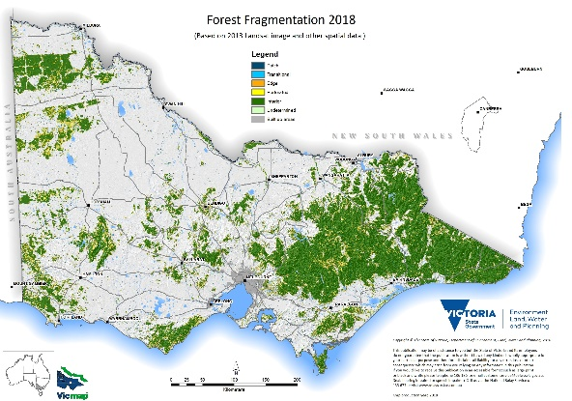
Figure 8: Forest fragmentation in Victoria (published 2018 reprinting 2013 baseline year)
The fragmentation analysis provided here is derived from two forest/non-forest datasets which represent baseline years of 2009 and 2013 and published in 2013 and 2018 respectively. This analysis uses five fragmentation categories. Increasing area of interior forest reflects an improvement, while increases in Patch, Edge and Perforated categories reflect an increasing level of fragmentation (Figure 9).
Increases of interior forest across all RFAs largely reflect the significant regeneration from major bushfires that occurred in the decade to 2010, as quantified through this remote-sensing approach. The overall trend for forest fragmentation across the RFA regions between 2009 and 2013 is good, as reflected in the Interior gains; however, site-scale analysis in some areas may provide different results than landscape-level analysis.

Figure 9: Change in fragmentation status between baseline years of 2009 and 2013

Table 30: Forest fragmentation 2009
 | Forest fragmentation 2009
RFA region | Patch  (ha) | Transitional  (ha) | Edge  (ha) | Perforated  (ha) | Interior  (ha)
Central Highlands | 15,600 | 22,600 | 81,900 | 29,400 | 590,200
East Gippsland | 5,300 | 9,900 | 56,400 | 28,400 | 1,003,500
Gippsland | 33,100 | 39,800 | 165,700 | 82,200 | 1,273,300
North East | 25,500 | 35,500 | 141,800 | 62,900 | 1,068,800
West | 62,100 | 75,300 | 267,400 | 100,300 | 828,000
Non-RFA | 141,600 | 183,100 | 713,200 | 303,200 | 4,763,800

Source: DELWP Corporate data (unpublished)

Table 31: Forest fragmentation 2013
 | Forest fragmentation 2013
RFA region | Patch  (ha) | Transitional  (ha) | Edge  (ha) | Perforated  (ha) | Interior  (ha)
Central Highlands | 17,800 | 22,100 | 76,900 | 29,000 | 590,400
East Gippsland | 4,500 | 8,700 | 50,200 | 27,600 | 1,019,700
Gippsland | 31,100 | 37,800 | 146,000 | 72,400 | 1,339,400
North East | 24,400 | 32,200 | 123,600 | 54,700 | 1,096,500
West | 62,400 | 74,400 | 259,900 | 99,200 | 873,000
Non-RFA | 140,200 | 175,200 | 656,600 | 282,900 | 4,919,000

Source: DELWP Corporate data (unpublished)

Indicator 1.2a Forest-dwelling species for which ecological information is available
This indicator reports the level of information available to manage forest-dwelling species and tracks changes in this knowledge over time. The amount of habitat, disturbance and life history information available to make management decisions indicates the capacity to assess risk to species and implement conservation strategies. The following section outlines the key information sources in Victoria and summarises information where available.

Victorian Biodiversity Atlas
The VBA species observations is a foundation dataset that feeds into some of the many biodiversity tools used in DELWP’s everyday decision-making, showing where wildlife is now and how this has changed over time. This makes it a core input to the majority of the government processes and programs that impact native species. It is used in conservation status assessments, HDMs that feed into the Strategic Management Prospects and Native Vegetation Removal Regulations and into our public land management, research activities and State of the Environment reporting.
The VBA dataset is collated from a wide range of contributors including DELWP biodiversity staff, government agencies and partner organisations, non-government organisations such as BirdLife Australia, ecological consultancies, university students and the many and varied community wildlife survey groups and individuals.
The majority of the data is from project-based work where structured surveys were undertaken to assess presence or abundance of targeted species. It also includes all the records from previous department-managed datasets such as the Victorian Rare and Threatened Plant Population monitoring database (VROTpop).
As part of the RFA modernisation program, landscape scale surveys are being conducted to collect new field data on high-priority forest-dependent threatened species (both presence and true absence data), which will be stored in the VBA and inform forest management. This process is described in the case study below on page 102.
In addition, as part of the Forest Protection Survey Program, surveys are being undertaken in planned timber harvesting areas in State forests in eastern Victoria. These surveys collect data on plants; arboreal and terrestrial mammals; some bird species, frogs, fish and crayfish; and vegetation communities prior to the commencement of harvesting operations. A target of 80% coupes are planned to be surveyed prior to harvesting. The VicForests’ Rolling Operations Plan provides the basic information about what is planned to be harvested and where. This information, along with a wide range of other information such as HDMs and species lists, is used to help prioritise what species will be surveyed where and when. The proposed harvest date is used by DELWP to prioritise the timing and location of surveys. Observations from this survey program will be stored in the VBA.

Habitat distribution models
Information that aids in understanding the distribution of the habitat for plant and animal species in Victoria is essential for conservation management. This information becomes critical for rare or threatened taxa.
Fauna and flora species have different habitat requirements. They need a place to live and reproduce. They also need to tolerate changes in the weather, and flood and fire disturbances. As a result of these different needs, species are found in different locations across the landscape. Some species have highly specific habitat requirements (such as the Mountain Pygmy-possum), while others can thrive in a number of different habitat types (such as the Australian Magpie).
Habitat distribution models collect and compare information on where a species has been recorded. They relate that data to environmental variables, such as soil, prevailing climate and topography. Sophisticated statistical and mathematical processes are then used to estimate the distribution of a species’ habitat. The HDMs do not predict whether or not a species currently occupies the habitat at a particular location. Many factors can influence whether a species is present in the habitat at any given time, including: biogeography, size of the habitat patch and distance from other suitable habitat, natural disturbance cycles, historic catastrophes, the impact of predators or disease and seasonal factors (DELWP 2017a).
Since the first RFA was signed in 1997, HDMs have been developed for all rare or threatened Victorian species where sufficient data is available. This information has been used to inform biodiversity decision-making, native vegetation clearing regulations and guide cost-effective investment decisions (see NaturePrint and Strategic Management Prospects).
Examples of HDMs for the Greater Glider (Petauroides volans), Sooty Owl (Tyto tenebricosa tenebricosa) and Tall Astelia (Astelia australiana), including the VBA survey points used to generate the model, are shown below (Figure 10). The models used to develop the maps in Figure 10 to Figure 12 have a colour gradient applied in the legend to represent the range of habitat values for each species from high (80 and above, represented as one colour) to low (30 and below, represented as one colour) to aid the reader in discerning areas of high and low habitat values.
Habitat distribution models can also be used to inform conservation strategies and levels of protection by assessing the area of a species’ modelled suitable habitat that is within the CAR reserve system – an analysis of the HDMs for priority EPBC Act listed species is at Appendix 4.
As part of the RFA modernisation program, HDMs for High-priority species are being updated with new field data and approaches to modelling. This process is described in the case study below on page 102. Currently published HDMs are publicly available on NatureKit.

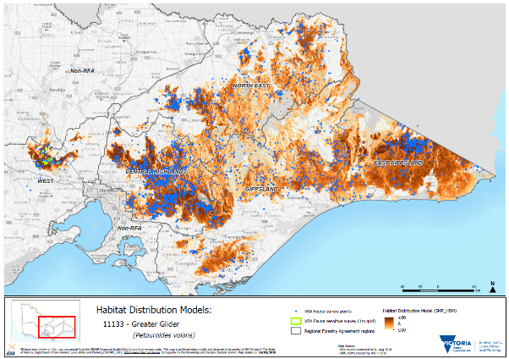
Figure 10: Habitat Distribution Model for the Greater Glider (Petauroides volans)
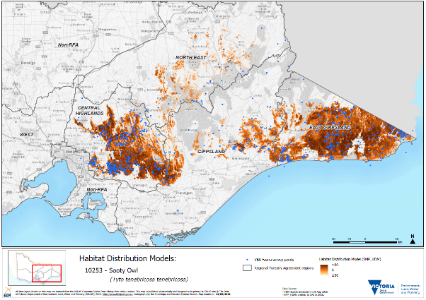
Figure 11: Habitat Distribution Model for the Sooty Owl (Tyto tenebricosa tenebricosa)
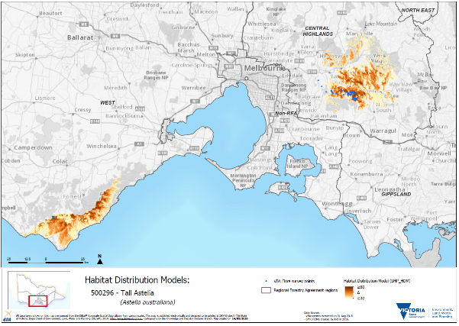
Figure 12: Habitat Distribution Model for the Tall Astelia (Astelia australiana)

NaturePrint and Strategic Management Prospects
Evidence-based decision-making is critical to improving outcomes for biodiversity. Strategic Management Prospects (SMP) is a decision-support tool that helps biodiversity managers identify and prioritise management options in a transparent, objective and repeatable way. SMP uses a new spatially explicit, landscape-scale approach to identify the most effective and efficient management actions to benefit biodiversity across Victoria (DELWP 2019a).
The aim of Biodiversity 2037 is to ‘see an overall improvement, where the majority of habitats and threatened species will be improved, and habitat gains will outweigh losses’ (DELWP 2017c, p. 14).
To have the best chance to achieve the greatest outcomes for biodiversity in Victoria we need to compare information about thousands of biodiversity values. There are a range of best-practice methods now available for use.
SMP integrates and simultaneously compares information on biodiversity values, threats, effectiveness of management actions and indicative costs of management actions for biodiversity across Victoria (Table 32). Example output is at Figure 13.
Habitat distribution models for over 4,000 species are used in the first version of SMP analysis. HDMs have been created for most of Victoria’s vertebrate fauna, threatened vascular flora and some rare or threatened invertebrates. The majority of terrestrial forest-dwelling species are considered in SMP. SMP can be used to make management decisions about forest-dependent species, assess risks to species and implement conservation strategies.
When undertaking management actions, it is important to know how those actions benefit different plants and animals in different places. Information on where actions have the greatest benefit, or the greatest prospects for change for particular species, is essential to guide investment or management planning.
Benefits can vary in spatial magnitude and temporal scale. Some actions (e.g. caging orchids to protect from herbivores) are only appropriate in unique situations, while other actions (e.g. fox baiting) can provide benefits for a number of species in many places. A common measure of benefit is required to enable comparisons across a wide range of species, threats and actions (DELWP 2017b).
Biodiversity 2037 identifies a new measure – Change in Suitable Habitat – that will standardise the measurement of benefit and be used to assess overall progress towards the plan’s targets.
In 2018, SMP was used to guide decision-making and investment for 85 new projects for on-ground biodiversity action worth $33.67 million through Biodiversity Response Planning. Funded projects will be delivered over three years, commencing in 2018–19 through to 2020-2021.

Table 32: Strategic Management Prospects inputs (DELWP 2017b)
Inputs to SMP | Relationships modelled
Habitat distribution models | Known observations of species and characteristics of the environment (e.g. terrain, climate).
Threat models | Known occurrences of threats (e.g. deer or rabbits) and characteristics of the environment (e.g. terrain, climate).
Benefit of action models | Expert opinion of site-specific and situation-specific settings assessed by multiple experts with a standardised method called expert elicitation. These opinions were extrapolated from sites to landscape.
Costs of actions | Costs of on-ground operations calculated as dollars per hectare, informed by considering temporal (time-related), spatial (place-related), and cost components (site costs, opportunity costs to private landholders, transaction costs and travel costs).

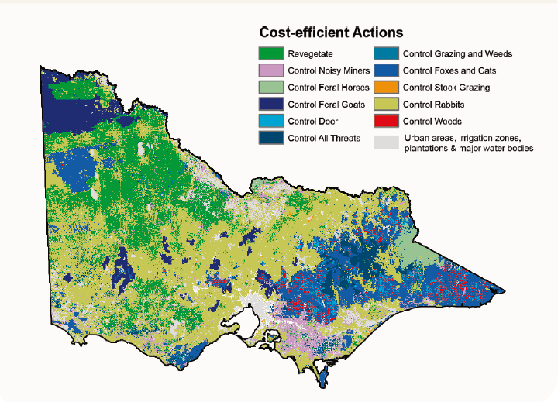
Figure 13: Strategic Management Prospects cost-effective actions (modelled output)

Indicator 1.2c: Representative species from a range of habitats monitored at scales relevant to regional forest management
As outlined above, the VBA is a repository for information on flora and fauna sightings across Victoria. The VBA database includes observations from dedicated monitoring programs implemented by government and non-government entities, as well as sightings from ‘citizen scientists’ (non-professionals who volunteer time and effort for scientific research). The VBA database helps managers understand where wildlife is now, and importantly, where it is not – in the form of absence data. It is a key tool for the government’s processes and programs that manage native species. Specifically, it is used in conservation status assessments, and for the development of HDMs that inform strategic decision-making processes, including Native Vegetation Removal Regulations (Commissioner for Environmental Sustainability Victoria 2019, p. 75).
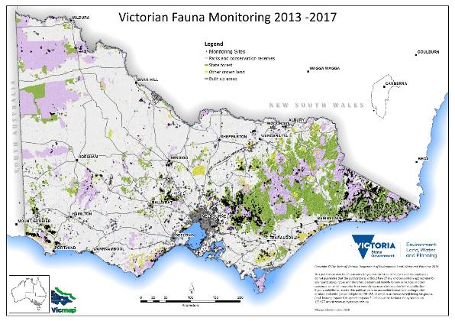
Figure 14: Monitoring sites across Victoria as recorded in the VBA as at 2018

Table 33: Number of species monitored, by taxonomy types, 2013–17
Taxon group | Central Highlands | East Gippsland | Gippsland | North East | West
Amphibians | 14 | 8 | 11 | 4 | 20
Aquatic invertebrates | 1 | 1 | 0 | 0 | 1
Fish | 7 | 13 | 13 | 7 | 7
Invertebrates | 6 | 2 | 4 | 1 | 5
Mammals | 42 | 17 | 26 | 12 | 67
Marine birds | 1 | 0 | 0 | 0 | 1
Mussels, decapod crustacea | 8 | 13 | 10 | 3 | 8
Non-passerine birds | 36 | 12 | 18 | 9 | 42
Passerine birds | 29 | 9 | 15 | 11 | 28
Reptiles | 21 | 10 | 10 | 5 | 25
Waders | 3 | 0 | 2 | 1 | 4
Total | 168 | 85 | 109 | 53 | 208
Source: VBA 2018
Table 34: Number of monitoring projects by year
Year | Central Highlands | East Gippsland | Gippsland | North East | West
2013 | 29 | 13 | 15 | 11 | 38
2014 | 27 | 12 | 18 | 6 | 42
2015 | 24 | 15 | 16 | 7 | 44
2016 | 22 | 14 | 13 | 6 | 37
2017 | 12 | 11 | 12 | 5 | 25
Note: ‘Total’ column not included, as many monitoring projects last more than a year, meaning a duplication in counts each year.
Data source: VBA 2018

Case study: biodiversity values assessment as part of the Victorian forest modernisation program
As part of the RFA modernisation program and Victoria’s broader forest management system reform, DELWP has commissioned a number of projects to improve the current information base and knowledge of threatened forest-dependent species and their habitat. These projects include:

Landscape scale survey
The Arthur Rylah Institute (ARI) is collecting new field data on high-priority forest-dependent threatened species from late 2018 to mid-2020. This new on-ground data will be used to improve DELWP’s understanding of where the species are likely to be found across forests in Victoria. It will also help to fine-tune current HDMs, which are based on records of species distribution and abundance stored in the VBA. Researchers will target 10 terrestrial fauna species for surveys in eastern Victoria, including Leadbeater’s Possum, Long-footed Potoroo, gliders and owls, Glossy Black-cockatoo, Large Brown Tree Frog and Giant Burrowing Frog. In addition, surveys will target up to 15 threatened aquatic species (galaxias and crayfish) and 27 threatened plants to improve our understanding of their distribution and enhance their protection. ARI is using a range of methods including motion-sensor cameras, spotlighting and call playback to survey for species.
Survey locations have been chosen to give the greatest information gain for the HDMs. Survey sites will be located across public and private land as well as on the edge of species range to test understanding of where species do not occur and improve model outputs. This is known as confirming true absence data. Surveys are only occurring in eastern Victoria (east of the Hume Highway). All species that are found through this survey work will be recorded in the VBA, helping to improve the understanding of all species, possibly including other threatened species that are not the targets of specific surveys.

Updated habitat distribution models for key forest-dependent species
Through the RFA modernisation process, ARI is developing a revised set of HDMs for selected forest-dependent threatened species. This project proposes to develop a series of HDMs that better reflects the current distribution of the selected forest-dependent taxa, particularly with respect to an increasing interest in ‘landscape scale’ threatened species management.

Population viability analysis
Researchers from the University of Melbourne, with input from DELWP, are undertaking a program to develop spatially explicit population viability models for seven key/focus forest-dependent fauna taxa (Greater Glider, Leadbeater's Possum, Long-footed Potoroo, Powerful Owl, Sooty Owl, Baw Baw Frog, Broad-toothed Rat), as well as series of metapopulation analyses for up to 77 other priority forest species.

Climate change vulnerability analysis of forest ecosystems
Over the next 50 years and beyond, climate change will continue to significantly impact our forests and the ecosystems and species they comprise. While it is known that increasing temperatures, reduced rainfall and increased frequency and severity of bushfires and other extreme weather events will impact forests, the potential changes are not clearly understood.
Forest changes due to climate change are a complex web of interacting factors. Climate change impacts in Victoria’s forests are currently difficult to predict due to limited field-based forest experimentation. In addition, many climate change and ecological modelling approaches are still in the early stages of development, particularly regarding their application to Australia’s forests.
DELWP has commissioned a project to identify key EVCs and key forest-dependent species impacted by timber harvesting that are most vulnerable to climate change. This information will be brought together to help inform decisions and assist the government in considering measures to better manage and protect those communities and species most vulnerable to the impacts of climate change as part of the RFA modernisation process.
A longer-term piece of work is required to determine how Victoria’s forests can be better protected from the impacts of climate change. This includes consideration of the optimal scale and design of a ‘climate smart’ CAR reserve system.
There are a number of discrete and complementary analyses that will provide information to help identify and inform the current state of ecological vegetation communities. They can also provide information on those communities and forest-dependent species most vulnerable to climate change over a 50-year outlook, given various climate scenarios. Useful information to be collected is as follows:
- current EVC status for recent fire history and tolerable fire interval
- ecological niche analysis of key forest-based EVCs and key forest-dependent species under climate scenarios Representative Concentration Pathway (RCP) 2.6, 4.5, 6.0 and 8.5
- expert elicitation of climate change vulnerability for key forest-dependent species under climate scenarios RCP 2.6 and 8.5.
Results from the various analyses will provide a current status of the tolerable fire interval of forest-based EVCs, which can be used as a surrogate for ecosystem resilience and potential current vulnerability of these communities. In addition, for key forest-based EVCs a climate niche analysis under a range of RCP climate change scenarios will provide a comparison of the modelled distribution of the ecological niche of EVCs under current climate with future modelled distributions (overlap analysis). This will determine the distribution of current areas that remain suitable under future climate scenarios.
Results for key forest-dependent species include a climate niche analysis as for the EVCs for those species able to be modelled under two climate scenarios, combined with expert elicitation. The models and information are considered, if experts choose to, among a range of other information and judgements by experts involved in the elicitation process, to judge key forest-dependent species vulnerability to climate change. The formal elicitation will identify the following across all five RFA regions:
- the perceived level of vulnerability to climate change over a 50-year time frame, considering climate scenarios RCP 2.6 and RCP 8.5
- the perceived causes of decline
- candidate protection measures or other conservation actions that may mitigate risks that could be considered in the short term under the RFA modernisation process and forest management planning process to adequately manage and protect those species and communities most vulnerable to climate change.

Integrated biodiversity values model
The purpose of the integrated biodiversity values model (IBVM) is to provide indicative spatial representations of relevant biodiversity ‘value’ which can support structured decision-making relating to forest and fire management planning. This product is a prototype grid-based spatial dataset incorporating attributes of specific biodiversity values (habitat for forest-dependent threatened species, forest ecosystems and old-growth forest – where available) across multiple layers. The IBVM will assist in decision-making around what areas of the forest estate should be prioritised for conservation, given (1) the distribution of biodiversity values, and (2) the predicted future state of biodiversity under scenarios of disturbance. Zonation algorithms are used to consider each grid cell’s relative contribution to net habitat (extent and quality).

Indicator 1.3a: Forest associated species at risk from isolation and the loss of genetic variation, and conservation efforts for those species

Risk of isolation and loss of genetic variation
This indicator assesses the risks to loss of forest genetic variation and describes the formal measures designed to mitigate this risk. A loss of genetic diversity in species can result in a decreased ability to adapt to future environmental change, and thus a higher risk of extinction.
Information on the number of forest-dependent species at risk from isolation is relatively limited and difficult to consolidate on a statewide scale; however, there are a number of studies that detail some species that are at particular risk, and also discuss some techniques to alleviate that risk. A selection of these studies is outlined in Table 35.
Isolated populations of a species are in greater danger of extinction due to genetic drift. Genetic drift is the loss of genetic variation in a small isolated population, which decreases a population’s ability to cope with changes in environment, and increases the effect and prevalence of genetic disease, due to inbreeding within the small population.
Amos et al. (2014) showed that a suite of woodland-occupying birds in central Victoria were at risk of genetic decline, largely due to habitat fragmentation. They found that these effects would be greater where habitat fragmentation was greatest and would affect the least dispersive species over more dispersive ones.
Genetic rescue – the addition of genes from an external population of the same taxa, but from a different, broader population – has been shown to alleviate some of the consequences of genetic drift and inbreeding, allowing a fitter overall population. In the case of the Mt Buller Mountain Pygmy-possum population, individuals from a larger, more diverse population were introduced to the site, along with more traditional management strategies, such as habitat restoration and construction of corridors linking suitable habitat, greatly increasing the chances of survival of this population.
Where a closely related taxon exists and is known to have interbred with the threatened taxon previously (e.g. breeding Helmeted Honeyeater (Lichenostomus melanops cassidix) with another subspecies of the Yellow-tufted Honeyeater (L. m. gippslandicus)), interbreeding may be successful in reducing loss of genetic variety; however, overuse of this technique will result in the threatened population’s genetics being ‘diluted’ by the larger population’s. It is suggested that only four new individuals per generation be introduced to the gene pool to allow for this dilution (Harrison et al. 2016).
Weeks, Stoklosa and Hoffman (2016) discuss various management programs for threatened mammals across Australia and demonstrate that managing small populations as separate genetic populations to the remainder of the species may contribute to the decline of these species as a whole.
Conversely, Hansen and Taylor (2008) show that an isolated population of Leadbeater’s Possum (Gymnobelideus leadbeateri) may not benefit from genetic rescue, as the population has evolved separately to occupy a markedly different habitat (lowland swamp forests, Eucalyptus camphora, Leptospermum spp. and Melaleuca spp.) to that of the main population (montane wet forests, E. regnans, E. delegatensis, Acacia spp.)
Van der Ree et al. (2010) and Soanes et al. (2018) have conducted a long running investigation into the effects of fragmentation, due to a large highway, on the Squirrel Glider (Petaurus norfolcensis). They have shown that large highways can impede isolated populations of the species from interbreeding, but a simple expedient of a rope bridge across the roadway enables individual gliders to cross and therefore allows genetic dispersal.
While these studies show that there are forest-dependent species in Victoria at risk from loss of genetic diversity, there are programs in place to reduce or remove some of these problems, both through interbreeding with other populations, and enabling isolated populations to connect with the broader population. More study is required to gain a broader idea of the extent of loss of genetics due to fragmentation, over the forest estate of Victoria.
Table 35: Recent studies examining risk from isolation and the loss of genetic variation
Species | Common name | Reference
 | Various woodland birds | Amos, JN et al. 2014, ‘Species- and sex-specific connectivity effects of habitat fragmentation in a suite of woodland birds’, Ecology, vol. 95, no. 6, pp. 1556–68.
Gymnobelideus leadbeateri | Leadbeater’s Possum (Yellingbo population) | Hansen, BD & Taylor, AC 2008, ‘Isolated remnant or recent introduction? Estimating the provenance of Yellingbo Leadbeater’s possums by genetic analysis and bottleneck simulation’, Molecular Ecology, vol. 17, pp. 4039–52.
Lichenostomus melanops cassidix | Helmeted Honeyeater | Harrisson, KA et al. 2016, ‘Scope for genetic rescue of an endangered subspecies though re-establishing natural gene flow with another subspecies’, Molecular Ecology, vol. 25, no. 6, 1242–58.
Petaurus norfolcensis | Squirrel Glider | Van der Ree, R, Cesarini, S, Sunnucks, P, Moore, JL & Taylor, A 2010, ‘Large gaps in canopy reduce road crossing by a gliding mammal’, Ecology and Society, vol. 15, no. 4: 35.  Soanes, K, Taylor, AC, Sunnucks, P, Vesk, PA, Cesarini, S, van der Ree, R 2018, ‘Evaluating the success of wildlife crossing structures using genetic approaches and an experimental design: lessons from a gliding mammal’, J Appl Ecol., vol. 55, no. 1, pp. 129–38.
Burramys parvus | Mountain Pygmy-possum | Weeks, AR et al. 2017, ‘Genetic rescue increases fitness and aids rapid recovery of an endangered marsupial population’, Nature Communications, vol. 8: 1071.
 | Endangered endemic mammals | Weeks, AR, Stoklosa, J & Hoffmann, AA 2016, ‘Conservation of genetic uniqueness of populations may increase extinction likelihood of endangered species: the case of Australian mammals’, Frontiers in Zoology, vol. 13:31.

Conservation efforts supporting vulnerable species
DELWP undertakes numerous management actions to promote the conservation of species. Table 36 shows the level of management activity for each forest-dependent threatened species for eight action categories, as provided by DELWP’s regional implementation teams. The categories are:
- community engagement;
- policy and planning;
- survey and monitoring;
- habitat protection and restoration;
- pest and weed control;
- population manipulation;
- captive management; and
- research.
All efforts were made to populate this table as comprehensively as possible; however, it should be viewed as a non-exhaustive list. Indeed, the categories of ‘survey and monitoring’ and ‘research’ may be underrepresented as initiatives from other research institutions or land management agencies implement may not have been captured.
Table 36: Management activity for each forest-dependent threatened species, 2013–17
Common name | Community engagement | Policy and planning | Survey and monitoring | Habitat protection and restoration | Pest and weed control | Population manipulation | Captive management | Research
Mammals
Broad-toothed rat
Brush-tailed phascogale
Brush-tailed rock-wallaby
Eastern horseshoe bat
Greater glider
Grey-headed flying-fox
Leadbeater's possum
Long-footed potoroo
Long-nosed potoroo
Smoky mouse
Spot-tailed quoll
Squirrel glider
Swamp antechinus
White-footed dunnart
Yellow-bellied glider
Yellow-bellied sheathtail bat
Birds
Barking owl
Brown treecreeper
Chestnut-rumped heathwren
Glossy black-cockatoo
Grey goshawk
Helmeted honeyeater
Hooded robin
Masked owl
Powerful owl
Regent honeyeater
Sooty owl
Speckled warbler
Spotted quail-thrush
Square-tailed kite
Swift parrot
Turquoise parrot
White-bellied sea-eagle
Reptiles
Alpine bog skink
Eastern she-oak skink
Lace monitor
Rosenberg's goanna
Swamp skink
Amphibians
Baw Baw frog
Booroolong tree frog
Brown toadlet
Giant burrowing frog
Green and golden bell frog
Large brown tree frog
Martin's toadlet
Southern toadlet
Spotted tree frog
Fish
Australian grayling
Barred galaxias
Cox's gudgeon
Dwarf galaxias
Empire gudgeon
Flat-headed galaxias
Macquarie perch
Murray cod
Trout cod
Invertebrates
Orbost spiny cray
Plants
Baw Baw berry
Blackfellow's hemp
Brown guinea-flower
Colquhoun grevillea
Eastern pomaderris
Elegant daisy
Forest geebung
Forest phebalium
Forest sedge
Gippsland stringybark
Gully grevillea
Leafless pink-bells
Outcrop guinea-flower
Oval fork-fern
Oval-leaf grevillea
Sandfly zieria
Serpent heath
Slender fork-fern
Small fork-fern
Smooth geebung
Tall astelia
Tasmanian wax-flower
Toothed leionema
Tree geebung
Upright pomaderris
Veined pomaderris
Velvety geebung
Note: Yellow cells denote minor activity – routine or ad hoc. Green cells denote substantial activity – targeted or sustained. Blank cells denote no activity.

Indicator 1.3b: Native forest and plantations of indigenous timber species which have genetic resource conservation mechanisms in place
Mountain Ash (Eucalyptus regnans) and Alpine Ash (E. delegatensis) forests are at risk of regeneration failure and forest type conversion following bushfires. Forests most at risk are those younger than seed-bearing age (20 years) because they lack their own seed and cannot self-regenerate. This is an increasing class of forest in Victoria due to frequent bushfires in the past 15 years.
This risk was acknowledged in June 2018 by the Victorian Auditor-General’s Office (VAGO). In their published follow-up of selected 2012–13 and 2013–14 performance audits, they noted, for the audit titled Managing Victoria’s native forest timber resources, that DELWP ‘still has more to do’ including ‘ensuring there is adequate seed supply for forest regeneration’ (VAGO 2018, p. 27). VAGO went on to note that DELWP has ‘increased its stores of ash seed to close to four tonnes but estimates that it needs 12 tonnes to assist in future fire recovery works’ (ibid., p. 35).
In response, DELWP has committed to improve its management of seed policy and seed stores and has established a Statewide Seed Coordination Group under the Forest Fire Operations Division. The aim of this group is to drive improvement in strategic seed management through coordinated liaison with relevant stakeholders and agencies such as VicForests and Parks Victoria.
The Management Standards and Procedures for timber harvesting operations in Victorian State forests 2014 defines the protocol for seed collection to support regeneration following timber harvesting. A number of provisions relate to the maintenance of genetic resources. These include (but are not limited to) the following:
9.1.3.1 Prioritise seed collection from within areas available for timber harvesting operations.
9.1.3.2 Ensure large hollow‐bearing trees and habitat trees retained during previous timber harvesting operations are not felled for seed collection.
9.1.3.3 Collect seed from stands that show no evidence of hybridisation and have experienced a widespread and preferably heavy flowering in which trees with good crops are close together.
9.1.3.4 Collect seed only from stands of natural origin or artificially regenerated stands of satisfactory genetic status in which the full, original gene pool of the population is represented. Stands regenerated from seed trees are regarded as of natural origin for seed collection purposes.
9.1.3.5 Prioritise using seed collected from the coupe; i.e., regenerate with seed fall from retained trees and/or logging slash, or sow the coupe with seed collected from that coupe. Otherwise, prioritise using seed that meets the following criteria:
(a) the collection site is within 25 km of the coupe to be sown;
(b) the mid‐elevation of the collection site is within 350 m above to 150 m below the mid‐elevation of the coupe to be sown;
(c) for slopes >10 ° the collection and sowing sites have similar aspect (separate between ‘drier' aspects (W, NW, N, NE) and ‘moister’ aspects (SW, S, SE, E); and
(d) the collection and sowing sites are of similar soil type and parent material.
9.1.3.6 Where seed quantities within areas available for timber harvesting operations are inadequate to meet regeneration requirements, application may be made to the Minister or delegate to collect seed from standing trees within areas excluded from timber harvesting operations in accordance with section 1.4 and clauses 9.1.3.7 to 9.1.3.10.
(Victorian Department of Environment and Primary Industries [DEPI] 2014b, pp. 64–5)
Seed harvests (Table 37) fluctuate depending on environmental factors associated with seed availability. Seed usage remains fairly constant, but collection peaks in times of better seed availability. When there are good crops available it is possible to collect enough to compensate for times of poorer availability. Eucalypts tend to only flower heavily about once every five years or so, with much lighter flowering and consequently poorer seed crops in between.
Table 37: Seed harvest
Year | Seed harvest  (kg)
2010–11 | 6,174
2011–12 | 4,457
2012–13 | 1,526
2013–14 | 1,192
2014–15 | 1,380
2015–16 | 4,317
2016–17 | 1,378
Data from VicForests.
The following table details the location of DELWP’s seed holdings for eastern regions as at end of September 2018. A summary of quantity and numbers of stored seed-lots are given, including specific reference to Alpine Ash (AA) and Mountain Ash (MA).
Table 38: DELWP’s seed holdings, eastern regions, September 2018
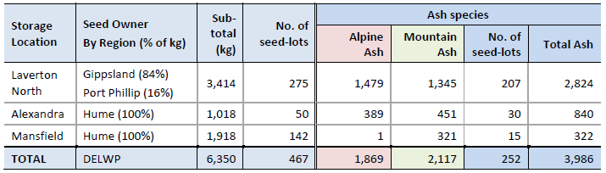
- DELWP’s current Ash seed holdings are 2.1 tonnes MA and 1.9 tonnes AA = 4.0 tonnes total.
- DELWP’s proposed Ash seed storage target of 14 tonnes = Milestone 2 + 2 additional tonnes.
- Stocks of Messmate, Shining Gum and Cut-tail are required, and current stocks are insufficient.
- Seed is stored at three locations. Laverton and Mansfield are the high-quality storage facilities.
- VicForests’ current Ash seed holdings are 2.1 tonnes MA and 4.5 tonnes AA = 6.6 tonnes total.
- Total Victorian Ash current seed stocks = 4.0 + 6.6 = 10.6 tonnes, approaching Milestone 2.
For non-Ash species, it is recommended DELWP maintains a store of 500 kilograms Messmate, and 200 kilograms each of Shining Gum, Errinundra Shining Gum and Cut-tail.

See agriculture.gov.au/abares/forestsaustralia/sofr
See agriculture.gov.au/abares/forestsaustralia/Pages/forest-cover.aspx
See https://apo.org.au/sites/default/files/resource-files/2013/01/apo-nid155511-1212976.pdf
Forest structure and dominant species
See http://maps.biodiversity.vic.gov.au/viewer/?viewer=NatureKit
Further information on the CRA forest ecosystems classification and mapping projects for the Victorian RFA regions can be found at .
‘Habitat hectares’ is a method for assessing native vegetation, in terms of both quality and extent. Quality is assessed by scoring habitat attributes at a site in comparison to a reference point (benchmark) for the relevant vegetation type - this provides a ‘habitat score’. The number of habitat hectares of a stand of native vegetation is determined by multiplying the score by the area of vegetation. For example, 10 hectares with a habitat score of 100 per cent is counted as 10 ‘habitat hectares’, whereas 10 hectares of vegetation with a score’ of 50 per cent would be scored as five ‘habitat hectares’
See http://maps.biodiversity.vic.gov.au/viewer/?viewer=NatureKit
See https://www.environment.vic.gov.au/biodiversity/biodiversity-response-planning

