Chapter 6 – Good work practices

This chapter looks at some basic good work practices for committees.

6.1 Introduction
Good work practices will help your committee manage the reserve in line with its legal obligations. Examples of how the department can assist your committee to have good work practices in place are:
- DELWP is introducing Landfolio, an electronic self-serve kiosk for committees. Your committee can use the kiosk to view information about the reserve and easily conduct certain transactions online (see below).
- DELWP can arrange for your committee to be incorporated under the Crown Land (Reserves) Act 1978. This is a safeguard for individual committee members.
Good record keeping and the proper handling of any public complaints are examples of other good work practices.

6.2 Landfolio self-serve kiosk
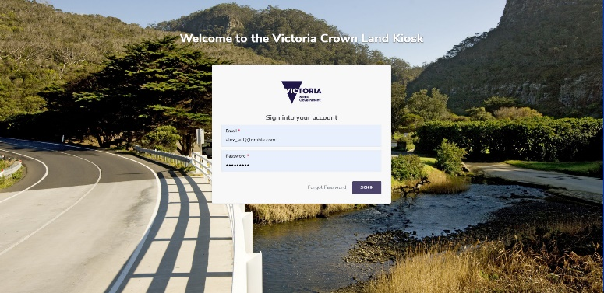
Landfolio is the department’s new Crown land information management system.
Landfolio will hold the department’s textual and spatial data for all of Victoria’s Crown land parcels, reserves and tenures, which include leases and licences.
An exciting addition to Landfolio will be an e-Gov, -serve kiosk for committees and other delegated land managers. It is scheduled to open during 2020 as an ‘opt-in’ resource.
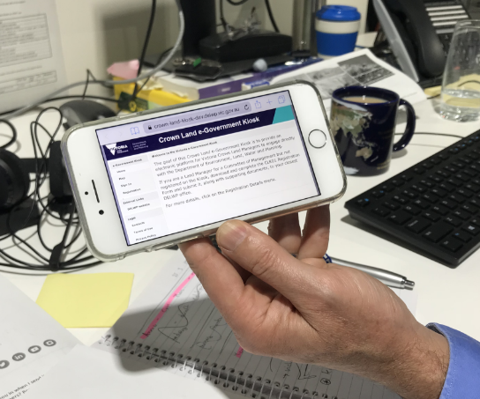
Using the kiosk, your committee will be able to access information about the reserve(s) it manages, including any related leases and licences.
You will be able to access the self-serve kiosk from a mobile phone, tablet, laptop or desktop computer.
Your committee can still seek advice from the local DELWP regional office. The kiosk will not replace the need to contact the regional office directly for specific requests, information and complex issues.

What can your committee do on the kiosk?
The kiosk offers a new and flexible way for your committee to communicate with DELWP and undertake a range of land management activities, for example:
Example photos
- View details of the reserve(s) it manages, including maps of the reserve.
- View details of leases and licences on the reserves(s), including maps of the area they cover.
- Submit financial returns, for example, your committee can choose to lodge its annual return or report through the kiosk instead of by post or email.

- Access grant information and apply for certain grants.
- Access standard document templates, for example, declarations of private interest.
- Access policies, procedures and guidelines.
- Process and view the status of tenure applications.
- Log issues related to the reserve, for example, dangerous trees.
- View and update contact details for committee members.
Contact your local DELWP regional office for further information.

6.3 Benefits and safety of incorporation
If your committee is not yet incorporated, it is strongly recommended that you contact DELWP and arrange for the committee to be incorporated under the Crown Land (Reserves) Act.
Incorporation turns a committee into an entity that is recognised in law as a legal ‘person’. This has many benefits and safeguards for your committee and for the people and organisations it deals with. For example:
- Legal action can be carried out by or against the entity, rather than individual committee members. It continues uninterrupted by changes in membership.
- An incorporated committee, rather than individual committee members, is liable for legal judgements made against the committee.
- Members of the public, tenants and contractors find it easier to deal with an ongoing body corporate than with a group of individuals who will join and leave the committee over time.
Example
If your committee intends to hire staff, check that it is incorporated. That way, the ‘entity’ is responsible for meeting the legal obligations of an employer, not you personally as a committee member.

Incorporation under the Crown Land (Reserves) Act
Incorporation under the Crown Land (Reserves) Act is:
- a simple, straightforward process
- undertaken by DELWP on behalf of the committee.

Common seal
An incorporated committee’s official signature on legal documents, such as contracts, is its ‘common’ seal. This is a stamp which must have certain information included on it. It is also known as a corporate seal.
6.4 Legal advice
If your committee needs legal advice, it can choose which law firm to use. If unsure which firm to choose, consider using the Victorian Government Solicitors Office (VGSO). The VGSO only provides legal advice to the Victorian Government and its statutory authorities (phone 8684 0421). While DELWP cannot provide or pay for legal advice for committees, the local DELWP regional office can help your committee to talk through its options.

6.5 Working with children checks
A working with children check helps protect children from sexual or physical harm. It ensures that people who work with or care for children are subject to a screening process. A working with children check differs from a national police record check. Cardholders are monitored on an ongoing basis for any new relevant criminal offences or adverse professional conduct findings.

When must a working with children check be obtained?
Under the Working with Children Act 2005, if a committee member, employee or volunteer meets all five of the following criteria, a working with children check is required:
- Engaged in work within the meaning of the Act, which includes engaging in voluntary work and providing practical training as well as paid employment.
- Working at, or for, one of the services, places or bodies, or in one of the activities listed in the Act (see the table below for details).
- Work which usually involves direct contact with a child or children. Direct contact means physical or face-to-face contact, or written (including postal), oral or electronic communication.
- The contact with children is not occasional direct contact and is not incidental to the work.
- Not otherwise exempt from needing a working with children check under the Act.

When is a working with children check not required?
The check is not required under the following circumstances:
- When an exemption under the Act applies.
- Where there is a private or domestic arrangement for family and friends (unless engaged as a kinship carer) which is unpaid.
- Supervising a student in practical training that has been organised by their educational institution. This includes work experience placements for students aged over 15 years.
- taking part in an activity with a child in the same way that a child participates, such as other players in a chess team.

What is child-related work?
If the role does not identify with any of the services or places listed in the categories below, then it is not considered child-related work. Therefore, a working with children check is not required.
Service or place of work | Details
Child care services | Child care services including:  - centre-based long day care  - occasional care  - family day care  - in-home care  - outside school hours care
Child employment – supervisors | Supervision of a child 14 years of age in employment under the Child Employment Act 2003
Child minding | Babysitting or child-minding services arranged by a commercial agency
Child protection services | Child protection services
Children's services | Children's services including kindergartens or preschools under the Children's Services Act 1996 and Education and Care Services National Law (Victoria)
Clubs and associations | Clubs, associations or movements of a cultural, recreational or sporting nature that provide services or conduct activities for, or directed at, children or whose membership comprises primarily children
Coaching and tuition | Coaching or private tuition services of any kind specifically for children
Counselling services | Counselling or other support services for children
Educational institutions | Educational institutions for children, specifically:  - state schools (all primary, secondary, technical and special state schools)  - non-government schools (all primary, secondary and special non-government schools)  - TAFE colleges and TAFE divisions of universities providing VCE and/or Victorian Certificate of Applied Learning (VCAL) subjects  - some adult education providers offering VCE and/or VCAL subjects  - other institutions providing children's study or training programs
Entertainment and party services | Commercial entertainment or party services for children unless they are merely incidental to or in support of other business activities
Foster care | Fostering children
Gym or play facilities | Commercial gym or play facilities for children unless they are merely incidental to or in support of other business activities
Kinship care | Caring for a child placed by Child Protection (under the Children, Youth and Families Act 2005)
Out-of-home care services | Out-of-home care services, under the Children, Youth and Families Act
Paediatric wards | Paediatric wards of public, private or denominational hospitals as defined in the Health Services Act 1988
Photography services | Commercial photography services for children unless they are merely incidental to, or in support of, other business activities
Refuges | Refuges or other residential facilities used by children
Religion | Religious organisations
School crossings | School crossing services
Student exchange programs/ homestay arrangements | Student exchange or homestay arrangement under Part 4.5A of the Education and Training Reform Act 2006, including accommodation in a person’s home
Talent and beauty competitions | Commercial talent or beauty competitions for children unless they are merely incidental to or in support of other business activities
Transport | Publicly-funded or commercial transport services specifically for children
Youth justice | Youth remand, residential, or justice centres, supervision units and probation services within the meaning of the Children Youth and Families Act

Guidance
The Victorian government has a Working with children check website. It includes information on:
- Do my workers need a check? This quiz applies to both workers and volunteers, including committee members. There is a list of the occupations covered by child-related work.
- Organisation obligations
- What organisations need to know
- Fact sheet.

Cost
A working with children check is free for volunteers. As at 1 November 2019, the cost for paid workers is $126.50.

Who applies for the check?
Workers and volunteers need to apply for their own checks. This is a simple process using the How to apply page on the working with children check website.

6.6 Dealing with public complaints
At some stage, your committee may receive a complaint from a member of the public about something it did or did not do. Most complaints will be resolved fairly easily and to everyone’s satisfaction. Remember to record:
- the complaint
- the decisions and actions of the committee in response
- whether the person was satisfied with the outcome.
The committee will need to contact the local DELWP regional office with problems that prove more difficult to resolve.

Complaints to DELWP
From time to time, DELWP receives complaints from members of the public, or a member of the committee itself, about how the committee is operating. Depending on the nature of the complaint, DELWP may:
- work with the committee to resolve the issue
- conduct an investigation
- refer the allegation to the Ombudsman, Victoria Police or the Independent Broad-based Anti-corruption Commission (IBAC).

Complaints to the Victorian Ombudsman
The Victorian Ombudsman investigates complaints about administrative actions and decisions by government agencies and public authorities. This includes committees of management. Any person can make a complaint. The Ombudsman can review the lawfulness of the committee’s actions or decisions, as well as the reasonableness and fairness of its actions in the circumstances. The Ombudsman can also conduct investigations of its own initiative.

Complaints to IBAC about corruption or serious improper conduct
The department takes allegations of corruption seriously. A person with a complaint about alleged improper or corrupt conduct of committee members or DELWP employees can provide any information they have about the conduct, and the employees involved, to the department’s Integrity Manager (integrity@delwp.vic.gov.au or 1800 903 877).
A person may also choose to take their concerns directly to IBAC. For further information visit the IBAC website or call 1300 735 135.

Whistleblower protections – IBAC
The Public Interest Disclosure Act 2012 provides protections for individuals who wish to make a disclosure about serious misconduct or corruption by a government agency or a public body such as a committee of management.
A disclosure is made directly to IBAC. It can be made by a member of the public or a member of the committee itself.
IBAC will assess the disclosure and may investigate, refer the matter to another body, or dismiss the matter. For further information visit the IBAC website or call 1300 735 135.
For the whistleblower to be protected, they must keep their disclosure confidential (not talk to anyone about it) and make it directly and only to IBAC. However if a person contacts the department’s Integrity Manager (protected.disclosures@delwp.vic.gov.au or 1800 903 877) as described above protections may still apply.

6.7 Record keeping
Your committee has a responsibility to maintain good records, including records of its activities. Sound record keeping is an essential good practice. Your committee has legal record-keeping obligations under laws, which include.
- Crown Land (Reserves) Act
- Freedom of Information Act 1982
- Public Records Act 1973
- Privacy and Data Protection Act 2014.

What records must be maintained by the committee?

Public records are not automatically open to the public
Public records produced by your committee are a public document. However, they are not automatically ‘open to the public’. For example, they may contain information that is commercial-in-confidence.
Unless your committee agrees, a member of the public who wants to see documents such as minutes of a committee meeting or an annual return would need to lodge an application under the Freedom of Information Act.
Contact the department if this occurs. DELWP can advise and help your committee to assess whether the records are exempt from disclosure.
Committees of management are ‘public bodies’ under the Public Records Act. Their records are public records, regardless of age.
Public records that must be maintained by your committee include:
- minutes of meetings
- correspondence
- lease and licence contracts and related documentation
- financial records
- contracts
- employment records
- any other information that documents a decision, agreement or communication to the public by the committee.
Public records come in many formats. For example, they may be written notes, letters, emails, electronic documents, photographs, and information on websites.
Ultimately, it is the information, not the format, that determines whether it needs to be preserved as a record.

Financial records
As part of its record-keeping requirements, your committee must keep records of all its financial transactions. For further information, see:
- Record-keeping for small business on the Australian Taxation Office website
- the Community Director’s website (https://communitydirectors.com.au/), including the page on Record-keeping for treasurers (https://communitydirectors.com.au/tools-resources/community-finance-centre). If these links do not open in your usual browser, try a different browser.

Normal administrative practice is not a record
Some information produced or collected by a committee does not constitute a committee record and should not be treated as such, for example:
- working notes
- duplicate copies
- reference material collected from books, the internet, and newspapers.
Information which is not a committee record should be disposed of under normal administrative practice once its use is completed. Avoid mixing this material in with committee records, as this makes it difficult to manage committee records efficiently. Failing to dispose of this kind of material when its use is completed also makes it difficult for future committee members to locate the committee’s actual records. Usually, normal administrative practice materials can be recycled or thrown out. However, if any sensitive information is included, it must first be shredded or otherwise made unreadable.

Creating and storing records
Committee records need to be full and accurate. This will:
- enable future committee members to take appropriate action and decisions
- protect the financial, legal and other rights of the committee
- protect people affected by any actions and decisions made by the committee.
To ensure its records are full and accurate, it is recommended that your committee:
- Store committee records in a readily accessible, clean, dry and secure place.
- Use a system that other people will be able to understand.
- Take written notes of important conversations. Where appropriate, send a ‘confirming’ email.
- Maintain a suitable filing system for your committee’s size and the complexities of managing its reserve.
Example
For a local committee where the management of the reserve is not complex, electronic documents can be placed in a simple folder system. Hard copy records can be stored in manila folders with:
  - A title that explains what the file is about. For example, ‘Kamba Mechanics Hall Committee - committee meeting minutes – 2014’.
  - The date the file was created.
  - The person’s name who created the file.
  - Include printed copies of electronic documents and emails, photos and other records on the file.
Identify all records that are essential to your committee’s function, such as minutes and contracts. Special care needs to be taken to prevent their loss or damage. If possible, store duplicates of these records in a different location to the originals.

Retention of records
All records created by your committee are public documents and must not be destroyed. Only the non-essential materials can be disposed of when no longer in use (see above, normal administrative practice.)

Handover of records from the outgoing to the incoming committee
Committee records are not the property of the committee members who created them. An outgoing committee must hand over all committee records to the incoming committee, so the incoming committee can properly carry out its duties. For details, see 3.9 ‘Outgoing committee – the hand-over process’.

Transfer of records to DELWP
Your committee must transfer all its records to DELWP if the committee ceases to exist. The records will be stored for periods determined by the Public Records Office of Victoria. DELWP will transfer certain records to the records office for permanent preservation.

6.7 Assets register
Your committee should maintain an up-to-date Assets register. This helps the committee to record and keep track of the assets it owns or manages, including:
- a description of the asset (record identifying information, such as the serial numbers, make and model of equipment)
- the date it was bought
- its estimated value
- its location.
An asset register can also provide information to help plan future asset investments. Check each asset item at least once a year. The asset’s value should be adjusted each year to reflect depreciation for physical assets, such as buildings, equipment and stock. There is no requirement to record the value of the reserved land.

6.8 Public access to committee records - freedom of information laws
Being a public record is different from being ‘open to the public’. Committee records can only be viewed by members of the public if the committee agrees or a successful application is made under the Freedom of Information Act.
Under the Freedom of Information Act, a person has the right to request access to documents generated or held by all government agencies, including committees of management. If your committee receives a request to access documents under this law, seek advice from DELWP’s Freedom of Information Unit as soon as possible. The law only allows 30 days in which to process a request. The unit provides advice on enquiries and support for processing requests. It can be contacted on 7022 6530 or email FOI.Unit@delwp.vic.gov.au.

6.9 Privacy of personal information
The Privacy and Data Protection Act requires your committee to comply with the 10 Information Privacy Principles in the Act when collecting, using, disclosing, storing or destroying personal information. These are available from the Office of the Victorian Information Commissioner website.
Personal information means recorded information or opinion about an identifiable individual. It includes, but is not limited to, the person’s name, address, sex, age, financial details, marital status, education, criminal record or employment history.
Do not include a person’s private contact details on publicly available documents and registers, such as the volunteer attendance register, without their permission.

6.10 Electronic copy
An electronic copy of this document is available from the DELWP website (www.delwp.vic.gov.au/committees).

