|  |
| --- |
| Voluntary Committees of Management Newsletter |

Edition 11 – March 2017



Gippsland- Tarraville Hall

**Hume:** <https://www.facebook.com/DELWPHume> **Port Phillip:** <https://www.facebook.com/DELWPPortPhillip> **Gippsland:** <https://www.facebook.com/DELWPGippsland> **Grampians:** <https://www.facebook.com/DELWPGrampians> **Loddon Mallee:** <https://www.facebook.com/DELWPLoddonMallee>

**Barwon South West:** <https://www.facebook.com/DELWPBarwonSouthWest>



Natte Yallock’s Community Spirit, Grampians Region

The Natte Yallock Recreation Reserve Committee of Management is an active and committed group.

The public hall was once the venue of choice for local dances and events but had recently been outshone by the recreation reserve’s modern club rooms and function area. The reserve’s building had become the venue of choice, leaving the hall unused and falling into disrepair.

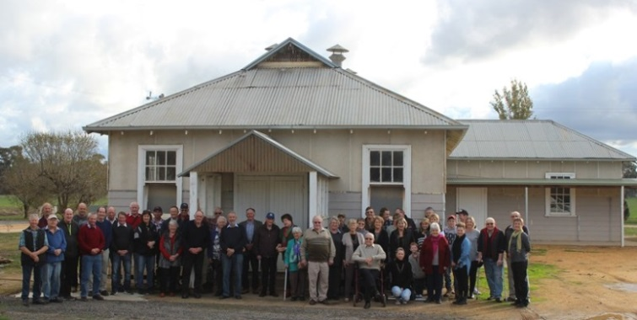

The old hall (source: Natte Yallock Recreation Reserve CoM)

The committee approached DELWP with a view to demolish the old hall and make the site available to accommodate a new CFA shed.

The decision to demolish a cherished asset like the community hall requires sensitive engagement. The hall housed the military service honour board and it was clear that any decision to demolish had to be fully supported by the community.

**Got Tenants?**

The *Crown Land (Reserves) Act 1978* makes provisions for committees to lease or licence land. Having a lease or licence can protect the interests of both the tenants and committees of management.

*The Responsibilities and Good Practice Guidelines* provide some information (found here: <http://delwp.vic.gov.au/about-us/boards-and-governance/on-board-governance-guides-and-resources/committees-of-management/committees-of-management-guidelines> )

You can also contact your local DELWP officerfor assistance and templates.

With the support of DELWP and local Council the committee worked through the planning process, this involved calling a public meeting to discuss options and to allow residents to have their say. The outcome of the meeting was overwhelming support for demolition and for the site to be made available for CFA use.

The committee organised a ‘farewell to the hall’ event (pictured), and an ANZAC day ceremony to unveil the newly renovated honour board, in its new home.

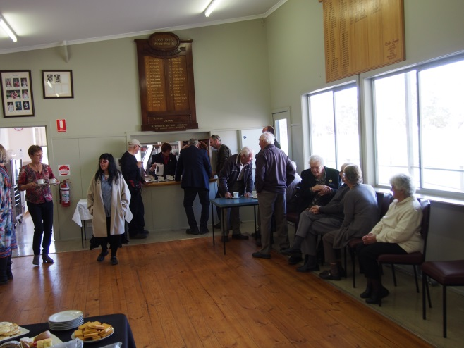

Honour board in the new space (source: Natte Yallock Rec Res CoM)

DELWP organised the removal and disposal of the asbestos, and electrical safety works for the site.

The committee worked with a local contractor to salvage as much as possible and the old hall was carefully demolished and building materials recycled. This includes the refurbishment of some of the old seating from the hall into the new space (pictured) and plans to use some of the flooring material to make a dresser and table for the entrance and corporate area of the club rooms.

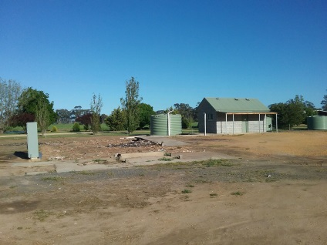 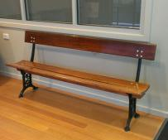

The old hall removed and the seating reused in the new space (source: Natte Yallock Rec Reserve CoM)

A fantastic outcome for the Natte Yallock community.

**Does your CoM have building insurance?**

Please remember CoMs are responsible for arranging building and/or contents insurance, WorkSafe insurance and other relevant insurance not covered by DELWP.

It may be worth checking with your local Council first as they may insure buildings on behalf of CoMs.

Further information can be found in Chapter 11 of the Committees of Management Responsibilities and Good Practice Guidelines 2015. Find them here: <http://www.depi.vic.gov.au/forestry-and-land-use/managing-land/managing-crown-land/committee-of-management-guidelines>

**Citizen Science - Red Capped Hooded Plover, Port Phillip Region**

The Friends of the Hooded Plover (Mornington Peninsula) Inc. (FoHP) has been successful in obtaining a Coastcare grant to establish a monitoring and management program for Red-capped Plovers (RCP) on Western Port beaches. The program will be carried out in conjunction with the BirdLife Australia Beach-nesting Birds team, who run a similar program for Hooded Plovers across Southern Australia.

The grant will enable information days, equipment for nest and chick protection and new signage.

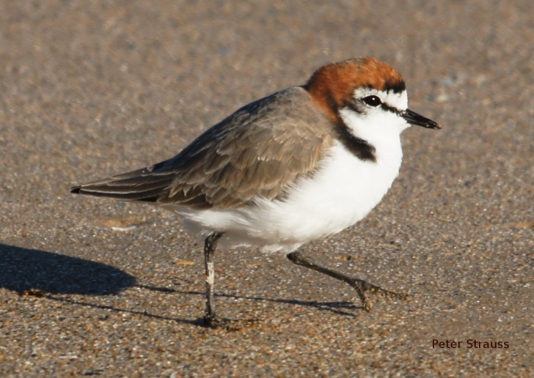

Red Capped Plover (source: Peter Strauss)

The Point Leo, Shoreham and Balnarring Foreshore Committees and their rangers are very supportive of the new program. A Land Managers workshop was held at Pt. Leo in late September. And a workshop for the interested public was held in October.

Trained volunteers will work with local rangers to manage new RCP nests and chicks, and the information collected will be recorded on an online BirdLife Australia Data Portal.

Although the Red-capped Plover is considered to have a stable population, little is really known about its breeding habits and life cycle. With the easy access and increased usage of beaches it is a good opportunity to see if data shows the species to be under more pressure.

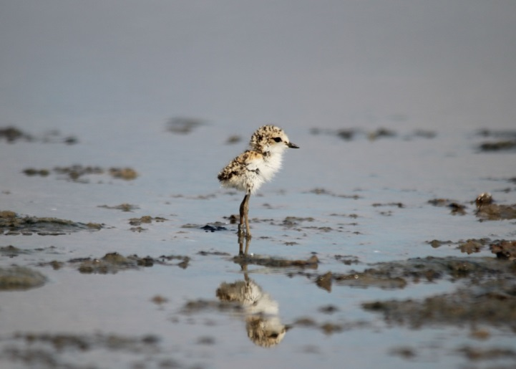

Red Capped Plover Chick (source: FoHp)

Like Hooded Plovers, these small beach-nesting birds nest on the sand above the high tide line. They usually lay two eggs, which can be very difficult to see as they use camouflage to protect them. Both parents incubate the eggs for 28 days. Once the chicks hatch they must feed themselves and it will be another five weeks before they are big enough to fly.

When disturbed the tiny chicks hide, as they are so tiny that might mean they are behind a piece of seaweed or in a footprint. We hope by increasing Red-capped Plover awareness and commencing nest and chick management, we can start to maintain a balance between recreational use of the beaches and public awareness of the bird’s vulnerability to disturbance.

Nine coastal CoMs re-appointed, Gippsland Region

Nine coastal committees of management, who collectively manage 880 hectares of coastal Crown land in Gippsland, have recently been re-appointed.

DELWP Gippsland has appointed 74 volunteer members to the Corinella, Grantville, Lang Lang, Loch Sport, Port Franklin, San Remo, Sandy Point, Shallow Inlet and Walkerville committees of management.

The volunteers manage a wide range of issues and look after many different types of infrastructure, including toilet blocks, boat ramps, walking tracks, car parks, viewing platforms and sea walls.

The photo below highlights what our committees do. Over a 10 year period the Port Franklin committee took a collapsed river bank with derelict jetties and transformed it into a safe and accessible facility.

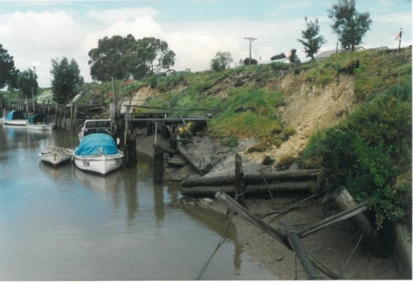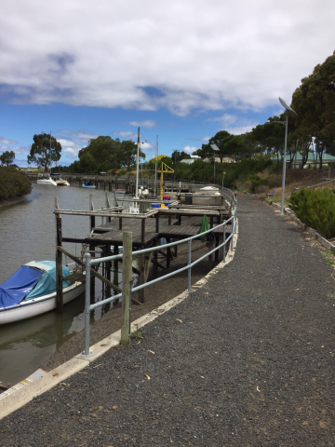

Before and after

The enthusiasm and depth of knowledge that committees bring to the management of the reserves, on behalf of all Victorians is highly valued by the local communities and DELWP.

**Looking for skilled volunteers?**

If your committee needs some professional assistance e.g. Website development, marketing, design, social media, why not try finding it on Vollie?

Vollie is an online marketplace that connects talented people to non-profits, charities and social enterprises for skills-based volunteering. And please let us know how you get on for our next newsletter.

More info and to sign up here: <https://www.vollie.com.au>

**Blackwood Mineral Springs Reserve, Grampians Region**

A $24,500 Victorian Government Mineral Springs Reserves Grant application has meant that the Blackwood Mineral Springs Reserve Committee of Management has been able to replace ageing barbecues and weathered picnic tables at the site.

“We are delighted with the grant from the Victorian Mineral Water Committee,” said Brain Moore, Blackwood CoM Chairperson. “It is our role to ensure that the Blackwood Mineral Springs are well-managed and appealing to visitors. The grant has given us the opportunity to improve facilities in the reserve and provide the community with a great mineral water experience when they visit.”

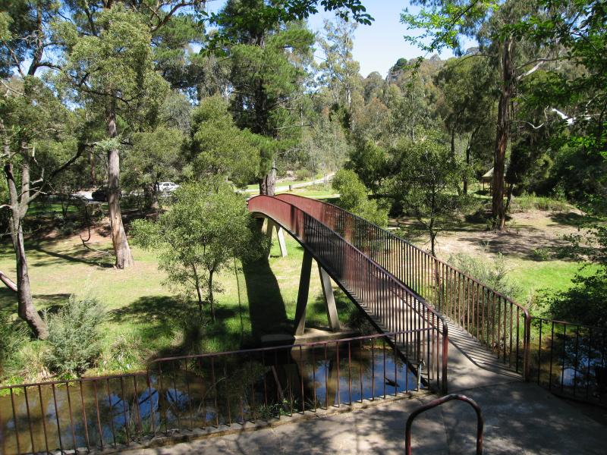

Blackwood Mineral Springs Reserve

This grants program complements the Victorian Mineral Springs Strategic Master Plan 2015-2024 that was developed to provide strategic direction for the management of mineral springs reserves in Victoria.

Recreation and visitor education are two priorities in the plan, which also emphasises the importance of educating visitors about the environmental and historic importance of Victoria’s mineral springs.

The Blackwood Mineral Springs Reserve is located 1km east of the historic village of Blackwood, between Ballan and Trentham. Situated on the Lerderderg River, Blackwood is surrounded by the Lerderderg State Park and Wombat State Forest.

Great Southern Rail Trail, Gippsland Region

Visitors to the iconic Great Southern Rail Trail in south Gippsland can now plan their trip with the touch of a button thanks to a new website.

The Great Southern Rail Trail was the Australian mainland's southern-most rail line, through lush green farmland and temperate rainforest with blue water views to the peaks of the Prom. It links many South Gippsland towns known for local food, wine and art.

You can walk, cycle or ride the entire 72kms or just take your time enjoying a shorter journey.

Information about the various stages of the trail and the local townships is a key feature of the website. You can view a profile of each stage and find information about parking, toilets and other visitor facilities.

As part of the project to re-brand the trail, the Committee of Management received funding to upgrade signage along the trail.

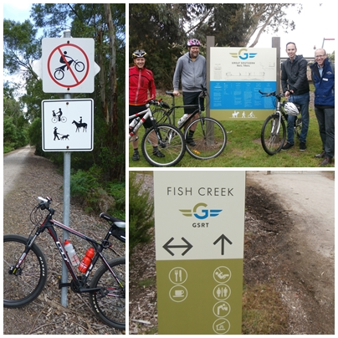

Check out the new website here: [www.gsrt.com.au](http://www.gsrt.com.au)

**Have Your Say**

DELWP’s Have Your Say website has been added to the Engage Victoria website. You can now provide feedback for projects across the state government in one place!

Find our current projects open for consultation here:

<https://engage.vic.gov.au/>

Cooler halls, London Mallee Region

Manangatang Public Hall and Nyah District Memorial Hall Committees of Management are breathing a little easier now. Thanks to the recent installation of split system air conditioners in both public halls.

Both committees secured funding through DELWP for the new systems, which will provide a great deal of comfort for users from the extreme weather conditions experienced in the Mallee.

Both halls are well used by their respective communities with weddings, family celebrations, community group meetings, and church gatherings. All of these will now be more pleasant to attend on those hot and cold days.

We think the most appreciative group will be the dance class attendees at Nyah hall!

**169 Years of Service – Toongabbie Recreation Reserve, Gippsland Region**

Last September, DELWP Regional Director Gippsland Stephen Chapple, recognised the service of members from the Toongabbie Recreation Reserve Committee of Management.

Years of service ranged from 17 to 36 years. In total, an outstanding 169 years of service has been achieved by the committee members.

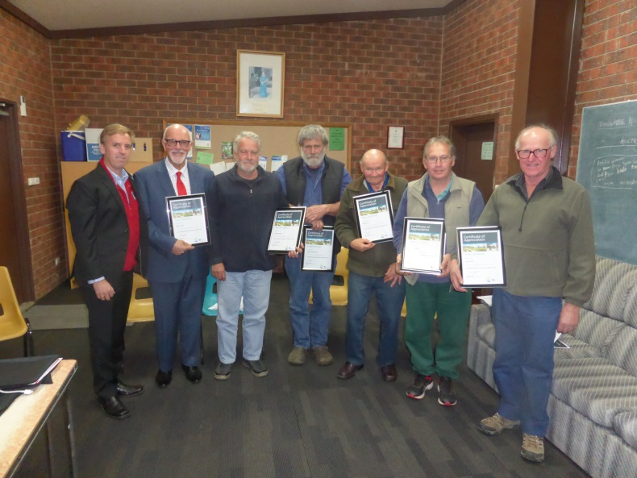

Stephen Chapple with Toongabbie Recreation Reserve CoM members

Mr Chapple congratulated the committee members for their ongoing service and commitment to their community. Well done to all members!

**DELWPs New Website**

DELWP launched a new website on 20 December 2016. It is important that committee members and general users can navigate the site easily and find the information you need.

The website is here: <http://www2.delwp.vic.gov.au/>

And feedback can be provided here: <http://www2.delwp.vic.gov.au/our-department/contact-us>

Sebastopol Community Centre CoM, Grampians Region

A successful application from the Sebastopol Community Centre Committee of Management for $165,000 funding through DELWP’s Public Safety on Public Land program has allowed safety upgrade works to the former Sebastopol State School building.

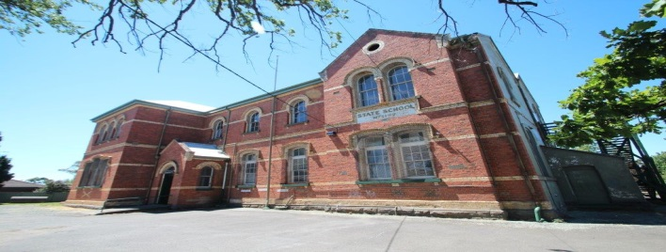

Former Sebastopol State School building

Built in 1873, the building now houses the Sebastopol Community Centre, which hosts several community groups including the Sebastopol and District Historical Society, Ballarat and District Lapidary Club, and the Filipino/Australian Association of Ballarat Inc.

The committee identified that the building needed urgent work, with patron safety being the main concern.

The grant has allowed the modification of the internal stairway to meet Australian Building Code standards, and to repaint and install signage that shows the location and direction to emergency exit doors.

**Lethbridge Public Hall, Grampians Region**

By Diane Lang, Secretary, Lethbridge Public Hall Committee of Management

We are a small town on the Midland Highway between Geelong and Ballarat.

Our hall was in need of some maintenance, so we formed a new Committee of Management and applied to the Golden Plains Shire for a grant to paint the exterior doors, windows and guttering.

This was going well until we realised the guttering was not worth painting and needed to be replaced, along with 6 cracked windows.

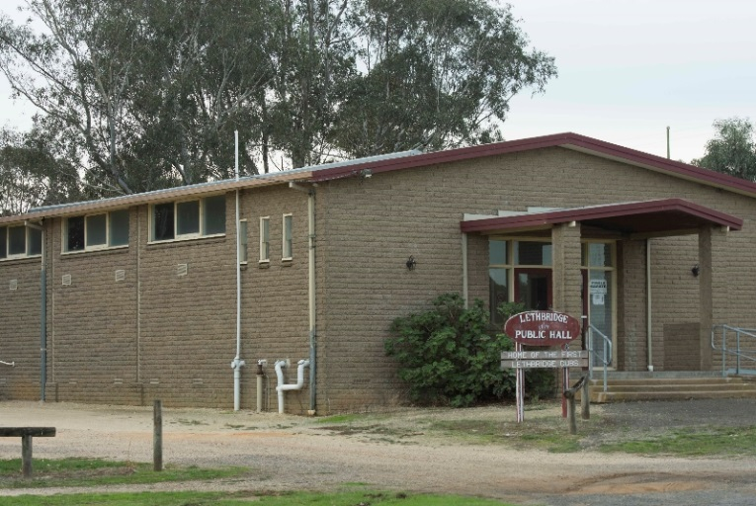

Lethbridge Hall (source: Diane Lang)

Budget now blown out, we sold calendars of our town to help raise more money to complete the job.

Our first run of 2016 calendars sold 50 making $500; word spread and we sold 125 2017 calendars for a profit of $1,250. This along with our three regular user groups paying fees at the hall has meant we have been able to pay for new guttering, repair of toilets and a new lock on the door. It is amazing what can be achieved in a short time (18 months).

Share your stories in Edition 12!

DELWP is seeking contributions for Edition 12, and any feedback on the frequency and content of the newsletter. Please send any comments, suggestions or articles and photos to [voluntary.committees@delwp.vic.gov.au](mailto:voluntary.committees@delwp.vic.gov.au)

Now our hall is starting to look like it is loved again! We are looking forward to some landscaping to give it some street appeal.

|  |  |  |  |  |
| --- | --- | --- | --- | --- |
| Grant name | Purpose | Amount | Key dates | Website |
| Victorian Heritage Restoration Funds (City of Melbourne, City of Yarra, City of Ballarat) | Restoration works to places of identified historical significance under a heritage overlay in the City of Melbourne, City of Yarra, and City of Ballarat. | Assessed on case by case basis | 27 April 2017 | <http://www.vhrf.org.au/> |
| Melbourne Water Corridors of green funding | To improve river health through the corridors of green program. | Up to $20,000 | 30 June 2017 | <https://melbournewater.smartygrants.com.au/corridorsofgreen> |
| Public Safety on Public Land – Major Projects | To improve public safety on public land through projects such as reconstruction or reinforcement of major structures, demolition of major structures, decontamination, control visitor access, or tree risk projects. | $20,000 and more | Contact your local DELWP representative | Applications must be made through your local DELWP representative. |
| Recreational Fishing – Small Grants Program | To support actions or programs which aim to boost participation in recreational fishing and related activities. | Up to $5,000 | Ongoing | <http://agriculture.vic.gov.au/fisheries/recreational-fishing/recreational-fishing-grants-program/small-grants-program> |
| Inspiring Environmental Solutions community funding program – EPA Victoria | To enhance the environment in a public place, or undertake environmental activities for the benefit of the community. | Varies | Ongoing | <http://www.epa.vic.gov.au/our-work/programs/inspiring-environmental-solutions> |
| Coastcare Grant | Support the conservation of coastal and marine ecosystems and environments across the state through rehabilitation, restoration and preventative actions undertaken by volunteer groups. | Up to $7500, check website | 31 March 2017 | <http://delwp.vic.gov.au/parks-forests-and-crown-land/coasts,-bays-and-marine-areas/coastcare-victoria-community-grants-program> |