Voluntary Committees of Management Newsletter
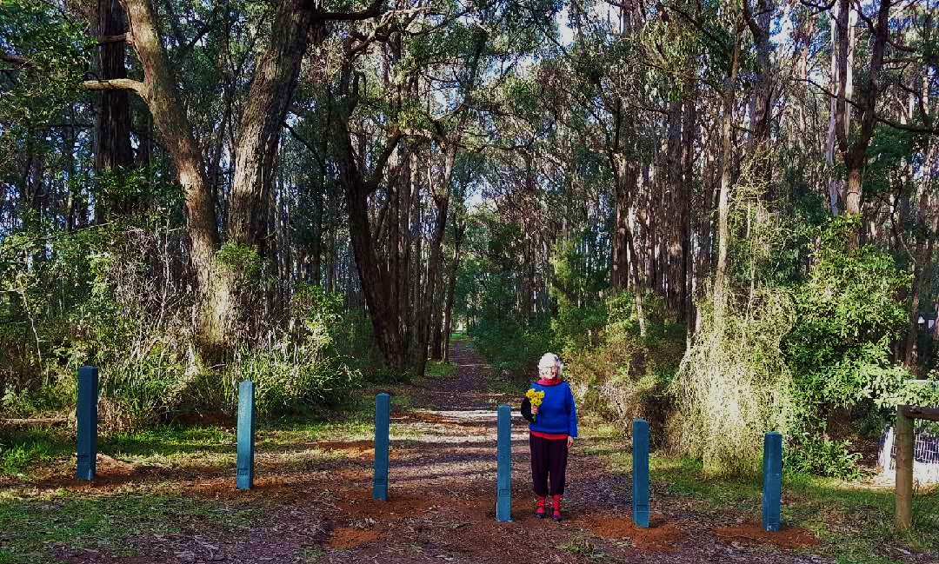
A hint of spring in Clematis Park with committee member Sue Walker

Edition 14 – September 2018

Hume: https://www.facebook.com/DELWPHume Port Phillip: https://www.facebook.com/DELWPPortPhillip Gippsland: https://www.facebook.com/DELWPGippsland Grampians: https://www.facebook.com/DELWPGrampians Loddon Mallee: https://www.facebook.com/DELWPLoddonMallee
Barwon South West: https://www.facebook.com/DELWPBarwonSouthWest

51 Years of Dedicated Service to Kallista Mechanics Institute, Port Phillip Region
What were you doing in 1967? John Lloyd, the President of the Committee of Management of the Kallista Mechanics Institute Hall, was elected to the Committee of Management of the Hall in that year. John was, at that time a local Parks Ranger for Sherbrooke Forest.
John will be stepping down as the President of the Committee after an unbelievable 51 years on the Committee and more than two decades as leader of the local Kallista Community Hall. John has been a member of the Committee of Management for almost half the life of the Hall's more than 100 years of being an essential element of the local community.
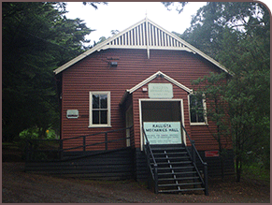
There are not enough words to describe the enormous dedication, contribution and sacrifice John and his wife Faye have given to the Hall and the community.
Yet John's contribution to the community does not stop with the Hall. He has been a driving force in the 'Friends of Sherbrooke' to protect the pristine nature of Sherbrooke Forest. You will find him every Tuesday working with other volunteers removing weed species from the forest to protect the historical significance of the region. John also volunteers for many other tasks throughout the local community, including a focus to recognise the war service of local men and women who have served in fields of conflict in Australia's armed services who were/are residents of the local area around Kallista.

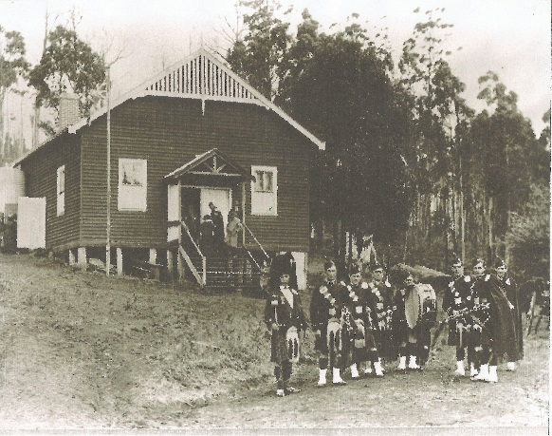
Kallista is a wonderful oasis of pristine forest and native forest wildlife where people from Australia and overseas flock to enjoy the environment so close to Melbourne. They will never know just how much of that environment is so beautiful because of the efforts of a few like John Lloyd. While he is stepping down from the Presidency of the Hall and membership of the Committee his 51 years of service will linger on for many more decades to come.

Nadaly Public Hall Reserve Repairs, Loddon Mallee Region
The Nandaly Public Hall Committee of Management Incorporated, recently received $8,000 from DELWP’s Public Safety on Public Land funding program to remove asbestos and repair the eaves on the hall.

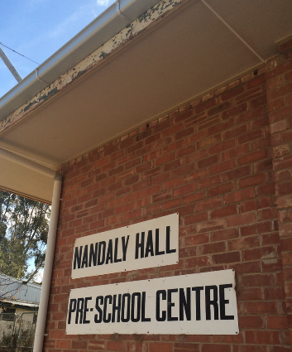
How it looks before and after

Does your CoM have building insurance?
Please remember CoMs are responsible for arranging building and/or contents insurance, WorkSafe insurance and other relevant insurance not covered by DELWP.
It may be worth checking with your local Council first as they may insure buildings on behalf of CoMs.
Further information can be found in Chapter 11 of the Committees of Management Responsibilities and Good Practice Guidelines 2015. Find them here: https://www2.delwp.vic.gov.au/__data/assets/pdf_file/0030/46488/13-Sept-2016-CoM-guidelines-Nov-2015-all-chapters.pdf.pdf

Lake Cartcarrong – the Jewel of Winslow,
Barwon South West Region
Prepared by Yvonne Kane, Secretary, Lake Cartcarrong Committee of Management
Like most lakes across the Western District of Victoria, Lake Cartcarrong has witnessed many changes.
The draining of its surrounding wetlands in the 19th century, dairy farming practices, the effluent discharge from a local tannery and a local rubbish dump on its edge have all contributed to its degradation.
The tannery was one of the largest in Victoria and the sketch below is a view from the tannery showing wooded areas before clearing.
Degradation continued last century with cattle grazing on the surrounding wetlands and trampling the fragile peat edges as well as eating reeds, mosses, sedge grasses and the remnants of the tea tree.
An article from the Warrnambool Standard, 1937, titled ‘Reminiscences of Winslow’ creates a picture of the lake very different from today.
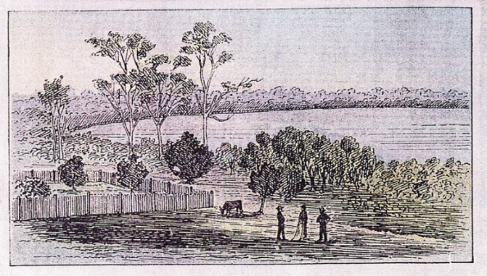
” Lake Cartcarrong was surrounded by a dense scrub. On the inner side grew a thick bed of reeds and on the landward side grew tall, thick clumps of rushes, which provided shelter for numerous wallabies. Kangaroos were very numerous; thousands of satin birds annually made their appearance; white cockatoos, also the funereal black cockatoo with its red crest, were common. Flying squirrels (gliders) parachuted from branch to branch; silver-grey opossums were so plentiful that shooters easily obtained two or three dozen on bright moonlit nights; native bears (koalas) were abundant; wedge-tailed eagles were often seen.”
The original flora and fauna surrounding the lake has largely disappeared. Water levels have also changed dramatically in the last fifty years. The days where once fly fishermen lured trout and the local angling clubs caught red fin and eels and children dived off the jetty have long gone. Now the lake is only used for passive recreation activities.
The Lake Cartcarrong Committee of Management consists of a small group of volunteers determined to restore Lake Cartcarrong to some of its former glory!
In 2012 the Committee were fortunate in accessing a Communities for Nature Grant which allocated substantial funding to support their vision.
The Committee’s immediate task was to research the history of Lake Cartcarrong so that the community become aware of the loss of biodiversity that has occurred since white settlement in the 1840s. They held two public meetings and produced and hand-delivered two brochures to build community awareness of the nature of wetlands and gain local support in sharing their vision of overcoming some of the degradation and the wetlands’ loss of biodiversity. Local businesses donated for fencing and loads of mulch were freely provided.
The Committee researched, designed and developed interpretative signage highlighting the history of Lake Cartcarrong, its volcanic origins, its spiritual significance and economic importance for the Cartcorang Gundidj clan and the significance of wetlands. They also discovered that Lake Cartcarrong was a potential source of water for the town of Warrnambool (The Argus, August 1883).
Mindful of not being overwhelmed by the enormity of the task the Committee targeted selected areas for tree planting. The purpose was to showcase the original indigenous species that provided habit for koalas, wallabies, possums and abundance of birdlife.
The committee and involved community members spent hours, clearing, weeding, spraying and mulching prior to planting. These areas also required fencing to protect the small plants due to an increasing number of rabbits and local wallabies returning.
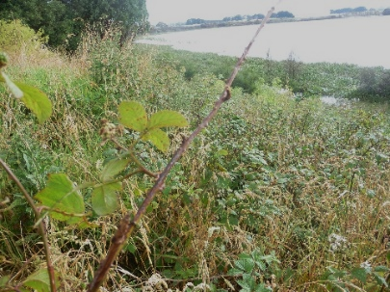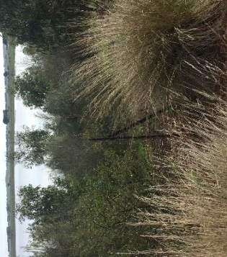
Before and after weeds in one of the targeted areas
Over years the jetty fell into serious disrepair posing a risk hazard to recreational fishers and the public. Funding was obtained through the [former] Department of Primary Industries and the [former] Department of Sustainability and Environment; supported by the Koroit Angling Club. The committee replaced the decking, added safety rails and provided easier and safer access for the public.
The committee accessed the Community Assistance fund in 2013 and built a picnic table and seating close to the jetty enhancing the lake as a passive recreation spot.
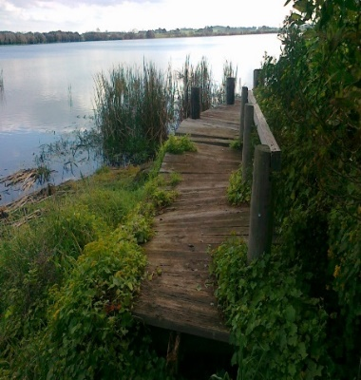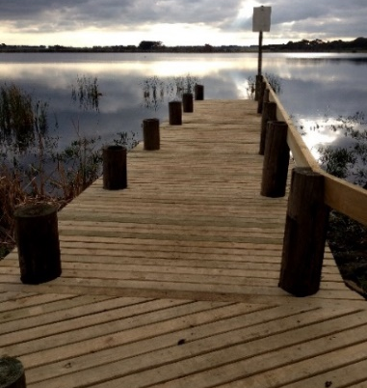
Before and after pictures
The committee are faced with continual challenges of black berry, cape ivy, weeds, and the emergence once again of rabbits. They work with farmers to ensure fences are maintained.
The drying up of the lake three times has seen water levels lower and in addition they’ve had to contend with three blue-green algae blooms.
Recently the committee received funding to replace a fence in disrepair and neglect. Cattle will no longer be able to access the wetlands and lake water and they can commence the next phase of planting around the lake.
The small committee has not faltered in the aim of bringing about long term sustainable change by improving the biodiversity of Lake Cartcarrong and developing lake facilities to create a unique and valued community asset.

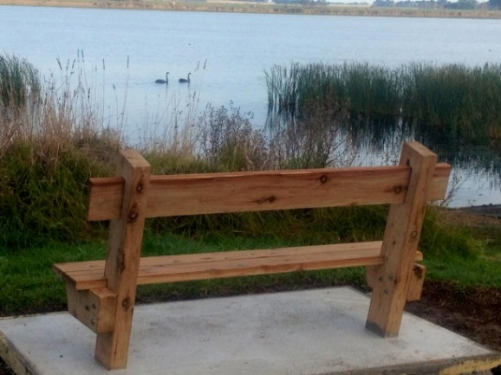

Enjoy the tranquillity of Lake Cartcarrong

DELWP Voluntary Committees together on Facebook
DELWP Port Phillip and Grampians Regions have started two closed Facebook groups.
These groups provide a private space for volunteer committees. Members can ask questions of DELWP staff and other committee members as well as share photos, posts, stories and event information.
DELWP welcomes the use of this group as a place for our committees to ask questions, engage in discussion and share information.
If you are a member of a committee in either Port Phillip or the Grampians and you would like to join a group please contact voluntary.committees@delwp.vic.gov.au

Celebrating Murrabit Recreation Reserve Committee of Management, Loddon Mallee Region
In May 2018, eight members of the Murrabit Recreation Reserve CoM were presented with certificates, by Regional Director Marg Allan, acknowledging a collective 234 years of service, ranging from 55 to 16 years of service each.
Marg was given a quick tour of the reserve by Vince Maher who was presented with a certificate for a whopping 55 years of service. He is still a trainer with the Murrabit Football Netball Club and made a special acknowledgement of his wife, Gwen.
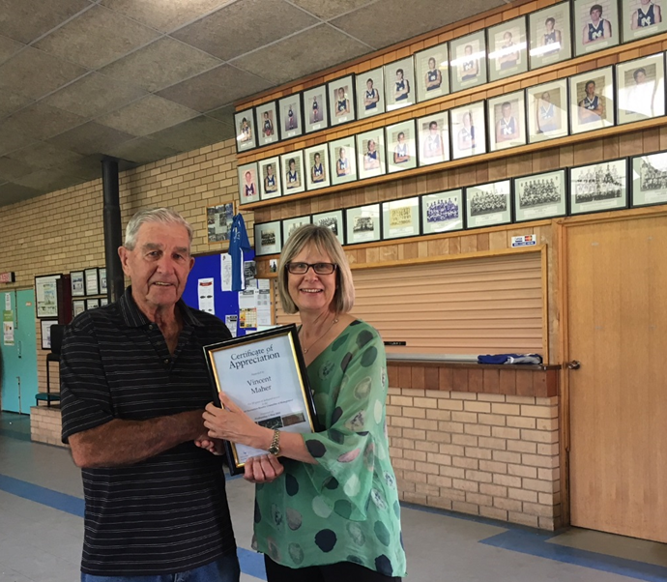
Marg receives a tour from Vince Maher
It was a small, informal gathering, coordinated by Cathie Boschert (Program Officer, Land and Built Environment Programs) and Stephen O'Donahue (Secretary, Murrabit Recreation Reserve CoM).
An afternoon tea was enjoyed at the end of the presentation and the CoM were appreciative of the acknowledgment.
DELWP appreciates the hard work of hundreds of volunteers who serve on committees of management.

Crown Land Information Improvement Project Update, State-wide
DELWP is happy to announce that Spatial Dimension (a subsidiary of Trimble) has been selected as the vendor for delivering the Crown Land Information Platform (CLIP).
Spatial Dimension was selected from an initial field of 22 suppliers. The process involved both an Open Expression of Interest, followed by invited Request for Tenders to the highest-ranking suppliers. The tender process was comprehensive and highly competitive.
Spatial Dimension’s Landfolio solution has been deployed in more than 25 government agencies globally and a host of private sector organisations. The solution is predominantly off the shelf and specifically focussed on land administration and land tenure management. Landfolio includes a back-office application which will be utilised by DELWP staff, and a land manager e-gov kiosk application, to be utilised by Committees of Management.
The solution has been implemented in a diverse range of jurisdictions including Idaho Department of Lands, Kenyan Ministry of Mines and the Jamaican Lands Agency. Landfolio has also been implemented for both Origin Energy and Rio Tinto in Australia.
You can find our more information about Landfolio at: https://landadmin.trimble.com/solutions/land-management/
And, information on Spatial Dimension’s parent company Trimble at: http://www.trimble.com/
As mentioned in previous announcements, the project will be delivering a Committee of Management Kiosk which will provide each committee with access to information on the Reserves and Tenures they are managing. The web site will also provide access to guidelines, standard templates and other types of documents.
The initial focus of work is on configuring the back-office system and loading in Parcel and Reserve data. Work on the Committee of Management Kiosk will commence in early 2019.
For further details, email the Project Manager, Michael Black: michael.black@delwp.vic.gov.au

Significant achievements celebrated in the Grampians, Grampians Region
In recognition of the significant achievements made by our committees and their individual members, the DELWP Grampians Region recently presented 12 recognition awards. The recipients were:
- Ballarat Environment Network - 25th anniversary of establishment
- Len Orr and Marlene Orr - Bullarto Hall - for 40 years of service
- Dooen Public Hall
- Joy Durston - Glenlyon Shire Hall
- Christine Collings - Great Western Public Hall
- Lethbridge Hall
- Maude Recreation Reserve
- Moonambell Public Hall
- Murtoa Stick Shed
- Gregory Weiner, Nicholas Alan McDonald, Roger Jeffrey - Pax Hill Scout Camp
- Heather Stone - Shelford Public Hall - for 40 years of service
- Lynn “Georgie” Patterson - Trentham Sports Ground
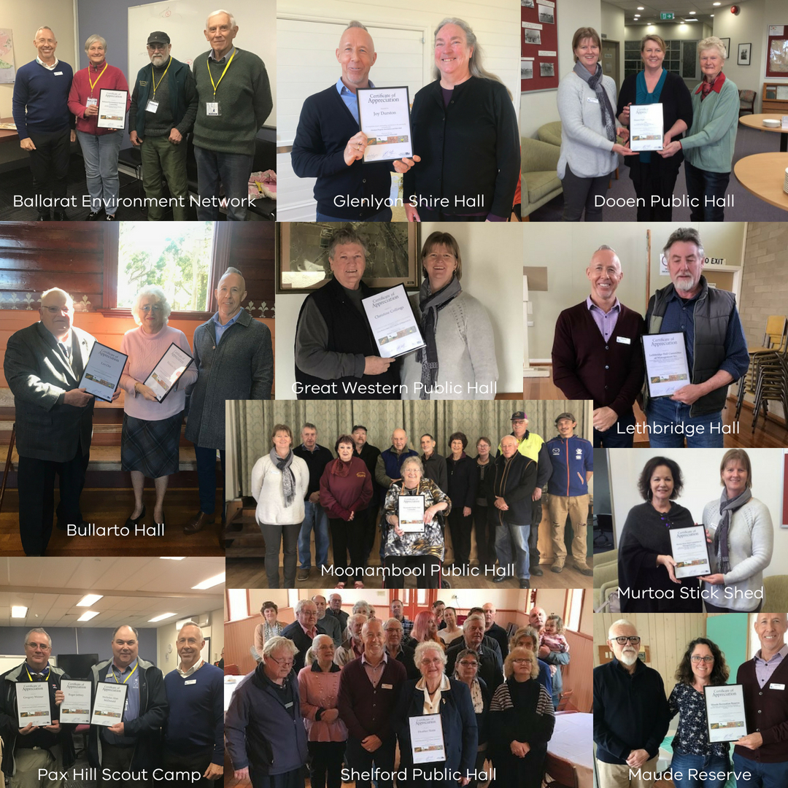

Rhonda McNeil, Program Manager, Land and Built Environment in the Wimmera said: "Something that stood out for me was that each of these committees had once again reinvented the purpose of their facility to fit the needs of the current community.
Moonambel Hall committee held an 80th celebration last year, but what I saw [as] their true success was the diversity in their committee and their willingness to look for new uses. The hall has a regular user of the Moonambeel Theatre Company.
Christine Collings from the Great Western Hall committee has worked tirelessly for many years to keep the doors open and affordable to community groups. In particular they hold 4 craft markets a year to help cover the costs of operating the hall so the costs to community groups hire is kept affordable.
Murtoa Stick Shed committee have taken on an incredible responsibility of a facility that is one of a kind in the state. They are continually looking at ways to increase use and recognition of this unique asset.
Dooen Hall committee rallied five years ago around a hall that was very close to the end of its life and by getting various groups and funding they have made the hall into a very useable community space."

Community’s tough decision Sea Lake Mechanics Institute and Free Library Reserve, Loddon Mallee Region
The Sea Lake Mechanics Institute and Free Library has stood as a community meeting place since 1924 and was built as a war memorial and originally called the Sea Lake Soldiers Memorial Hall.
In recent times, through infrequent use, the hall began to fall into disrepair. Asbestos and building audits were conducted and these found that the building in its current state was beyond safe use. The local committee of management, Sea Lake Mechanics Institute and Free Library Incorporated, in conjunction with DELWP had the task of assessing options for future use of the hall.
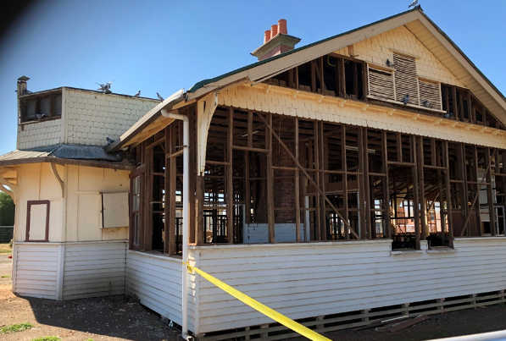
After extensive consultation with the community and investigation into the possibility of renovation which would come at a significant cost, it was decided that the hall would be demolished. This was a very difficult decision for the community and one that was not taken lightly.
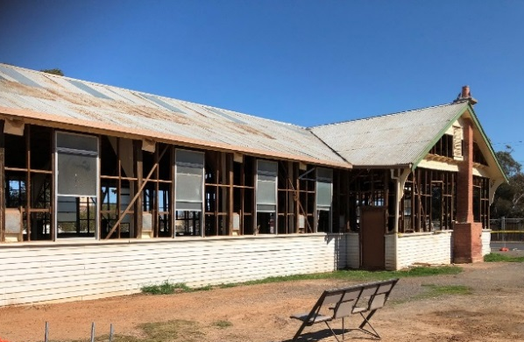
The Sea Lake RSL will still occupy the rear of the reserve and proposals from the community consultation included providing an upgraded front and toilets to the RSL building with a memorial garden located where the hall used to be. These proposed works are subject to securing appropriate funding.
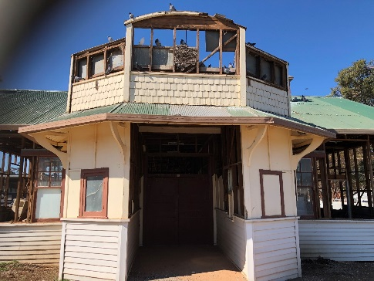
Approximately $90,000 of DELWP Public Safety on Public Land funds were granted to the committee for demolition works, which are currently underway.

Cowwarr Recreation Reserve shining bright with upgrades, Gippsland Region
A new-look reserve was officially unveiled in August 2018 with the help of DELWP’s Community Managed Places fund and Solar on Public Buildings project.
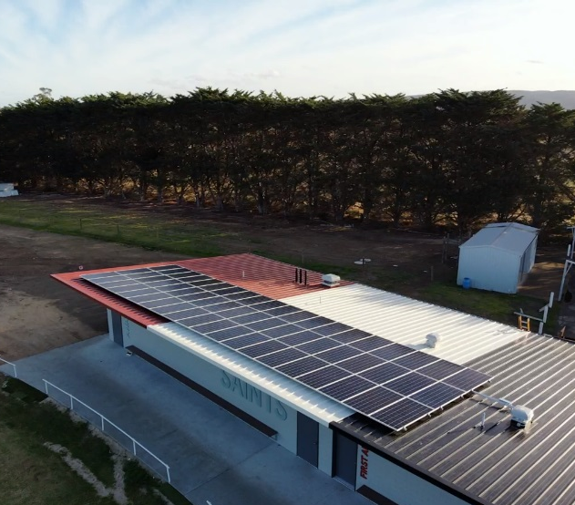
The upgrades include new unisex home-and-away change rooms, trainers’ change rooms, umpires’ change rooms, and male, female and family friendly amenities.
Cowwarr is the first of nine reserves to be upgraded under the state government's $5 million Community Managed Places fund for Gippsland sporting venues. This program is part of the $85 million package of sport and community infrastructure being implemented to support Latrobe Valley communities.
At the unveiling event, Gippsland Regional Director Steve Chapple announced funding for another eight reserves: Traralgon, Glengarry, Monash, Gormandale, Heyfield, Maryvale, Willow Grove and Ronald Reserve.
Grant name | Purpose | Amount | Key dates | Website
Victorian Heritage Restoration Funds | Restoration works to places of identified historical significance under a heritage overlay in the City of Melbourne, City of Yarra, and City of Ballarat. | Assessed on case by case basis | Various dates – see their website | http://www.vhrf.org.au/
Melbourne Water Corridors of green funding | To improve river health through the corridors of green program. | Up to $20,000 | Ongoing | https://melbournewater.smartygrants.com.au/corridorsofgreen
Recreational Fishing – Small Grants Program | To support actions or programs which aim to boost participation in recreational fishing and related activities. | Up to $5,000 | Ongoing | http://agriculture.vic.gov.au/fisheries/recreational-fishing/recreational-fishing-grants-program/small-grants-program
Inspiring Environmental Solutions community funding program – EPA | To enhance the environment in a public place, or undertake environmental activities for the benefit of the community. | Varies | Ongoing | http://www.epa.vic.gov.au/our-work/programs/inspiring-environmental-solutions
Corangamite CMA Waterways Protection Program 2016-2020 | To improve ‘priority waterways’ via a range of on ground actions. |  | Contact for further information | http://www.ccma.vic.gov.au/What-we-do/Community-Funding-/Waterways-Protection-Program-2016-2020.aspx
Renewable Communities Program | To support the delivery of implementation ready community led renewable energy project/s. | Up to $1,000,000 | Closes 1 Oct 2018 | https://www.energy.vic.gov.au/renewable-energy/community-energy
Melbourne Water Community Grants program | Melbourne Water offer grants annually to volunteer community groups to support them to deliver waterway improvements on public land. | Support grants up to $1,000 and Project grants up to $20,000 | Closes 15 Oct 2018 | https://www.melbournewater.com.au/community-and-education/apply-funding/community-grants-program
Cemetery Grants | Established to provide funding as a contribution to the cost of cemetery infrastructure, amenities, maintenance, equipment and training. |  | Closes 31 Oct 2018 | https://www2.health.vic.gov.au/public-health/cemeteries-and-crematoria/grants
Multicultural Community Infrastructure Fund | Offers grants to culturally diverse communities across Victoria to support the building, upgrading and fit out of community infrastructure. | Small grants: $500 to $100,000  Large grants: 100,001 to $750,000 | Closes 22 Feb 2019 | https://www.multicultural.vic.gov.au/grants/apply-for-a-grant/multicultural-community-infrastructure-fund
Boating Safety and Facilities Program | Funding available for Boating infrastructure and Master Planning for significant boating projects. |  | 2017-18 round will open soon | https://transport.vic.gov.au/ways-to-travel/ports-and-freight/boating-safety-and-facilities/
Share your stories in Edition 15!
DELWP is seeking contributions for Edition 15, and any feedback on the frequency and content of the newsletter.
Please send any comments, suggestions or articles and photos to voluntary.committees@delwp.vic.gov.au

