VOLUNTARY COMMITTEES OF MANAGEMENT NEWSLETTER



## Voluntary Committees of Management Newsletter- Edition 7

# VOLUNTARY COMMITTEES OF MANAGEMENT NEWSLETTER

Edition 7

 EDITION 7- September 2014

*FOREWORD*

Welcome to the seventh edition of the Voluntary Committees of Management Newsletter. Our theme for this edition is *celebrating achievements*. We look at successful projects and profile a long serving member in order to recognise the valuable contribution of committees and their members.

This edition also strives to promote and improve communication between DEPI and committees of management. I encourage all committees to engage with DEPI and each other through all forms of communication, including social media to facilitate a collaborative and inclusive approach to managing public land in Victoria.

On behalf of DEPI and all Victorians, I thank and congratulate you for your dedication and contribution to your committees and to managing Victoria’s valuable public land.

**Peter Beaumont**

Executive Director Land Management Policy

Social Media at DEPI

DEPI has numerous social media channels which are a great tool when communicating or engaging with your communities.

DEPI has recently published an induction to committees of management video targeted towards smaller committees on YouTube. The online induction program was developed in consultation with committees and the regions and delivers essential information for committee members in an easy to follow, quality presentation. The presentation is designed for appointees to view before their first committee meeting and can be accessed here: <https://www.youtube.com/watch?v=RIW9BEvUQyM>

Each of DEPI’s regions has a Facebook page. We invite all committees of management to engage with these pages using the links provided below.

For more information on social media at DEPI and links to DEPI’s twitter, Instagram, YouTube and Flickr pages: <http://www.depi.vic.gov.au/about-us/media-centre/social-media>

For all information provided by DEPI to committees of management: [www.depi.vic.gov.au/coms](http://www.depi.vic.gov.au/forestry-and-land-use/managing-land/managing-crown-land)

Peter Beaumont

C:\Users\SPF\Documents\TMC\DEPI\To mod\DEPI_RGB_right.png

**Port Phillip:** <https://www.facebook.com/DEPIPortPhillip> **Gippsland:** <https://www.facebook.com/DEPIGippsland> **Barwon South West:** <https://www.facebook.com/DepiBarwonSouthWest> **Grampians:** <https://www.facebook.com/DEPIGrampians> **Hume:** <https://www.facebook.com/DEPIHume> **Loddon Mallee:** <https://www.facebook.com/DEPILoddonMallee>



## Voluntary Committees of Management Newsletter- Edition 7



150 Years of Volunteering

# Electricity Safety (Bushfire Mitigation) Regulations 2013

On 20 June 2013, new Electricity Safety (Bushfire Mitigation) Regulations 2013 came into effect. The Act provides for amendment of the Electrical Safety Act 1998 and changes are designed to improve the effectiveness and efficiency of regulatory arrangements for mitigation of bushfire risk in relation to electricity assets. The key impact of these changes for committees of management is removal of responsibility for keeping trees clear of power lines. This responsibility will now fall to distribution companies. For more information on these changes or to view the Act: <http://www.esv.vic.gov.au/Legislation-Regulations/Recent-changes-and-updates>

The eight members of the former Harcourt Recreation Reserve Committee of Management have collectively volunteered for over 150 years, with a number of members having served upwards of 30 years on the committee. The reserve is now managed by Mount Alexander Shire Council, however the achievements and contribution of the committee over the last 30 years were recognised both on Australia Day and at a morning tea held by DEPI and Mount Alexander Shire Council. The committee successfully maintained the pavilion and oval, upgraded facilities in accordance with community demand and managed hire and usage allocations of facilities. Congratulations and thanks go to Ray Rice, John Jenkin, Tyrone Rice, Norman Jenkin, Jane McLean, Rod Watson, Neil Charter and Des Rice for your outstanding work!

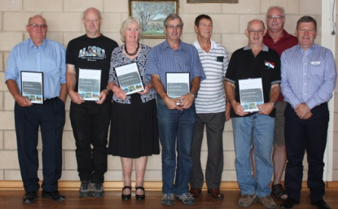

Enjoying this newsletter? Want to contribute to Edition 8?

Do you have an article or a photograph you would like included in the next newsletter? DEPI is seeking contributions for edition 8 and would also welcome any feedback on the frequency of the newsletter and its content. Please send any comments, suggestions or articles and photos to [hannah.sealey@depi.vic.gov.au](mailto:hannah.sealey@depi.vic.gov.au).



C:\Users\SPF\Documents\TMC\DEPI\To mod\DEPI_RGB_right.png



## Voluntary Committees of Management Newsletter- Edition 7

# Lake Marma Committee Of Management: Reflections on the First Triennial Term

Lake Marma Committee of Management is nearing the end of its highly successful first triennial term as manager of Lake Marma Public Park and Gardens Reserve. It is therefore an ideal time to reflect on the committee’s achievements.

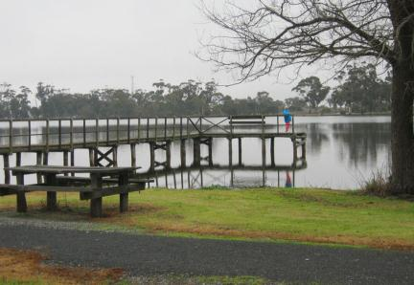Lake Marma Reserve is of local significance as an important recreational facility. The serene aesthetics make the reserve a valuable piece of public land enjoyed by residents of Murtoa and the surrounding district. Over the years many community facilities have been constructed on the reserve including a caravan park, tennis courts, a Country Fire Authority (CFA) training track, a public swimming pool, picnic amenities, a scout hall, playground equipment and boating and fishing infrastructure.

Lake Marma reserve is also known for its mass planting of sugar gums which is believed to be the first known designed mass planting of native trees in Victoria. Furthermore, the reserve is home to a 1920 World War I memorial arch and gate, a 1907 band rotunda and the 1895 Sprott Fountain, all of which are included in the Yarriambiack Shire Council’s Heritage Overlay.

Historically, management of the reserve was split between Grampians Wimmera Mallee Water Authority (GWMW) and Yarriambiack Shire Council. In 2010, the Wimmera Mallee

stock and domestic pipeline was constructed and replaced the largest open channel system in the southern hemisphere. As a result, Lake Marma was no longer required for the supply of water. This drew interest from the community and led to the review of the existing management arrangements of the reserve by DEPI in conjunction with council and the water authority. Subsequently, Lake Marma Committee of Management was appointed as manager of the reserve.

Over the past three years, the committee have been successful in obtaining a number of grants including a DEPI Flood Recovery for Community Infrastructure Fund to replace flood damaged tennis courts, a regional development Victoria grant for major revitalisation works, a DEPI fisheries grant for upgrade of boat ramp facilities and a DEPI Public safety on Public Land grant for public hazard mitigation works. Proactive and enthusiastic support from Yarriambiack Shire Council and local community organisations have also contributed to further develop Lake Marma as an important recreational and tourism attraction for the township of Murtoa.

C:\Users\SPF\Documents\TMC\DEPI\To mod\DEPI_RGB_right.pngOne of the first tasks facing the committee was negotiating a licence agreement with GWMW for the township’s water supply tower, located within the reserve. A favourable outcome was achieved and provides the committee with a means of maintaining finances which is crucial to the ongoing management and development



## Voluntary Committees of Management Newsletter- Edition 7

Lake Marma Committee Of Management continued…

of the reserve. The committee also negotiated with the water authority as to the future of a

decommissioned water supply pump-house and the Murtoa Angling club, originally earmarked for demolition, has been refurbished as a clubhouse.

Additional significant projects carried out by the committee in their first three year term include working closely with DEPI’s Fisheries Department to facilitate regular fish stocking, construction of a new fishing platform, restoration of wetlands through de-silting and creation of wildlife habitat and working with Transport Safety Victoria to be appointed as the waterway manager over the lake. And construction of a new fishing platform.

It has been a busy and productive three years for Lake Marma Committee of Management. They have transformed a tired and underutilised reserve into a vibrant asset for the local community. The department commends them for their enormous efforts and wishes them every success in the coming years.

A few photos

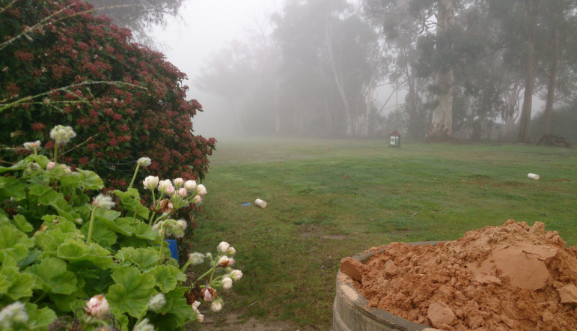

Above: Yackandandah Golf and Recreation Reserve during winter

Above: Cattle grazing/ lawn mowing at the Winslow Recreation Reserve

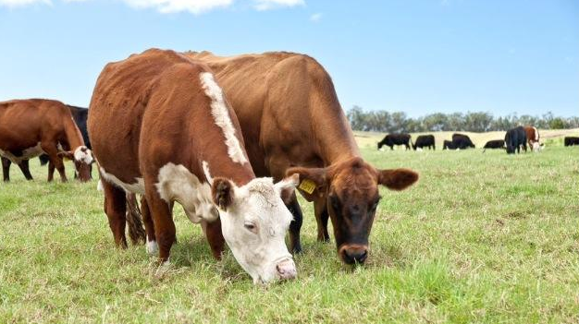

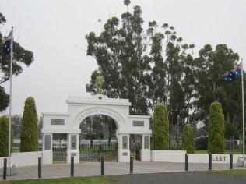

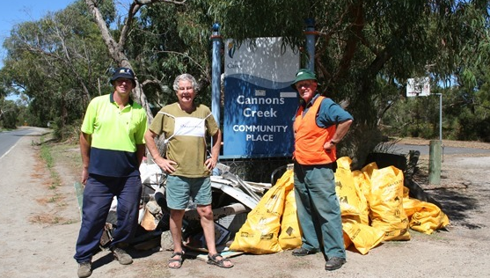

Above: Members of the Cannons Creek Community Place Committee of Management hard at work



# Certificates of Insurance

Public liability, professional indemnity and personal accident insurance for Committees of Management of Crown land reserves is provided by DEPI through the Victorian Managed Insurance Agency. The annual certificates of insurance for the 2014-15 financial year are now available for committees to download from the Committee of Management page on the DEPI website here: <http://www.depi.vic.gov.au/coms>



## Voluntary Committees of Management Newsletter- Edition 7

Chiltern Grandstand Restoration

In June this year, the member for Benambra, Bill Tilley, officially opened the 147 year old historic grandstand at the Chiltern Recreation Reserve. The grandstand was first built atop the former site of the Alliance Company Gold Mine in 1879 and is now the oldest surviving grandstand of its kind in Victoria.

When the project began, “the grandstand was in bad shape” according to a member of the Chiltern Recreation Reserve Committee of Management, Joy Lee. A DEPI Public Safety on Public Land grant of $25,900 was contributed to the cost of the first stage of the project which involved ensuring the structure was kept standing and safe. Collaboration between a number of other organisations and members of the community, including Indigo Shire, Chiltern Tourism and Development Inc., heritage builder Darryl McCormack, several local tradespersons and the Chiltern Recreation Reserve Committee of Management resulted in the successful completion of the project. The committee of management have since been recognised at the Indigo Heritage Awards with the ‘Restoration of a Heritage Place Award’.

The total cost of the project was approximately $50,000 and the committee of management are now seeking to have the grandstand placed on the Victorian Heritage Register. The completion of this project has reinforced the cultural significance of the structure through its link with the town’s early mining roots and will contribute to the value of the recreation reserve which forms the lifeblood of small C:\Users\SPF\Documents\TMC\DEPI\To mod\DEPI_RGB_right.pngcommunities such as Chiltern with long-standing traditions in country racing, football, netball and cricket.

The restoration of the Chiltern Grandstand provides an excellent example of all that can be achieved when committees of management and DEPI work together with partners and local communities. The end result in this case is

fantastic, providing the local community with an opportunity to flourish and an important local asset. DEPI congratulates the Chiltern Recreational Reserve Committee of Management on achieving such an outstanding outcome.

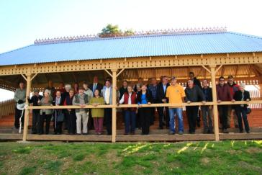

Got a great project planned but no money to fund it? With the right grant, your project could become a reality…

A number of government bodies offer funding for projects that protect and enhance biodiversity, repair and conserve heritage places and objects, improve fishing and boating facilities, upgrade access to sporting grounds, or include general community works. It can be hard to know where to look for these grants so we have compiled a short list of opportunities and links to grants you may be eligible for on the next page.

|  |  |  |  |  |
| --- | --- | --- | --- | --- |
| Grant name | Purpose | Amount | Key dates | For More Information: |
| Victoria’s Heritage Restoration Fund | Repair/ conservation of Victorian Heritage registered objects/ places | 5k-200k | Closes 27/02/2015 | **W:**  <http://www.vhrf.org.au/> |
| ANZAC Centenary Major Grants Program | projects which commemorate, honour and remember the service and sacrifice of Victoria's World War I veterans and their communities | 20k- $100k | Ongoing | **W:**http://www.dpc.vic.gov.au/index.php/veterans/veterans-grants/anzac-centenary-major-grants-program |
| Victorian Veteran’s Council ANZAC Centenary Community Grants program | Preservation of WW1 history | Up to $20k | Closes 21/10/2014 | **W:**http://www.dpc.vic.gov.au/index.php/veterans/veterans-grants/victorian-veterans-council-anzac-centenary-community-grants-program |
| Community Infrastructure Fund | Delivering liveable communities and neighbourhoods in precincts likely to experience population growth | Up to 1M | Ongoing | **W:** http://www.dpcd.vic.gov.au/home/grants/all-grants/community-infrastructure-fund |
| Country Football and Netball Program | Assist country football and netball clubs, associations, umpiring organisations to develop facilities | Up to 100k | Ongoing | **W:** http://www.dpcd.vic.gov.au/home/grants/all-grants/country-football-and-netball |
| Recreational Fishing Grants Program  -Small Grants  -Large Grants | Improvement of public recreational fishing | Small: up to 5k  Large: 5k- 100k | Small: Ongoing  Large:  Opens 1/10/2014 | [**W:** http://www.depi.vic.gov.au/fishing-and-hunting/fisheries/recreational-fishing-grants-program](W:%20http://www.depi.vic.gov.au/fishing-and-hunting/fisheries/recreational-fishing-grants-program)  **P:**(03) 9658 4779  **E:** rec.fishinggrants@depi.vic.gov.au |
| Restoring Community War Memorials and Avenues of Honour Grants Program | Restore/ improve local war memorials, honour rolls, avenues of honour | Up to 20k | Ongoing | **W:**http://www.dpc.vic.gov.au/index.php/veterans/veterans-grants/commemorative-grants-restoring-war-memorials-and-avenues-of-honour |
| Local Landscape Enhancement Grants | New grants program to help community groups improve their local environment, increase people's environmental knowledge and encourage people to enjoy their local area. | Up to 50k | Closes 15/09/2014 | **W:** http://www.depi.vic.gov.au/environment-and-wildlife/community-programs/LLEG-program |
| Food & Fibre Marketing Cooperatives Grant  For all grants, more information can also be obtained by calling the Grants Info Line on **1300 366 356** between 8.30 am and 5.00 pm Monday to Friday (excluding public holidays).   * **Federal government grants:**  http://www.business.gov.au/grantfinder/grantfinder.aspx * **Grants Victoria:** http://www.vic.gov.au/grants.html | Encourage the establishment of cooperative groups of farmers and value chain participants, using the collective capability of the groups to generate better access to markets and customers for the products of their food and fibre activities | Up to 50k | Closes 30/06/2015 | **W:** http://www.depi.vic.gov.au/agriculture-and-food/food-and-fibre-industries/food-and-fibre-marketing-cooperatives-grants |

**List of Available Grants**

C:\Users\SPF\Documents\TMC\DEPI\To mod\DEPI_RGB_right.png