|  |
| --- |
| FACT SHEET: ENERGY |
| VICTORIAN BUDGET 2017/18 |

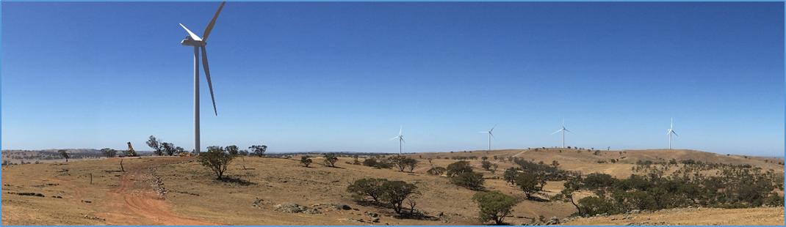

The Andrews Labor Government has committed **$122 million** in the 2017/18 Victorian Budget to help modernise our energy system and maintain an affordable energy market for all Victorians.

## The funding provides:

* **$38.6 million** for renewable energy purchasing and **$9.5 million** to power Victoria’s tram fleet with solar energy;
* **$29.4 million** for initiatives that promote and achieve energy efficiency, including:
  + The *Home Energy Assist* package to upgrade the energy efficiency of homes of over 3,300 Victorians, helping them manage energy bills;
  + improvements to poorly performing residential and commercial buildings;
  + broadening the Victorian Energy Efficiency Target scheme;
  + new financing models for investment in energy efficiency and renewable energy projects; and
  + upgrades to the *Victorian Energy Compare* website.
* **$15.8 million** for smart systems and microgrid projects;
* **$5 million** for an energy storage initiative to develop utility-scale energy storage projects;
* **$12.9 million** to support reforms and advocacy to the National Energy Market to ensure Victorian consumer interests are represented, particularly as the energy sector undergoes major transformation; and
* **$10.8 million** to minimise energy costs for consumers, including the ongoing delivery of the *Victorian Energy Compare* tool and an associated consumer awareness campaign, a concept study to deliver an energy data hub to significantly increase consumer and third-party access to energy data and a pilot energy brokerage service to support hardship and culturally diverse consumers.

We know our energy sector is undergoing a significant transformation, so it is important to ensure we move toward a modern, renewable, affordable and reliable energy system.

As a Government, we are committed to managing this change and establish Victoria as Australia’s leader for energy efficiency and renewable energy.

We are modernising our energy system by making it more diverse, flexible and responsive, and therefore more resilient, affordable and secure.

## Creating jobs

Our solar trams initiative alone will deliver **$150 million** in new capital investment **and 300 new jobs** in regional Victoria.

Our energy efficiency initiatives will support **432 new jobs** in energy efficiency services and other Victorian industries.

More broadly, realising our commitment to increase renewable energy generation to 25 per cent by 2020 and 40 per cent by 2025, we will deliver up to **$9 billion** in new capital expenditure and deliver **11,000 energy sector jobs.**

## Building on momentum

This budget builds on the **$25 million** already announced to support large-scale energy storage initiatives across Victoria, creating jobs, protecting affordability and maintaining the reliability of our energy grid. *($5 million of this $25 million is listed in the 2017-18 Budget, on the previous page).*

The **$900,000** *Pilot Community Power Hubs* program, announced earlier this year, will assist Ballarat, Bendigo and the Latrobe Valley communities access the skills and expertise to develop and deliver community-based renewable energy projects. Sustainability Victoria will deliver the pilot program.

Through the **$5 million** Latrobe Valley Home Energy Upgrades program we will deliver (at no cost to households) home energy assessment, energy efficiency upgrades and/or installation of rooftop photovoltaic systems to up to **1,000 vulnerable households** in the Latrobe City, Wellington and Baw Baw local government areas during 2017 and 2018.

This year’s budget also builds on the **$24.2 million** across three years for *Saving Energy, Growing Jobs and* **$12 million** for *Driving Growth in Renewable Energy from the* 2016-17 Budget and the **$20 million** *New Energy Jobs Fund*, announced as part of the 2015-16 Budget.

## Find out more

[www.delwp.vic.gov.au/energy](http://www.delwp.vic.gov.au/energy) outlines the latest policies, consultations and openings for tender processes.

**Boosting Business Productivity** delivers grants to industry to help them cut energy costs and reduce greenhouse emissions. The program is open for businesses throughout the year.

Visit: [sustainability.vic.gov.au](http://www.sustainability.vic.gov.au) or

phone 1300 363 744

**Residential Efficiency Scorecard** will enable you to obtain a star rating for your home. As more accredited assessors come on board throughout 2017, availability of assessments will increase. Register interest at:

[victorianenergysaver.vic.gov.au/residential-efficiency-scorecard](http://victorianenergysaver.vic.gov.au/residential-efficiency-scorecard)

**Help for cutting power bills:**

For deals and incentives for energy efficient products and appliances for home and business visit:

victorianenergysaver.vic.gov.au/more-ways-to-save/energy-saver-incentive

Compare energy deals independently at *Victorian Energy Compare* www.vic.gov.au/victorianenergycompare

*Home Energy Assist: Affordable Upgrades* will be rolled out progressively in 2017-18.

Register for updates at

[delwp.vic.gov.au/energy/making-home-energy-more-affordable](http://delwp.vic.gov.au/energy/making-home-energy-more-affordable)

Register your interest in the *Latrobe Valley Home Energy Upgrades Program* at www.lva.vic.gov.au

|  |  |
| --- | --- |
| © The State of Victoria Department of Environment, Land, Water and Planning 2017  LogoThis work is licensed under a Creative Commons Attribution 4.0 International licence. To view a copy of this licence, visit http://creativecommons.org/licenses/by/4.0/ |  |