www.delwp.vic.gov.au

Ministerial Visit
Timor-Leste
March 2017

Hon Richard Wynne MP
Minister Responsible for the
Relationship with Timor-Leste

The Governments of Victoria and Timor-Leste share a long-standing relationship based on friendship and mutual respect. This relationship recognises the significant Timorese population in Victoria of more than 10,000 people, the largest outside Timor-Leste. There has been bipartisan support for this relationship from successive State Governments since Timor-Leste’s independence in 2002.

Minister Richard Wynne is currently responsible for the relationship between the Victorian Government and Timor-Leste, and the travel was aimed at maintaining our good relations, as well as announcing funding initiatives in Balibo. Meetings were held with senior governmental representatives including the Prime Minister and Minister of State Administration, as well as Australia’s Ambassador to Timor-Leste.

Insights from the visit are being used to inform future government-to-government activities, including training and work placement programs. The Victorian Government is seeking to refine the relationship to better align with the Timor-Leste Government’s strategic plan for the next 30 years, offering support where it can be of most benefit.

Meeting with Prime Minister Dr Rui Maria de Araújo

On arrival in Dili on Monday evening, March 13, the delegation met the Prime Minister, His Excellency Dr Rui Maria de Araújo. Minister Wynne was accompanied by former Victorian Premier, the Hon Steve Bracks AO, who has done a great deal of work in Timor-Leste in the past decade to assist with establishing good governance processes following independence in 2002. The long-term relationship between the Victorian Government and Timor-Leste was discussed, as well as the Minister’s upcoming visit to Balibo, where funding for a small conference facility and a local dental program would be announced.

The Prime Minister talked about the need to diversify the Timor-Leste economy from farming to other activities, including construction and tourism. The Prime Minister also noted that more public service reform and fiscal reform was needed. He spoke positively about the “friendly and constructive” relationship with the Victorian Government and the municipal agreements between Victorian councils and municipalities in Timor-Leste.  There was discussion around renewing the Memorandum of Understanding (MOU) between the Victorian and Timor-Leste Governments, with an updated MOU well progressed. As there are parliamentary elections in Timor-Leste in July this year, it’s planned the signing will be done under its new Government. The Prime Minister noted the MOU will marry with Timor-Leste’s Strategic Development Plan, which sets out priorities for the next 30 years. | 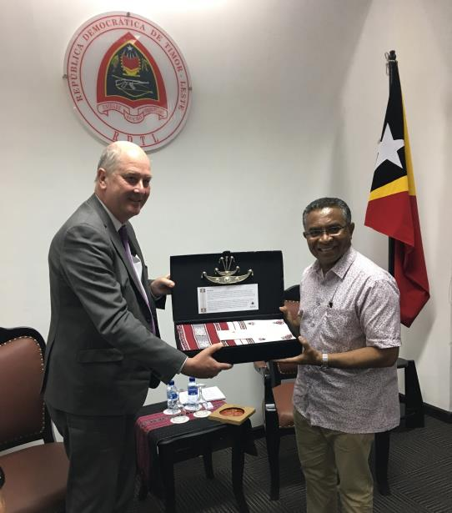  Minister Wynne with Prime Minister H.E. Dr Rui Maria de Araújo

Sanitation and waste management was also a topic of discussion, as there is a continuing need for clean drinking water to reduce disease and high rates of infant mortality. Melbourne Water and Yarra Valley Water have provided some technical expertise in Timor-Leste in the past and Minister Wynne undertook to investigate future opportunities for cooperation. The Prime Minister discussed using irrigation more effectively and making best use of the land available – he noted that more industrialised production mechanisms are needed to increase production. Rice is currently being imported from Vietnam and Cambodia, whereas the capacity to provide more rice in Timor-Leste to meet demand is there. There was an agreement made to talk to the Water Minister, Lisa Neville, on return, to discuss opportunities for practical support.

The Director General of Urban Organisation, Miguel de Carvalho was also present at the meeting, and discussed rubbish collection and treatment. He noted it is a considerable problem, however the Timor-Leste Government is working on a plan to place communal containers (centralised skips) along the 175 kms of road around Dili. Related discussions noted the Victorian Government, possibly through Melbourne Water, could consider support in this area.

The Municipal Partnership Program was also discussed, through which 15 Victorian councils are partnered with 11 Timorese municipalities. The discussion noted recent study visits and training and work placement programs hosted by the Victorian Government in partnership with Victorian councils, which are focussed on building skills in municipal administration and related services such as land use planning and waste management. The Prime Minister talked about the ultimate aim of decentralisation as providing municipalities with their own budgets for goods and services, and for minor capital works programs. There was also discussion around land titles, given current difficulties for local municipalities in establishing a tax base.

There was general agreement to continue to consolidate the relationship between the Victorian and Timor-Leste Governments, including through exchange programs and sharing of information and support.

Meeting with Andrew and Alice Mahar

On Tuesday morning March 14, the delegation met Andrew Mahar and his daughter Alice, who are involved with the Xpand Foundation, a group that is doing several social entrepreneurial projects in Timor-Leste involving tree planting for carbon off-set, coffee growing and providing computers to schoolchildren. There are links with the Victorian Government, councils and community groups in Melbourne and regional areas.

Andrew discussed his scheme WithOneSeed, which encourages local farmers to plant trees as a long-term investment with environmental benefits. In 1975, 75 per cent of East Timor was covered with forest – following the Indonesian occupation it’s now 30 per cent. Andrew advises that the Xpand Foundation is encouraging planting, and paying the East Timorese 50 cents per tree per year - if they plant 500 trees, they will receive US$250. This program will run over 30 years and it’s aimed at small land holders. He notes the program is internationally certified by the Gold Standard Foundation. WithOneBean is selling carbon credits into the trading market; there are 10,000 credits at present, with an aim of 500,000 in 30 years. Andrew is keen to talk to Sustainability Victoria around buying carbon credits and we agreed to raise this at a ministerial office and departmental level on our return.

Andrew expects the project to plant 600,000 trees in the next 20 years. Of 110,000 that have been planted to date, 85,000 have survived. There are now 13 village based nurseries and an education process underway with the local communities. Noting DELWP’s forest management role, the department will consider opportunities to contribute expertise to the project.

Andrew also talked about Info Timor – this is an exchange where reconditioned computers are brought to Timor to assist schoolchildren, employing 35 staff. Info Timor currently processes about three containers of used IT equipment per year, mostly donated by the private sector. Andrew notes he is keen to expand this program if possible with the Victorian Government’s help, for example through accessing decommissioned IT equipment.
Alice Mahar then discussed WithOneBean – a coffee program where beans are sourced from a cooperative of subsistence farmers in Timor-Leste. WithOneBean allows the farmers to be paid a fair price for their coffee crop and supports education programs that increase their knowledge and skills, thereby improving their livelihoods. There are 11 tonnes being imported as roast beans to Melbourne and going to a warehouse in Clayton to be processed. The model is a cooperative involving 450 farming communities and families. The cooperative - Alter Trade Timor (ATT) - works with the farmers to bring coffee down from the mountains and the profits go to the communities and also into tree planting. They pay an above fair trade price of $3.20 per kilo. There are outlets in Melbourne, as well as Australia wide and in Singapore. Alice suggests they would like to sell the coffee to the Victorian Parliament, in departments and ministerial offices and Minister Wynne says this will be followed up at a departmental and ministerial office level.

The coffee industry is Timor-Leste’s second largest industry, generating $26 million per year for the local economy.

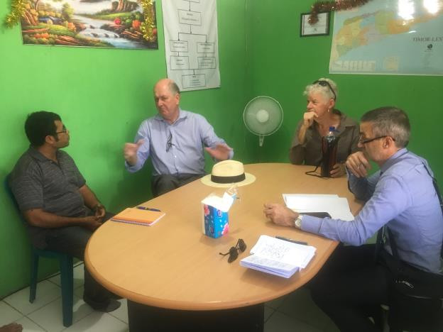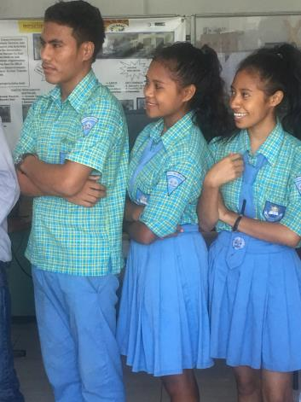
Minister Wynne with Andrew Mahar and Graeme Emonson (Executive Director Local Government Victoria) meeting with Sr Evangelino Monterra from WithOneBean; local students at Info Timor

Meeting with Australia’s Ambassador to Timor-Leste, Peter Doyle

Following the meeting with Andrew and Alice Mahar, the Minister paid a courtesy call on the Australian Ambassador to Timor-Leste, Peter Doyle. The importance of the Victorian Government and Timor-Leste relationship was discussed and Minister Wynne described how the greatest population outside Timor-Leste is in Melbourne.
Ambassador Doyle shared his insights from being based in Timor-Leste over recent years. He also commented on the degree of structure and the thoughtful approach to Timor-Leste at the Victorian Government level, whilst acknowledging Victorian municipal and community level activities as being successful in assisting local Timorese communities.

Trip to Balibo

On Tuesday afternoon, March 14, the delegation travelled by car to Balibo, a journey of approximately three and a half hours. On arrival, Minister Wynne visited the Balibo Fort facility and the “Flag House” where Australian journalist Greg Shackleton painted an Australian flag in 1975, in the hope it would signify neutrality and protect him and his colleagues from the invading Indonesian forces. It was one of the last places that the Balibo Five were seen alive. The “Flag House” has been purchased and refurbished through a Trust established by the Victorian Government, and is now operated as a social enterprise, providing a community learning centre, cultural centre and small museum. A dental clinic was opened in August 2016 to improve the dental health of the local community, particularly the schoolchildren.

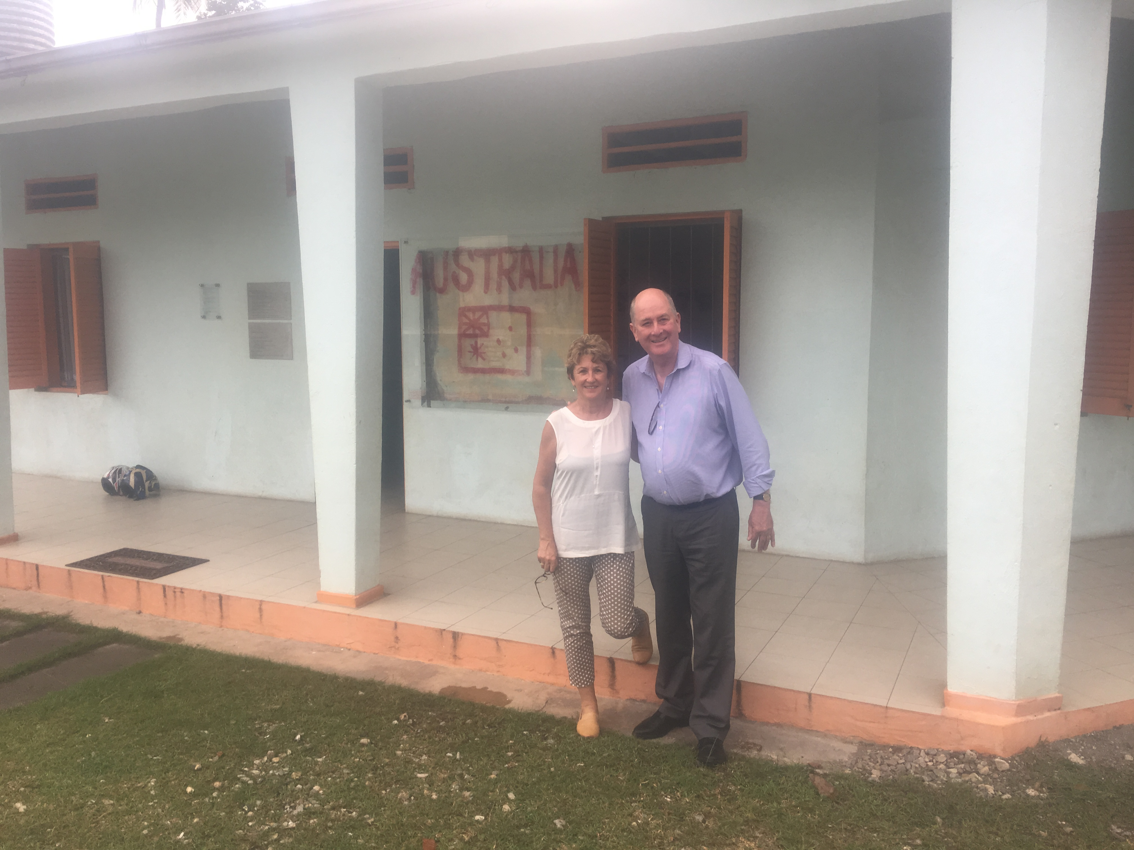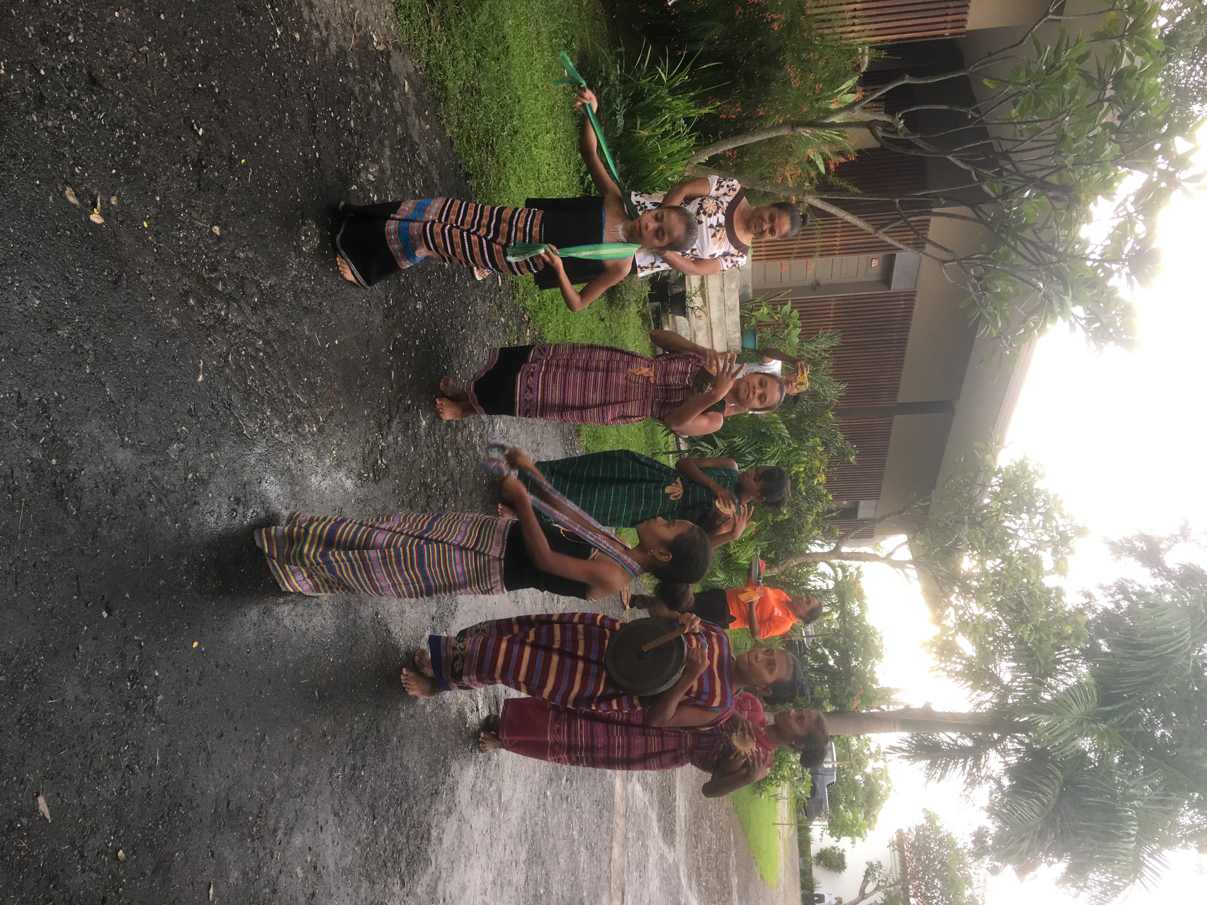
Terry Bracks (Balibo House Trust Executive Officer) and Minister Wynne at Balibo Flag House; local dancers arriving for the ceremony

On Wednesday morning, March 15, there was a ceremony to announce the Victorian Government funding, attended by the Vice Minister of State Administration, H.E. Tomas do Rosario Cabral of the Timor-Leste Government. The Chair of the Balibo House Trust, Mr Rob Hudson, was also present.

The Victorian Government is contributing $100,000 toward a conference facility at the Fort, which supports the decentralisation process by providing a high-quality meeting space for consultation and decision-making processes outside of the capital, and also contributing to local economic opportunities. Funding of $60,000 over three years was also announced through Dental Health Services Victoria, to support local dental nurses related to the new clinic at the “Flag House”.

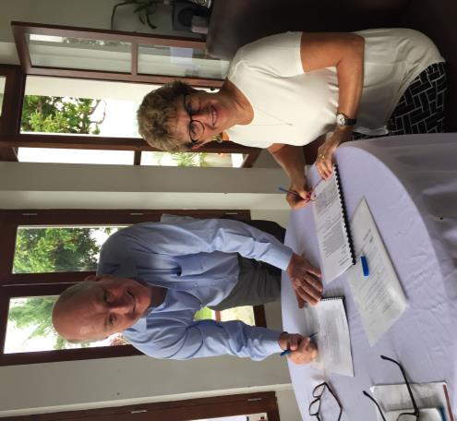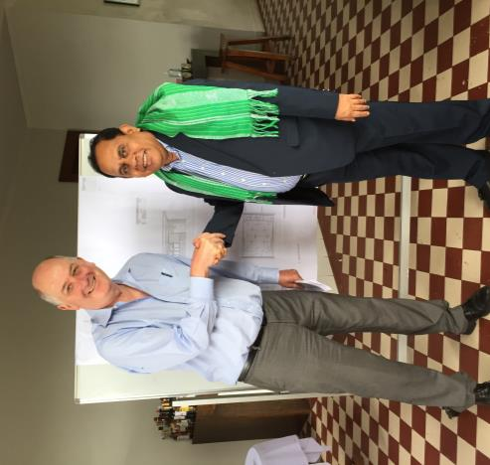
Signing the grant agreement with Terry Bracks; displaying conference facility designs with Vice Minister for State Administration, H.E. Tomas do Rosario Cabral

Vice Minister Cabral also discussed the Timor-Leste Government’s interest in redesigning an existing monument precinct in Balibo, including developing a new statue to commemorate the Balibo Five. The Ministry of State Administration noted its intention to prepare a proposal for the Victorian Government to provide technical expertise in precinct design and planning.

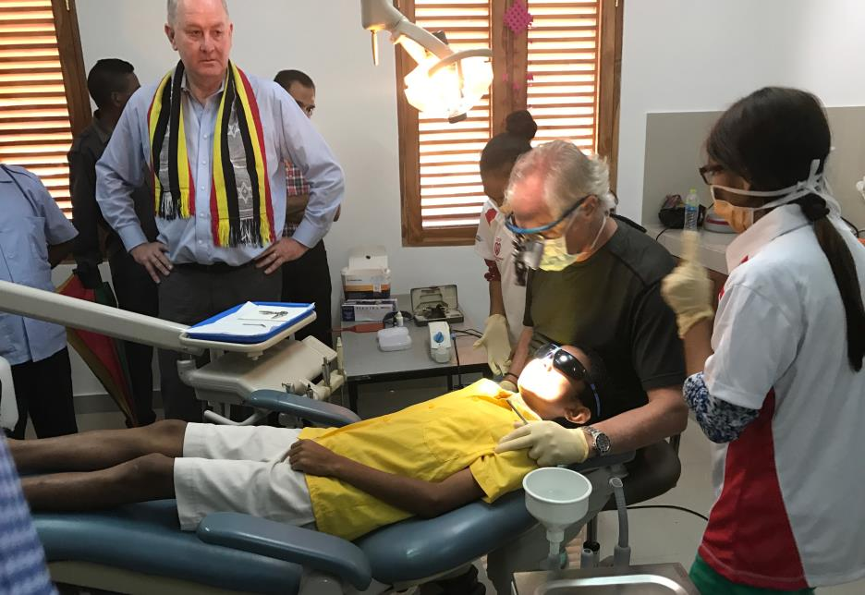
With volunteer dentists, staff and clients at the recently opened dental clinic
On Wednesday afternoon, March 15, the delegation travelled from Balibo back to Dili – there was a chance meeting with the Minister for Planning and Strategic Investment, His Excellency Xanana Gusmão, who was inspecting damage on the road along the coast outside of Dili, where monsoonal weather had caused mudslides and roadslip. The delegation stopped to speak to the Minister and there was some discussion around road engineering and safety measures to ensure vehicles could continue to pass.

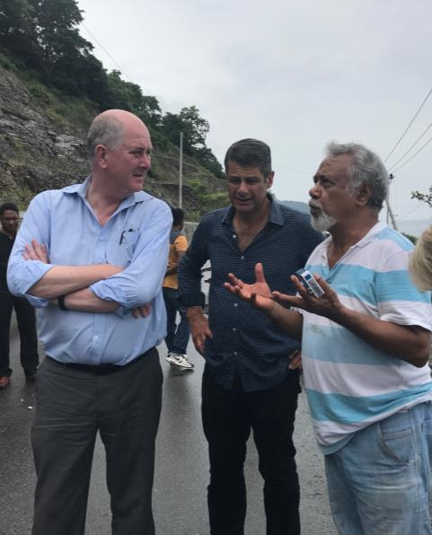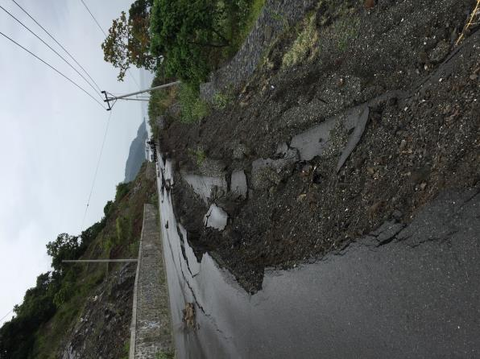
With the Hon Steve Bracks AO and Minister for Planning and Strategic Investment, H.E. Xanana Gusmão inspecting weather related road damage

Visit to community water facility in Mascarenhas, Dili

On his return to Dili, Minister Wynne met with water adviser Vasco Leitao, who runs Oasis Sustainable Projects, and representatives of the Timorese Ministry of Public Works, Transport and Communications. They took the delegation to a community in Dili - Mascarenhas - where a communal water facility for washing clothes, as well as showers and toilets, has been established. The facility was built in 2012 with some practical expertise provided by Melbourne Water. It has been a success and has been well utilised by the local community, with the support of the Chefe (village head).

Discussions pointed to a number of areas where the Victorian Government may be able to provide expertise or support, including in developing additional community water facilities, and providing expertise to support implementation of the Dili Sanitation and Drainage Masterplan. Minister Wynne confirmed he would brief Minister Neville on his return, noting her interest in visiting Timor-Leste in the near future. The Government of Timor-Leste will prepare a formal request, enabling Victoria to consider opportunities for support.
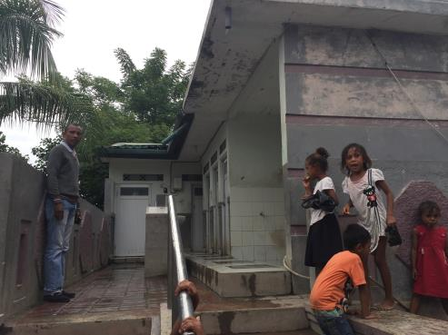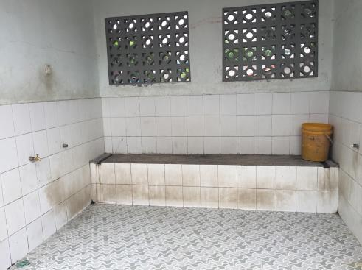
Communal water and sanitation facilities

On the evening of Wednesday, March 15, the Vice Minister for State Administration, H.E. Tomas do Rosario Cabral invited the delegation to a dinner at the Hotel Timor, which was also attended by the Hon. Steve Bracks AO and his adviser Kim McGrath.

Meeting with Minister for State Administration, H.E. Dionísio Babo Soares

On Thursday morning, March 16, Minister Wynne met the Minister of State, Coordinator of State Administration Affairs and Justice and Minister of State Administration, H.E. Dionísio Babo Soares.

The two ministers discussed the funding announced by the Victorian Government in Balibo, and the long relationship between the Victorian Government and the Government of Timor-Leste. The ministers also discussed the signing of the refreshed Memorandum of Understanding between governments, which supports a focus on the public administration reform agenda for which Minister Babo Soares is coordinating minister.

Training and work placement programs related to urban planning were also discussed, noting the successful 2016 program hosted by DELWP, and plans for a 2017 program focussed on urban planning and waste management.

Minister Soares noted that Timor-Leste is progressing towards full decentralisation, including recognition of Dili, Baucau, Bobonaro and Ermera as Municipal Authorities, having greater autonomy of local decision making. Remaining municipalities will have the opportunity to demonstrate budget and probity management in order to achieve Authority status.

Minister Soares also discussed modernisation of the public service, including a focus on staff training and recruitment methods to support career development, leadership modelling and improved communications. Minister Wynne noted the Victorian Government’s willingness to support public sector reform through the renewed MOU.

The Ministers also discussed the importance of rate bases for municipal operations, including challenges associated with land registration. Minister Soares indicated Timor-Leste’s land registration system is expected to be in place by 2018/19, with sophisticated mapping technology having identified 100,000 parcels of land, estimated as one third of the total across the country. These parcels have been registered, also enabling registration of changes of ownership.

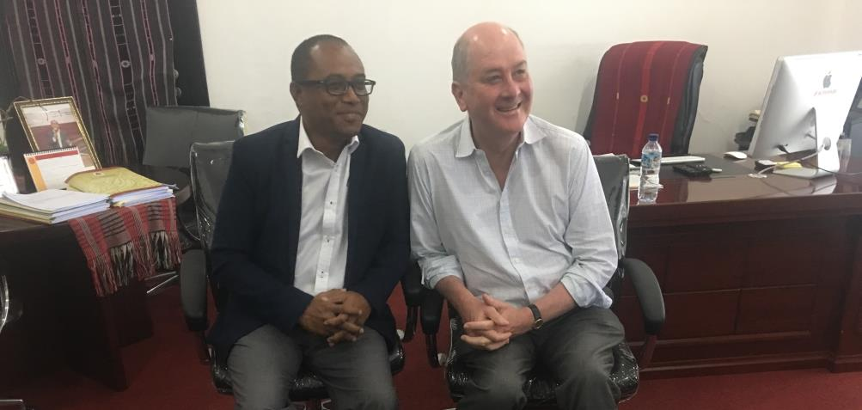
With His Excellency H.E. Dionísio Babo Soares

Visit to Tasi Tolu

On Thursday afternoon, March 16, Minister Wynne visited Tasi Tolu, on the outskirts of Dili, with representatives of the Ministry of Planning and Strategic Investment and Ministry of State Administration. The site is highly polluted, with significant (and currently unchallenged) illegal occupation of public land. It is estimated there are 1,000 illegal houses in the area (known as Tasi Tolu village). Timorese citizens have moved to Dili in search of employment, and in the absence of available land, have built houses illegally. This creates challenges for the government in relocating inhabitants, noting that earlier removal of inhabitants has resulted in occupants moving on to occupy other areas illegally. The site also has health difficulties created through contaminated water, lack of sewerage treatment and reticulation, and lack of proper rubbish collection and disposal.

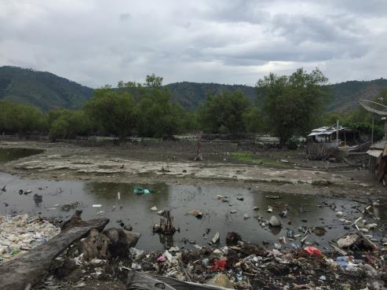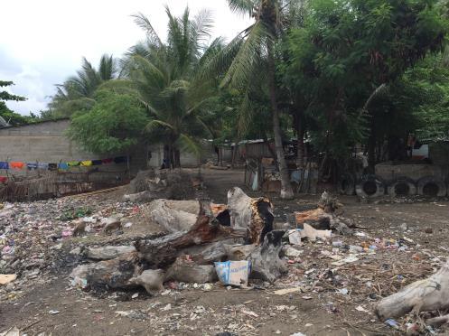
Waste and pollution issues at Tasi Tolu
Visit to the Xanana Gusmão Reading Room

On Thursday afternoon, March 16, the Minister visited the Xanana Gusmão Reading Room in Dili, which provides a library and reference service to the Dili community. It specifically targets young people whose studies have been interrupted by periods of conflict. DELWP is coordinating donations of books from Victorian libraries to the Reading Room, and the Minister presented a small sample whilst the bulk of materials are transported by ship.

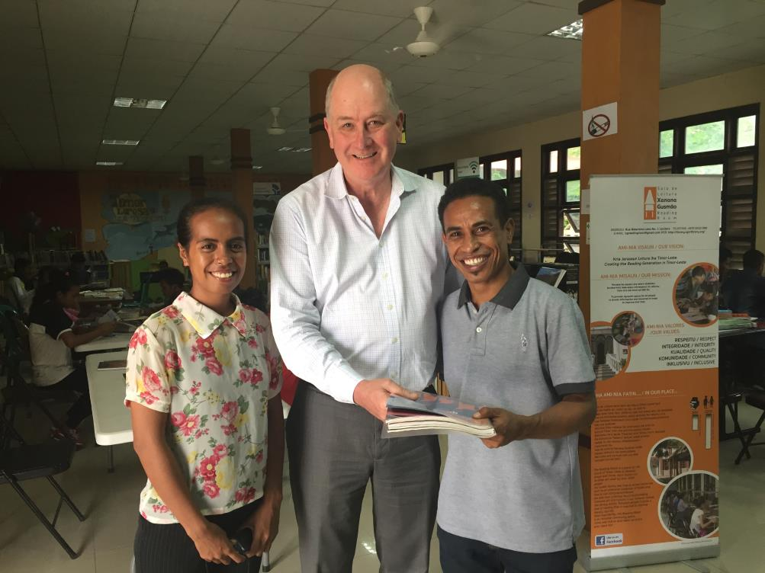
With Xanana Gusmão Reading Room staff, Maria and Gaspar

Reception for training and work placement program participants

On Thursday evening, March 16, Minister Wynne hosted a reception for participants of recent work placement and training programs hosted by the Government of Victoria, also attended by Ambassador Peter Doyle and staff, Timor-Leste’s Honorary Consul to Victoria, Rae Kingsbury, and key stakeholders from the Government of Timor-Leste. This was the final event in the program of Minister Wynne, consolidating visits made during the past three days and re-emphasising the importance of the relationship between Timor-Leste and the Victorian Government.

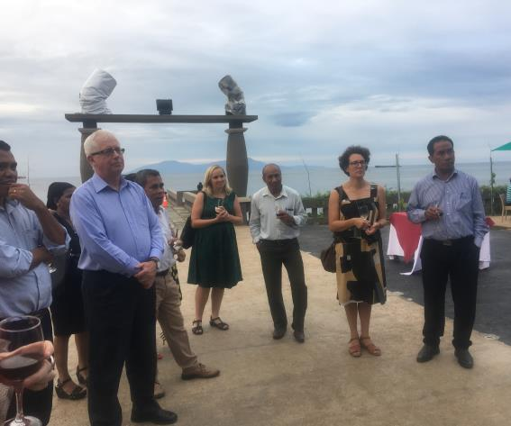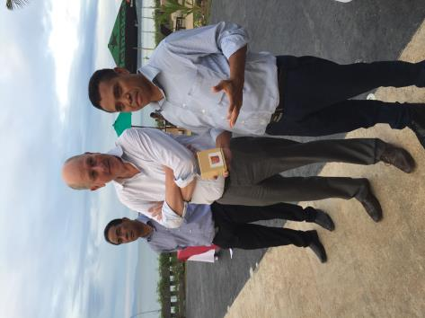
With stakeholders at the reception, including Ambassador Peter Doyle; with Director General of Administrative Decentralisation Abilio Caetano and Director General of Urban Modernisation Miguel de Carvalho

Concluding comments

The visit was successful in building on the positive relationship between the Governments of Victoria and Timor-Leste. The visit also provided valuable information and insights to guide future partnership activities, as well as continuation of existing efforts in areas such as public administration reform, youth affairs and support for the Vocational Education and Training sector.

In particular, the Victorian Government will continue to offer assistance to the Government of Timor-Leste in the areas of sanitation and waste management, in an endeavour to ensure safe drinking water and healthy facilities for communities. Liveability Victoria International stands ready to facilitate technical advice, including working with Melbourne Water and Yarra Valley Water given their strong contributions to drainage and sanitation planning in Dili.

The relationships between Victorian councils and municipalities across Timor-Leste will continue to be strengthened, and the exchange of public servants in the areas of urban planning and government administration will continue through training and work placement activities in 2017.

The Victorian Government’s support of facilities in Balibo, including the Balibo Fort facility and the “Flag House”, is also important to the Government, considering the tragic story of the Australian journalists murdered there in 1975 and the ongoing relationship with their families.

