|  |
| --- |
| FACT SHEET: WASTE AND RESOURCE RECOVERY |
| VICTORIAN BUDGET 2017/18 |

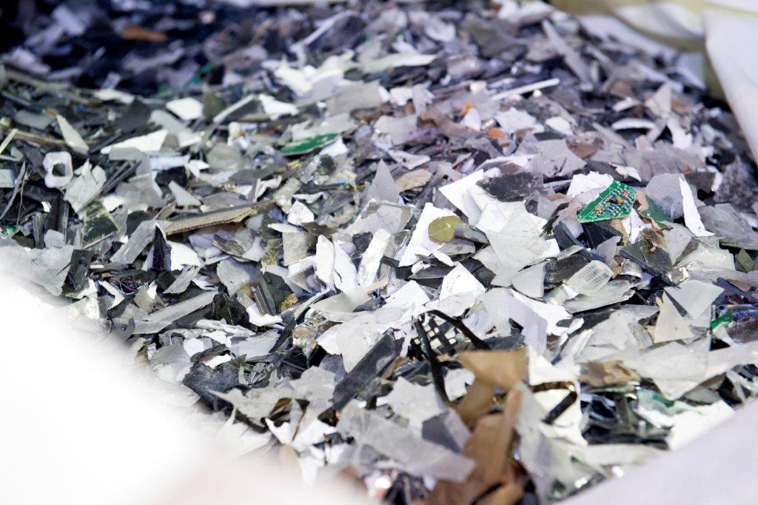

The Victorian Budget 2017/18 provides **$30.4 million** over four years from the Sustainability Fund to implement Victoria’s waste and resource recovery planning framework.

This initiative will increase the recovery rate for priority materials and reduce the amount of waste being landfilled.

It will deliver jobs and improved liveability for Victorians through investment in resource recovery infrastructure, and supporting the Andrews Labor Government’s election commitment to ban e-waste from landfill.

**The funding provides:**

* **$15 million** to support implementation of the government’s election commitment to ban e‑waste from landfill, assisting councils with collection infrastructure and processes;
* **$7.6 million** for the resource recovery infrastructure fund, boosting its grants program, bettering our ability to deal with waste;
* **$4.5 million** for education and litter programs;
* **$2.5 million** to develop markets for materials and energy recovered from waste;
* **$500,000** for waste to energy policy development; and
* **$280,000** to improve the quality of the waste data program

**This means:**

Programs and funding to support local councils to improve waste transfer stations and introduce new collection and transport measures.

Support for schools, businesses, community groups and local government to reduce litter.

More investment in waste to energy and resource recovery infrastructure across Victoria.

**Job creation**

This funding is expected to create **490 new jobs** over four years in waste and resource recovery and **115 new construction jobs.**

**Building momentum**

Additionally, **$620,000** from the 2017/18 Budget will support the Metropolitan Waste and Resource Recovery Group to recover waste from landfill to reduce methane emissions.

This budget also builds on the **$21 million** for waste and resource recovery from the 2016-17 Victorian Budget and the **$2 million** to leverage private investment in developing Waste to Energy facilities to reduce greenhouse gas emissions.

## Find out more

For more information on the Sustainability Fund, visit [environment.vic.gov.au](http://www.environment.vic.gov.au)

Litter programs and the resource recovery infrastructure fund process will be rolled out progressively in 2017 and 2018. Visit [sustainability.vic.gov.au](http://www.sustainability.vic.gov.au)

|  |  |
| --- | --- |
| © The State of Victoria Department of Environment, Land, Water and Planning 2017  LogoThis work is licensed under a Creative Commons Attribution 4.0 International licence. To view a copy of this licence, visit http://creativecommons.org/licenses/by/4.0/ |  |