Voluntary Committees of Management Newsletter
Edition 6

Welcome to this sixth edition of the Voluntary Committees of Management Newsletter. Our theme for this edition is money for your committee. We look at how to find grants to fund that next project, how to write applications to land that grant, and more.

This year will bring about positive change in the way the department provides support for committees of management. We are committed to a number of actions which are identified in the recent Victorian Auditor-General’s Office report (see opposite). I urge you all to read this.

One of the first changes you'll notice is a new edition of the Responsibilities and Good Practice guidelines. The guidelines are currently being revised and updated and the new edition will be available in May.

On behalf of all Victorians, I thank you for your hard work and time that you contribute as a Committee member to managing Victoria’s valuable public estate.

Peter Beaumont

Victorian Auditor-General’s Office Report
into Oversight and Accountability of
Committees of Management tabled in
Parliament

On 5 February 2014, John Doyle, Auditor-General, presented a report on the Department of
Environment and Primary Industries’ (DEPI) governance and oversight of committees of management of Crown Land reserves. The audit assessed whether the support DEPI provides to committees enables them to effectively and efficiently manage Crown land reserves. The audit report includes 11 recommendations for improvements.

DEPI is taking steps to improve its support for committees of management.

DEPI has agreed to tackle the problems identified by the audit and has begun work to address the areas of concern raised in the report.

The report, including DEPI’s response, can be found at the Victorian Auditor-General’s website: http://www.audit.vic.gov.au

Peter Beaumont

Executive Director
Land Management Policy
Voluntary Committees of Management Newsletter- Edition 6

Money for your committee
Does your Committee have a great project planned to improve your site but no money to fund it? With the right grant, it could be a reality.
A number of government bodies, Local, State and Federal, offer funding for projects that protect and enhance biodiversity, repair and conserve heritage places and objects, improve fishing and boating facilities, upgrade access to sporting grounds, or include general community works. To make it easier for you, we’ve compiled a short list of opportunities and links to grants you may be eligible for.
Name | Amount | Purpose | Open date | Website
Communities for Nature Grant | Up to $10,000 | Biodiversity/ habitat preservation; revegetation; waterway clean up; control pests/ weeds | Now open, closes April 11 | www.depi.vic.gov.au/environment-and-wildlife/community-programs/communities-for-nature-grants
Community Environment Grant | Up to $50,000 | Maintain sustainable environment; environmental/ cultural values | Not yet announced- check website | www.nrm.gov.au/funding/environment/ceg/index.html
Recreational Fishing Grants Program | Up to $5,000 | Improve/ implement fishing facilities; promote responsible recreational fishing | Ongoing, apply any time | www.dpi.vic.gov.au/fisheries/about-fisheries/fishing-grants-program
Boating Safety Grants | Unspecified | Develop/ upgrade boating facilities | July/ August 2014 | www.transport.vic.gov.au/freight/boating-safety-and-facilities-program
Community Facility Funding Program | Minor Grants up to $100,000 | Develop/ upgrade community sport and rec. facilities with local govt. authorities | March/ April 2014-check website | www.dpcd.vic.gov.au/home/grants/all-grants/community-facilities-funding-program
Victorian Heritage Register Places and Objects Fund | Up to $200,000 | Repair/ conservation publicly-accessible places and objects on Victorian Heritage Register | Two rounds before July 2015 | www.dpcd.vic.gov.au/heritage/grants
Other Places to find grants
Check your Local Council’s website www.dpcd.vic.gov.au/localgovernment/find-your-local-council as they have grants available from time to time.
Grants Victoria www.vic.gov.au/grants.html allows you to search for grants using this Victorian Government directory.
GrantsLINK www.grantslink.gov.au is a one-stop shop for Australian Government grants, and includes links to Victorian State Government grants

Voluntary Committees of Management Newsletter- Edition 6

Ensure you get that grant using our list of ten tips for successful grant applications

- Finding the right grant for your organisation requires lateral thinking. What are your activities, members and interests? You may be eligible for more grants than you initially thought.
- Allow plenty of time to research the funding body and the grant before beginning your application. Do seek out groups that have received this grant, and contact them for examples of successful applications. Do not leave your application to the last minute- this reflects poorly on your group’s organisational skills.
- Read all the guidelines and make sure your organisation meets them. Do target your submission to the guidelines and ensure you address each one. Do not make your application excessively long- if there are page/ word limits, stick to them.
- Have an achievable goal. Do make this objective clear in your application, and describe how you will carry out the project to meet your goal. Do not try to be too ambitious- design a realistic project that can be accomplished by the end of the grant period.
- Create a realistic budget. Do be honest about how much it will cost, and ensure that you justify all items. Do not include items that are not covered by the grant.

- Demonstrate your capability and expertise. Do prove yourself and your group as qualified to successfully carry out your project in a creative and fiscally-responsible manner. Do not undersell yourselves or assume the grant agency knows about the good work you have already done- outlining relevant successes strengthens your application.
- Establish community support. Do demonstrate this support not just for your group but for your particular project. Do not assume you know what is best for your community- consider consulting them.
- Explain how you will measure the success of the project. Do have an evaluation strategy in place prior to commencing the project. Do not presume the success will be obvious to the grant agency.
- Before submission, thoroughly check your application. Do make sure you have included all of the requested details and attachments. Do not forget to have someone unrelated to the project to read over your application for clarity of expression, spelling, grammar, formatting and consistency.
- If you have been unsuccessful, seek feedback to help improve your next application. If you have been successful, ensure you always submit reports on time. This reflects favourably on any subsequent applications you submit.

Voluntary Committees of Management Newsletter- Edition 6

Voluntary CoM Community Consultation Fact Sheet
The voluntary committees of management community engagement fact sheet is now available.
Thank you for your responses to our survey, which we used to developed this fact sheet.
The fact sheet provides information on when a CoM should consult its community, highlights the benefits of effective consultation, and also gives some tips on effective communication. At the end of the fact sheet, a case study of a Committee has been provided to illustrate effective community consultation. The fact sheet is available at:
http://www.depi.vic.gov.au/forestry-and-land-use/managing-land/managing-crown-land/managing-crown-land-fact-sheets

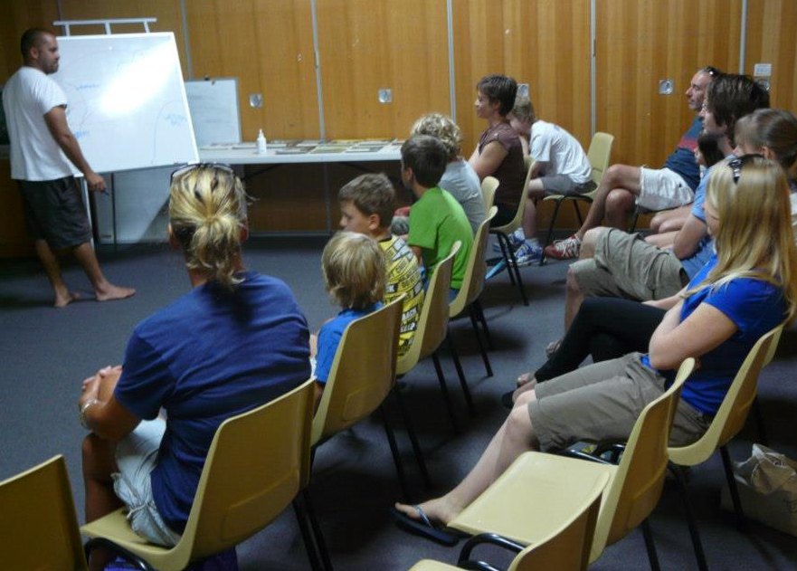

Fire Services Property levy
Confused about how the Fire Services Property Levy applies to the land you manage?
The Fire Services Property Levy was introduced in July 2013, after the Victorian Bushfires Royal Commission found that the old, insurance-based scheme was unfair and lacked transparency. Now, a property-based levy is collected with council rates. The Levy funds vital services provided by the Country Fire Authority and the Metropolitan Fire Brigade, including personnel, training, infrastructure and equipment.

Under the Fire Services Property levy Act 2012, Crown land, which is not leased or licensed to another person is exempt from the fire services property levy. Therefore, Committees of Management are not required to pay the fire services property levy on the Crown land reserve which they manage.
However, if a Committee of Management leases or licences part of its reserve, the lessee or licensee may become liable for the fire services property levy.
For general information regarding the fire services property levy and its application to Committees of Management, please visit the State Revenue Office website: www.sro.vic.gov.au or the Fire Services Property Levy website: http://www.firelevy.vic.gov.au/

New smoke-free areas
New tobacco reforms come into force April 1, 2014. Committees of Management need to be aware that:
Smoking will be banned at areas commonly used by children and young people for recreational and sporting activities.
Under the Tobacco Act 1987 (the Act) smoking will be banned:
- at or within 10 metres of children’s playground equipment that is an outdoor public place;
- at or within 10 metres of a skate park that is an outdoor public place;
- at or within 10 metres of a sporting venue that is an outdoor public place during an organised underage sporting event, including training or practice sessions and during breaks or intervals in play;
- in an outdoor area of a swimming pool complex that is a public place.

More information can be found via the following link:

http://www.health.vic.gov.au/tobaccoreforms/index.htm

