|  |
| --- |
| Information for Applicants |
| **Victorian Water Corporation Board Members** |

|  |  |
| --- | --- |
| Role: | Board member |
| Entity: | Victorian Water Corporation |
| Accountable to: | Minister for Water |
| Location: | Throughout Victoria |

Context

The Victorian government is committed to community engagement and increasing diversity in water sector leadership. This will encourage new ideas and ensure we best reflect our diverse communities.

With the terms of 89 existing water board directors, including seven chair positions, expiring on 30 September 2017, the Minister for Water, the Hon Lisa Neville MP, is inviting expressions of interest in these positions.

**Victorian Water Corporations**

The 19 Victorian water corporations are essential to improving Victoria’s liveability and sustaining the state’s economy and prosperity. They do this by providing water and sewerage services, bulk water supplies, irrigation and drainage services, domestic and stock water, along with other urban and rural water services.

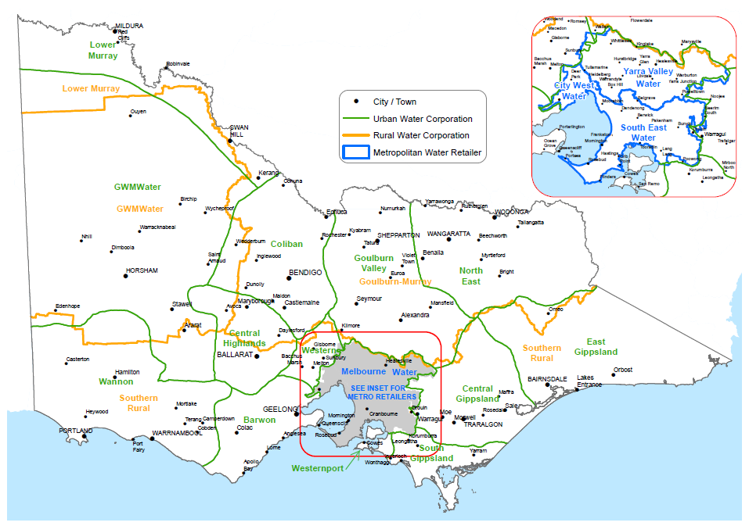

Collectively, the water corporations in 2015 / 16 were responsible for:

* providing water services to approximately 2.7 million customers;
* supplying 3,075 GL of water;
* directly employing around 5,963 staff;
* collecting $6.03 billion in revenue per annum;
* spending $1.39 billion on capital works and $2.89 billion on operational works per annum;
* holding $10.49 billion in borrowings.

An overview of the Victorian water sector can be found at [delwp.vic.gov.au/water-corporations](http://www.delwp.vic.gov.au/water-corporations)

The water corporations are stand-alone entities that provide services to customers with their defined geographic area. Each water corporation has a board of directors appointed by the Minister for Water.

Information on individual water corporations can be found by clicking on the following links:

[Barwon Water](http://www.barwonwater.vic.gov.au/)

[Central Highlands Water](http://www.chw.net.au/)

[City West Water](http://www.citywestwater.com.au/)

[Coliban Water](http://www.coliban.com.au/)

[East Gippsland Water](http://www.egwater.vic.gov.au/)

[Gippsland Water](https://www.gippswater.com.au)

[Goulburn Valley Water](http://www.gvwater.vic.gov.au/)

[Goulburn-Murray Water](http://www.g-mwater.com.au/)

[GWMWater](http://www.gwmwater.org.au/)

[Lower Murray Water](http://www.lmw.vic.gov.au/)

[Melbourne Water](http://www.melbournewater.com.au/)

[North East Water](http://www.newater.com.au/)

[South East Water](http://www.southeastwater.com.au/)

[South Gippsland Water](http://www.sgwater.com.au/)

[Southern Rural Water](http://www.srw.com.au/)

[Wannon Water](http://www.wannonwater.com.au/index.php)

[Western Water](http://www.westernwater.vic.gov.au/)

[Westernport Water](http://www.westernportwater.com.au/)

[Yarra Valley Water](http://www.yvw.com.au/)

Strategic direction

In October 2016, the Victorian Government released its long term direction for managing Victoria’s water resources, [*Water for Victoria*](http://www.delwp.vic.gov.au/water/water-for-victoria)*. Water for Victoria* states that Victoria’s water sector, including the water corporations, will support jobs, economic growth, the environment, and our health and wellbeing by continuing to deliver efficient services with a focus on innovation, performance and affordability.

*Water for Victoria* sets a new long-term direction for managing our precious water resources as we deal with the impacts of climate change and a growing population.

*Water for Victoria* sets out 69 actions under nine themes:

* Climate change
* Waterway and catchment health
* Water for agriculture
* Resilient and liveable cities and towns
* Recognising and managing for Aboriginal values
* Recognising recreational values
* Water entitlements and planning
* Realising the potential of Victoria's water grid and water markets
* Jobs, economy and innovation

For further information on *Water for Victoria*, refer to  
[delwp.vic.gov.au/water/water-for-victoria](http://www.delwp.vic.gov.au/water/water-for-victoria)

Victoria’s water challenges

Water corporations face several challenges within the short to medium term.

* Climate change: Changing climate and adverse weather requires managing water availability and security of supply.
* Service delivery and population growth: Victoria’s strong economy requires water, as does its growing population. Servicing this growth, in new developments and within existing towns, is a key challenge.
* Project delivery and infrastructure management: Together, the water corporations manage approximately $40 billion in assets. Boards must ensure the sustainable management of these assets and the efficient delivery of new projects by approving cost-effective project options.
* Strategic risks: Water corporations are increasingly required to manage the impacts of events such as bushfires and floods on water services and infrastructure. Other issues impacting water corporations include emerging technologies.
* Local issues: Each water corporation has challenges unique to its area, and some have unique responsibilities in managing Victoria’s water resources. This can include delivering irrigation services to a high standard, or managing the demand of high-growth residential areas.

**Composition of the Board**

The board of a water corporation typically consists of seven non-executive directors with a presiding chair, plus the managing director of the water corporation who is appointed by the board. The Minister for Water appoints all directors, including the chair.

For Melbourne Water and the three metropolitan water corporations – City West Water, South East Water and Yarra Valley Water – the board of directors is appointed by the Minister for Water in consultation with the Treasurer.

**The governance framework**

Legislative context

The Board is regulated by a range of legislation which includes:

* *Water Act 1989*: establishes the Boards.
* *Public Administration Act 2004*: sets out the expected standards of conduct across the public sector.
* *Financial Management Act 1994*: provides the basis for financial management and reporting requirements for public bodies in Victoria.

Some of the key reporting requirements that the board will need to prepare include its:

* Annual Report;
* Corporate Plan; and
* Pricing Submission to the Essential Services Commission.

Accountability and key relationships

In fulfilling its responsibilities, the Board remains accountable to the Minister for Water who is accountable to Parliament and the community for the performance of the entities.

In overseeing the performance of the Board, the Minister is supported by the Department of Environment, Land, Water and Planning (DELWP).

In addition to the Minister, Parliament of Victoria and DELWP, board directors also maintain relationships with a range of other key stakeholders. These can include the:

* water corporation’s customers and clients;
* community in which the corporation operates;
* Treasurer and the Department of Treasury and Finance;
* Department of Health and Human Services;
* Essential Services Commission;
* Environment Protection Authority;
* Energy and Water Ombudsman Victoria;
* Australian Consumer and Competition Commission;
* Murray-Darling Basin Authority; and
* local government.

**The role**

The role of the Board

The Board is responsible for the strategic planning of the corporation, and ensuring that the water corporation fulfils its statutory functions consistently with its overall governance framework. This includes:

* Providing strategic direction and setting performance targets for the corporation;
* appointing and overseeing the performance of the managing director;
* establishing and monitoring accountability, compliance and risk management policies and procedures;
* ensuring compliance with legislation and government policy;
* reviewing reports on the operations of the water corporation;
* submitting the annual report to the Minister;
* liaising with DELWP and the Minister through the chair;
* establishing board processes such as meeting procedures and the management of conflicts of interest; and
* establishing and monitoring delegations and committees.

The role of a Director

Directors, working together under the guidance of the chair, make strategic and high level operational decisions in the best interests of the corporation. Board directors are expected to actively contribute to board decisions, applying their specialist skills and experience.

In performing their role, board members must conduct themselves in a manner that is consistent with:

* the public sector values of responsiveness, integrity, impartiality, accountability, respect, leadership and human rights (as set out in section 7 of the *Public Administration Act 2004*);
* The duties of directors as set out under section 79 of the *Public Administration Act 2004*;

1. A director of a public entity must at all times in the exercise of the functions of his or her office act:
   * 1. honestly; and
     2. in good faith in the best interests of the public entity; and
     3. with integrity; and
     4. in a financially responsible manner; and
     5. with a reasonable degree of care, diligence and skill; and
     6. in compliance with the Act or subordinate instrument or other document under which the public entity is established.
   1. A person who is or has been a director of a public entity must not, except to the extent necessary:
   2. to exercise functions under this or any other Act; or
   3. to give any information that he or she is expressly authorised, permitted or required to give under this or any other Act – give to any other person, whether directly or indirectly, any information acquired by him or her by reason of being a director.
2. A director of a public entity must not improperly use his or her position, or any information acquired by him or her by reason of his or her position, to:
   * 1. gain an advantage for himself or herself or another person; or
     2. cause detriment to the public entity.
   1. A director of a public entity who becomes a candidate for an election to the Parliament of Victoria or of the Commonwealth or of any other State or a Territory or to a Council within the meaning of the *Local Government Act 1989* or a corresponding body in another jurisdiction:
   2. must notify the board of the public entity of that fact; and
   3. must not use any resources of the public entity in connection with his or her candidature.

A copy of the Director’s Code of Conduct and guidance notes can be found by visiting [vpsc.vic.gov.au/resources/code-of-conduct-for-directors/](http://vpsc.vic.gov.au/resources/code-of-conduct-for-directors/)

More information regarding the roles and responsibilities of a public entity board member can be found by visiting [vpsc.vic.gov.au/information-for-board-members/](http://vpsc.vic.gov.au/information-for-board-members/)

The role of the Chair

Being the chair of a water corporation requires a further level of expertise and commitment. The chair is responsible for the cohesive operation of the board and ensures the smooth running of board meetings. The chair must ensure that all board directors’ views are considered in decision-making.

The Minister for Water, under the *Water Act 1989*, appoints a chair from the available board directors. Potential chairs are identified as part of the normal director recruitment process. The duties of a chair are outlined in Section 80 of the *Public Administration Act 2004*.

More information on water corporation chairs and directors’ responsibilities can be obtained through DELWP’s [On Board website](http://www2.delwp.vic.gov.au/boards-and-governance/on-board-basic-requirements-of-good-governance).

Time commitment

Boards generally meet 11 times a year, however additional meetings and out-of-session discussions are expected. Staff from the water corporation will submit plans, proposals or other documents to the board for consideration. The board will assess each agenda item to ensure the proposed options meet a range of economic, social, service, environmental and government objectives.

Board committees are formed for specific topics, such as risk, audit and remuneration. Board directors may need to contribute additional time to board committees, for which they are eligible for additional remuneration under government guidelines. A board director can usually expect to be a member of at least one committee of the board.

Appointees are generally expected to attend at least 75 per cent of Board meetings. If applicants are appointed to other boards, they are expected to manage their time appropriately. Applicants should give careful consideration to any existing and anticipated demands on their time.

Remuneration and expenses

All directors are eligible for remuneration in line with the [Appointment and Remuneration Guidelines](http://www.dpc.vic.gov.au/index.php/policies/governance/appointment-and-remuneration-guidelines), published by the Department of Premier and Cabinet

The remuneration is on a per annum basis and the remuneration varies depending on the individual water corporation.

There is a fixed allowance for additional committee work that may also apply for each water corporation.

Directors are eligible for reasonable out of pocket expenses. Reimbursement will be in accordance with the policies of DELWP.

There are limited circumstances where public sector employees may be eligible for remuneration for their service on a Victorian Government board. Current Government policy regarding public sector employee remuneration is discussed further below.

Term of appointment

In accordance with the Act members, including the Chair, may be appointed for terms of up to four years.

**Key Selection Criteria**

Applicants will be shortlisted on the basis of high level skills, experience and knowledge in relation to the following criteria.

Mandatory skills under the Water *Act 1989*

In accordance with the Act, the Minister must ensure that a director has qualifications and experience that are relevant to the operation of the water corporation.

Highly desirable skills

In addition to the mandatory skill outlined above, skills, knowledge or experience in the following areas will be considered highly desirable:

* Financial & commercial management
* Community engagement
* Land & water management
* Climate change adaptation
* Strategy & business management
* Infrastructure & project management
* Corporate governance.

**Information and forms to be provided by applicants**

How to apply

* Expressions of Interest open in March 2017 for four weeks.
* Information on how to apply will be available in March 2017.
* If you are interested in being contacted when board appointments become available, please email your name and contact details –  
  [waterandcatchments@delwp.vic.gov.au](mailto:waterandcatchments@delwp.vic.gov.au)
* In the meantime, please register on [Get On Board](http://www.getonboard.vic.gov.au)

Applicants are required to upload a current curriculum vitae and complete a questionnaire outlining their relevant skills, experience and knowledge in relation to the Key Selection Criteria.

Applicants shortlisted for an interview may be requested to submit additional documents and be subject to the following probity checks, prior to their appointment:

* National Criminal Record Check;
* Australian Securities & Investment Commission register of person’s banned and disqualified check; and
* Australian Financial Security Authority and National Personal Insolvency Index check.

**Information about relevant Government policies**

The Victorian Government’s [Appointment and Remuneration Guidelines](http://www.dpc.vic.gov.au/index.php/policies/governance/appointment-and-remuneration-guidelines) outline relevant policies in relation to board and committee membership, which include the following:

Gender Equity

It is Government policy that no less than 50 per cent of all appointments to paid Victorian Government boards and Victorian courts be women.

Encouraging Diversity

Appointments to Victorian Government entities should, as far as practicable, reflect the diversity of the Victorian Community. Women, Indigenous Australians, people with a disability, people from culturally and linguistically diverse backgrounds and lesbian, gay, bisexual, transgender and intersex people are encouraged to apply.

Reappointment

Candidates being considered for reappointment undergo the same open and competitive selection process as candidates who have not served on the Board.

Multiple boards

An individual should hold no more than three positions on government boards at any one time.

Victorian residents

It is preferred that appointees reside in Victoria, so that they act in the best interests of the State.

Public sector employees – remuneration

Public sector employees are not eligible for remuneration in circumstances where board membership is a requirement of their substantive position.

Public sector employees may be eligible for remuneration only in circumstances where the proposed appointment is on a personal basis and the work required for the board will be undertaken in their own time or during periods of approved leave.

Remuneration of executive level or equivalent public sector employees requires written approval from the Secretary, Department of Premier and Cabinet.

For further information regarding the Appointment and Remuneration Guidelines visit  
[dpc.vic.gov.au/index.php/policies/governance/appointment-and-remuneration-guidelines](http://www.dpc.vic.gov.au/index.php/policies/governance/appointment-and-remuneration-guidelines)

**Further information**

A number of resources are available which may assist applicants in understanding the requirements of the role of a board member and the public sector environment.

* DELWP’s [On Board website](http://www2.delwp.vic.gov.au/boards-and-governance/on-board-basic-requirements-of-good-governance) is the central place for governance information about DELWP agencies. It contains information about governance requirements, governance guides and resources and links to current expressions of interest for vacancies on DELWP boards. [delwp.vic.gov.au/boards-and-governance/on-board-basic-requirements-of-good-governance](http://www2.delwp.vic.gov.au/boards-and-governance/on-board-basic-requirements-of-good-governance)
* The [Victorian Public Sector Commission](http://vpsc.vic.gov.au/)’s website provides further governance and policy information for candidates and public sector board members.
* The [Appointment and Remuneration Guidelines](http://www.dpc.vic.gov.au/index.php/policies/governance/appointment-and-remuneration-guidelines) outline the standard processes and principles for appointing and remunerating board members of non-departmental entities in Victoria.
* The [Public Board Appointments Victoria](http://www.publicboards.vic.gov.au/) website lists the current members of most DELWP major agencies.

|  |  |
| --- | --- |
| © The State of Victoria Department of Environment, Land, Water and Planning 2017  LogoThis work is licensed under a Creative Commons Attribution 4.0 International licence. You are free to re-use the work under that licence, on the condition that you credit the State of Victoria as author. The licence does not apply to any images, photographs or branding, including the Victorian Coat of Arms, the Victorian Government logo and the Department of Environment, Land, Water and Planning (DELWP) logo. To view a copy of this licence, visit http://creativecommons.org/licenses/by/4.0/  **Disclaimer**  This publication may be of assistance to you but the State of Victoria and its employees do not guarantee that the publication is without flaw of any kind or is wholly appropriate for your particular purposes and therefore disclaims all liability for any error, loss or other consequence which may arise from you relying on any information in this publication. | **Accessibility**  If you would like to receive this publication in an alternative format, please telephone the DELWP Customer Service Centre on 136 186, email [customer.service@delwp.vic.gov.au](mailto:customer.service@delwp.vic.gov.au), or via the National Relay Service on 133 677 [www.relayservice.com.au](http://www.relayservice.com.au). This document is also available on the internet at [www.delwp.vic.gov.au](http://www.delwp.vic.gov.au) |