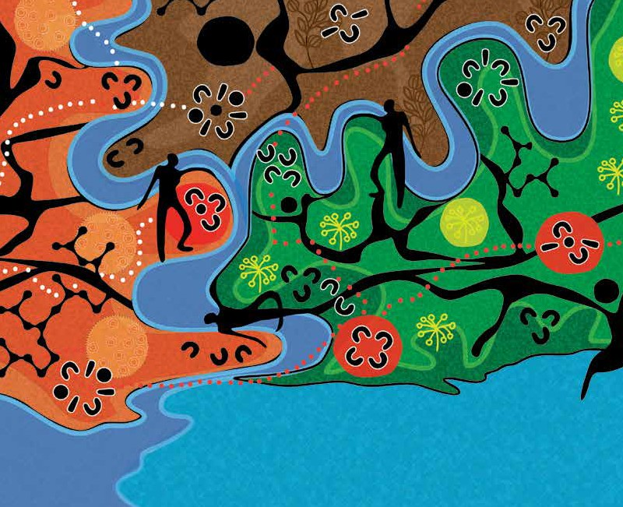
Munganin – Gadhaba
‘Achieve Together’
Annual Work Plan 2016

DELWP Aboriginal Employment Plan 2016-2020

OBJECTIVE 1 DEPARTMENT OF ENVIRONMENT, LAND, WATER AND PLANNING (DELWP) ATTRACTS AND
RECRUITS TALENTED ABORIGINAL PEOPLE - DELWP will focus on improving our external branding, recruitment procedures and strategies to ensure they are culturally appropriate and designed to attract and support Aboriginal people becoming DELWP employees.
Goals | Action | Key Performance Measure | Accountability/ Lead Responsibility
1. Establish and recruit an ongoing senior dedicated resource to drive and provide technical support  for the delivery of the Aboriginal Employment Plan 2016 - 2020. | Establish an ongoing Aboriginal Employment Programs Coordinator position within People and Culture to provide technical advice and coordinate the delivery of the Aboriginal Employment Plan. | Aboriginal and Diversity Employment Programs Coordinator is recruited. | A: Executive Director People and Culture  LR: Director HR Services and Business Partnering
2. Increase the number of Aboriginal people employed within DELWP to 3 per cent by 2020. | Ensure all persons involved in interview panels undertake appropriate cultural awareness training. | All recruitment and selection training to be reviewed and updated. | A: Deputy Secretaries, Executive and Regional Directors  LR: Munganin-Gadhaba Steering Committee
 | Establish periodic reviews of selection panel members based on the recruitment selection reports. | 95 per cent of selection panels members have completed appropriate cultural awareness training. | A: Deputy Secretaries, Executive and Regional Directors  LR: Munganin-Gadhaba Steering Committee
3. Increase the number of Aboriginal people employed through the graduate and Project Firefighter Programs. | Work with the Victorian Public Sector Commission (VPSC) and DELWP Groups to identify potential roles to be filled by Aboriginal graduates through the GRADS program. | Increase the percentage of DELWP’s Graduate intake who identify as Aboriginal. | A: Deputy Secretaries, Executive and Regional Directors  LR: Munganin-Gadhaba Steering Committee
4. Increase the rate of Aboriginal people applying for all advertised positions in DELWP by identifying DELWP as an employer of choice and removing barriers to the recruitment of Aboriginal people. | Demonstrate DELWP’s support for Aboriginal inclusion by placing DELWP’s Aboriginal Employment Plan on DELWP’s external website. | Munganin - Gadhaba Aboriginal Inclusion Plan (AIP) and DELWP’s Aboriginal Employment Plan are available on DELWP’s external website. | A: Executive Director Communications  LR: Manager Diversity Programs and Innovation
 | Review and modify policies, procedures and processes to identify and remove barriers to recruitment of Aboriginal employees including identified and designated Aboriginal positions. | Policies, procedures and processes are reviewed and modified. | A: Executive Director People and Culture  LR: Director HR Services and Business Partnering
5. Establish the Aboriginal Employment Plan (AEP) governance and reporting arrangements. | Establish clear governance, consultation arrangements and reporting framework for the Aboriginal Employment Plan. | Arrangements for the governance for the AEP are established and articulated within the Terms  of Reference of the Muganin- Gadhaba Steering Committee. | A: Executive Director People and Culture  LR: Manager Diversity Programs and Innovation
6. DELWP supports recruitment of Aboriginal people by broadening recruitment advertising to include Aboriginal community networks. | Review the media outlets and networks DELWP uses for all positions and broaden the recruitment process to include providing recruitment notifications to the VPSC  and Aurora Foundation, Aboriginal Affairs Victoria, university hubs and group training organisations with specific Aboriginal networks. | A list of media outlets and networks to support  advertisements in Aboriginal community networks is established. | A: Executive Director People and Culture  LR: Director HR Services and Business Partnering
 | Investigate, review and apply options for confirmation of Aboriginality. | Process for confirmation of Aboriginality is reviewed and modifications are made to recruitment policies and procedures. | A: Executive Director People and Culture  LR: Director HR Services and Business Partnering

Munganin – Gadhaba ‘Achieve Together’ DELWP Aboriginal Employment Plan 2016-2020

OBJECTIVE 2 | ABORIGINAL PEOPLE HAVE REWARDING CAREERS IN DELWP - Providing our current Aboriginal employees with new opportunities to build on their capabilities and to apply them in different roles across DELWP will be a key focus for this plan. This will include a strong focus on career progression  and ensuring Aboriginal staff are supported to develop their educational qualifications and seek vacancies and promotions to more senior positions within the department.  The first year’s work on this objective will be focussed on the evaluation of current arrangements leading to a range of proposed actions in 2017 and later years.
Goals |  | Action | Key Performance Measure | Accountability/ Lead Responsibility
1. Career pathways and mobility programs supporting the development of all Aboriginal employees including those in roles not classified as designated or identified. |  | Evaluate current arrangements to support DELWP Aboriginal employees and Aboriginal communities to undertake further tertiary and other studies are aligned with DELWP’s priority areas. Review and respond to recommendations. | Current arrangements for tertiary and other study support programs are evaluated.  Actions are taken following the recommendations from the review of tertiary and other studies support programs. | A: Executive Director People and Culture  LR: Manager Workforce Capability

OBJECTIVE 3 | ABORIGINAL PEOPLE FEEL CULTURALLY SAFE WITHIN DELWP WORKPLACES - Cultural safety in an  organisational context means that the workplace is equipped to provide a culturally safe atmosphere where a person’s cultural identify is respected.  Cultural Safety is an environment, which is safe for people; where there is no assault, challenge or denial of their identity, of who they are and what they need. It is about shared respect, shared meaning, shared knowledge and experience, of learning together with dignity, and truly listening  In line with DELWP’s approach to workplace culture and values, the department is committed to providing such a workplace.
Goals |  | Action | Key Performance Measure | Accountability/ Lead Responsibility
1. DELWP workplaces understand, respect and celebrate Aboriginal cultures and accommodate cultural differences. |  | Review the DELWP Aboriginal Staff Network to enhance and extend the network to include Aboriginal people in DELWP’s public entities. | Number of Aboriginal Staff network members.  Number of Aboriginal staff network members from DELWP entities. | A: Executive Director People and Culture  LR: Manager Diversity Programs and Innovation
 |  | Establish an events committee to assist in the planning and staging of key events in the Aboriginal Community Calendar such as  - Reconciliation Week, NAIDOC week, Mabo Day and Sorry Day. | Events committee is established. | A: Executive Director People and Culture  LR: Manager Diversity Programs and Innovation
 |  | Amend the department’s Diversity and Inclusion Strategy to incorporate key outcomes in supporting Aboriginal culture in Victoria. | DELWPs Diversity and Inclusion Strategy incorporates relevant action items from the Aboriginal Employment Plan and Munganin- Gadhaba. | A: Executive Director People and Culture  LR: Manager Diversity Programs and Innovation
 |  | Establish a program (including guest speakers, information sessions, online and face to  face training) to assist groups to increase their level of knowledge and understanding about contemporary Aboriginal issues within a DELWP service delivery and legislative compliance context. | Number of Aboriginal cultural events and awareness initiatives facilitated by DELWP.  Number of staff attended / participated in the events or initiatives. | A: Executive Director People and Culture  LR: Manager Diversity Programs and Innovation
2. DELWP workplaces are where Aboriginal people want to work and where Aboriginal staff feel they are understood and respected. |  | Respond to the review of the Indigenous Cultural Awareness Program (ICAP) and re-launch the program. | Recommendations from the evaluation of ICAP are reviewed and responded to.  The ICAP is re-launched. | A: Executive Director People and Culture  LR: Manager Diversity Programs and Innovation

Munganin – Gadhaba ‘Achieve Together’ DELWP Aboriginal Employment Plan 2016-2020

OBJECTIVE 4 DELWP IMPLEMENTS A PLACE-BASED APPROACH TO CLOSE THE PARTICIPATION GAP
DELWP’s groups will provide a range of employment and training opportunities for Traditional Owner groups and local Aboriginal communities. DELWP will work with these groups to identify opportunities in our projects for employment and training via traineeships, cadetships, scholarships and casual and full time employment.
The level and success of that engagement will be influenced by the relationships we establish and how we partner with each community. We will build our reputation by:
- Demonstrating our knowledge and understanding of Aboriginal issues and our willingness to collaborate.
- Actively engaging with local stakeholders to determine opportunities and priorities.
- Building relationships with local recruitment and training agencies specialising in Aboriginal placements.
- Becoming recognised locally as an organisation where Aboriginal people can compete successfully for jobs.
DELWP’s on-the-ground strategy will be developed in partnership with Aboriginal organisations and tailored to local needs. This will involve extensive local engagement and be guided across all groups by our place-based approach. The delivery model aims to consider regional and local differences and complexities.
The first year’s work on the Aboriginal Employment Plan Objectives 1 to 3 in 2016 will develop the programs and tools to allow for the implementation of the place-based approach actions that will begin in 2017.

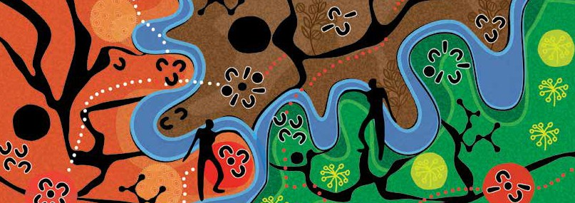
© The State of Victoria Department of Environment, Land, Water and Planning 2016

This work is licensed under a Creative Commons Attribution 4.0 International licence. You are free to re-use the work under that licence, on the condition that you credit the State of Victoria as author. The licence does not apply to any images, photographs or branding, including the Victorian Coat of Arms, the Victorian Government logo and the Department of Environment, Land, Water and Planning (DELWP) logo. To view a copy of this licence, visit http://creativecommons.org/ licenses/by/4.0/
Graphic Design and Artwork by Mazart Design Studio www.mazartdesignstudio.com | Supply Nation certified.
Printed by Impact Digital - Brunswick. ISBN 978-1-76047-058-6 (Print)
ISBN 978-1-76047-059-3 (pdf/online)
Disclaimer
This publication may be of assistance to you but the State of Victoria and its employees do not guarantee that the publication is without flaw of any kind or is wholly appropriate for your particular purposes and therefore disclaims all liability for any error, loss or other consequence which may arise from you relying on any information in this publication.
Accessibility
If you would like to receive this publication in an alternative format, please telephone the DELWP Customer Service Centre on 136 186, email customer.service@delwp.vic.gov.au
or via the National Relay Service on 133 677 www.relayservice.com.au
This document is also available on the internet at www.delwp.vic.gov.au

www.delwp.vic.gov.au

